**Character and Set Design Couse Work 1 Report**

**Introduction**

In this report I will be detail my entire design and modelling process for the robotic athlete. This will include the design pipeline, working and adapting from inspiration, the modelling techniques used, and justification to sing a wide variety of techniques that Maya has to offer.

**Pre-Production and Planning**

To begin with I created a style sheet and mood board in order to get inspiration and ideas about what I could use for my robot model. I used pictures of robots from films such as *Real Steel*, *iRobot,* and *Star Wars*, along with some examples of real-life robots from companies such as Boston Dynamics. Along with these, I also added pictures of human Olympians in order to get ideas for both the types of movements the Robotic Olympoid should be able to perform, as well as ideas for real-world objects that could be modelled alongside the main robot as either props/items or as part of the Olympoid itself.

**Development drawings, sketches and blueprints**

**Techniques and Surfaces**

2-3 pages

**Body**

* Imported blueprint sketched as image planes in Maya, and scaled to all be the same size

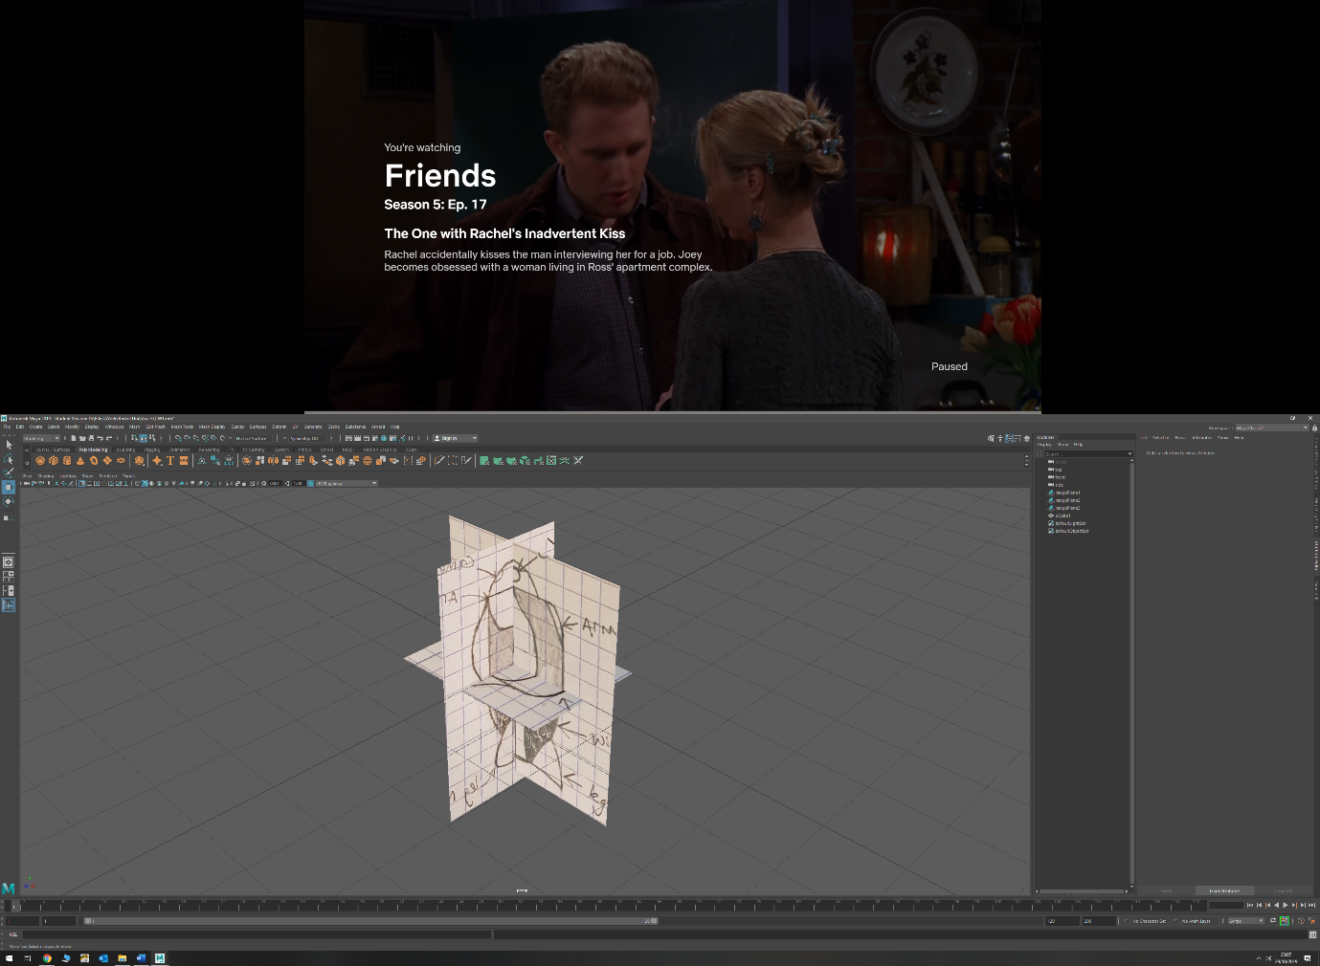

* Added edge loops to a cube after manipulating size to match sketches

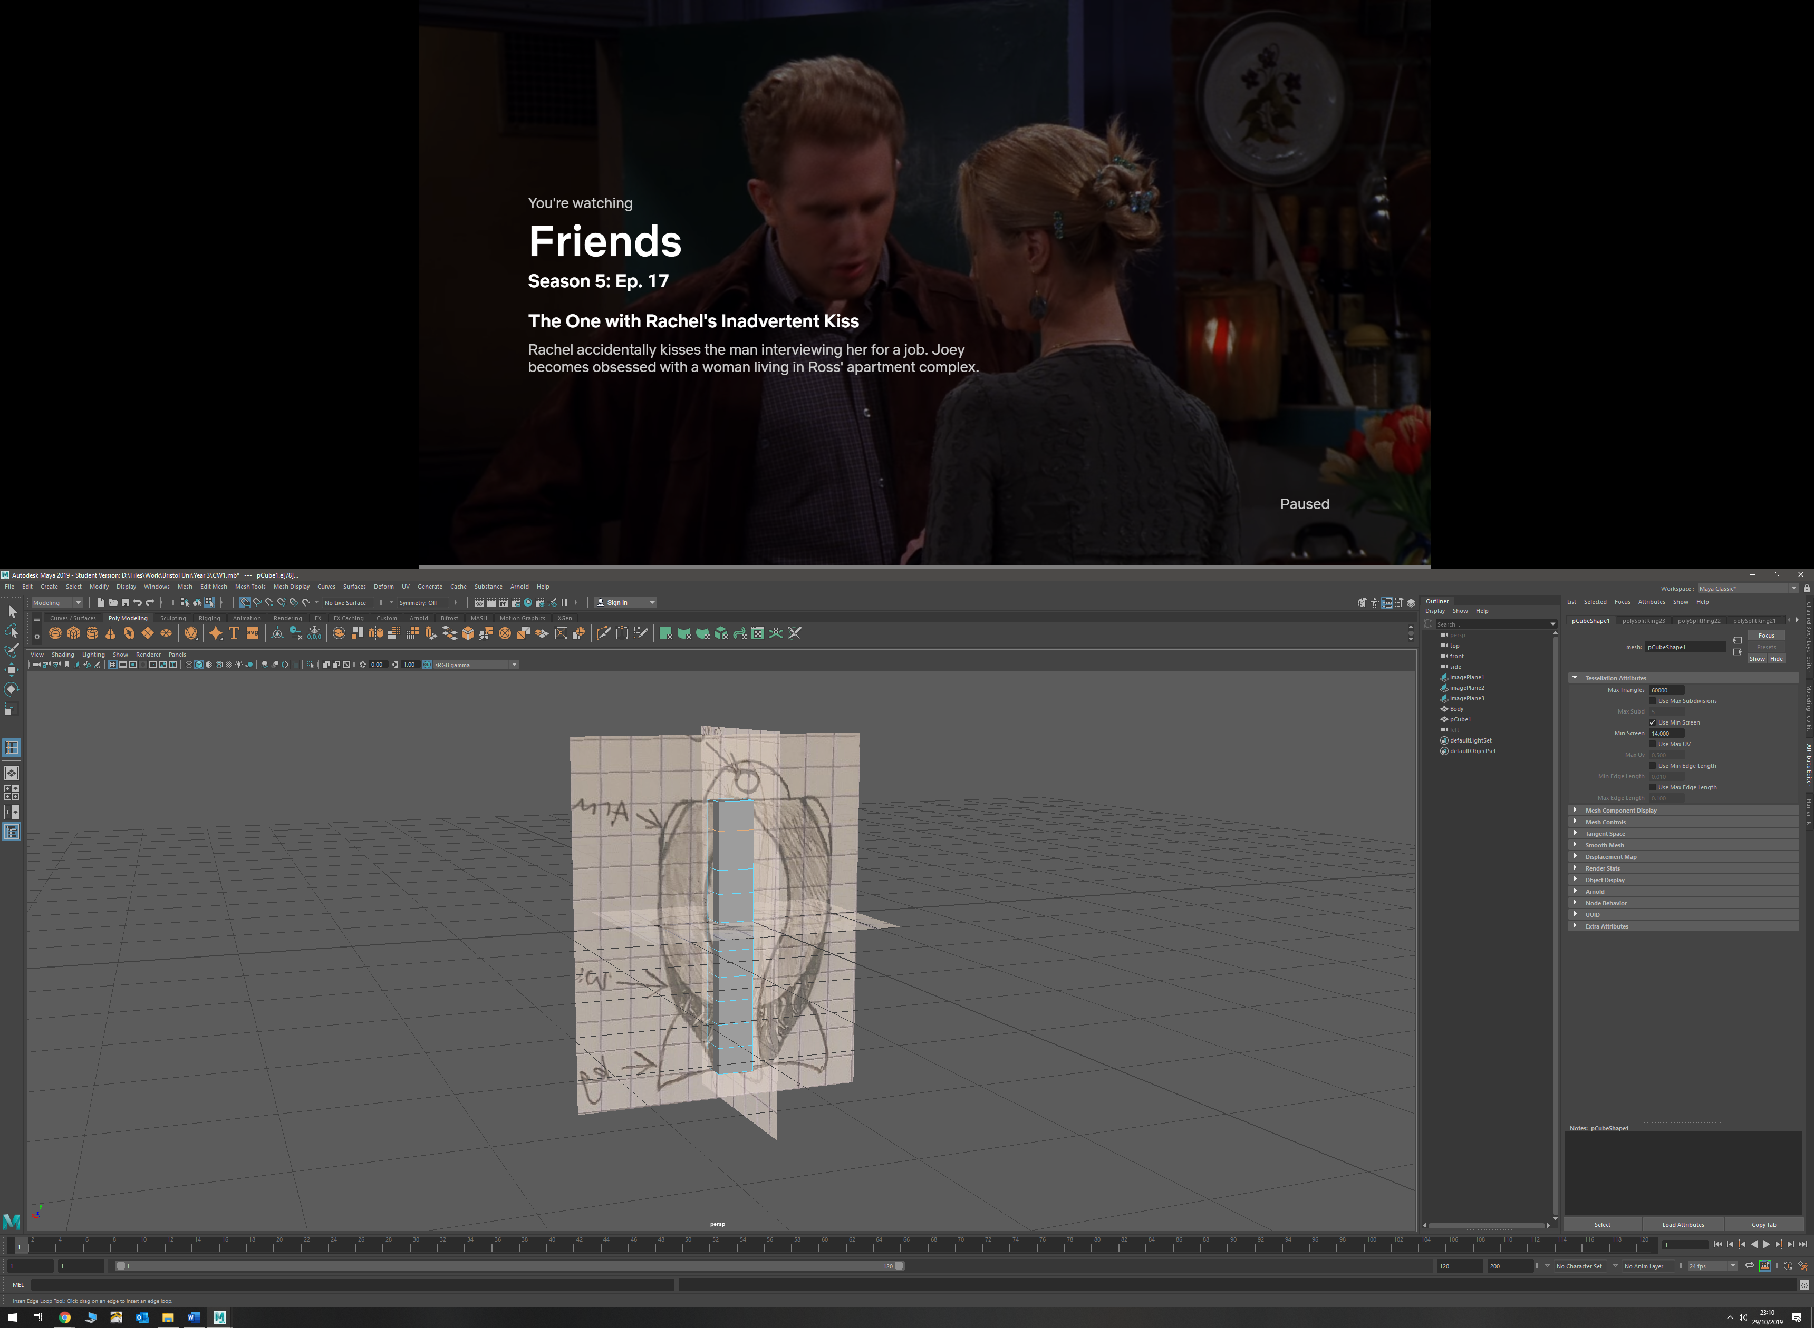

* Manipulated new edges in order to fit body to match blueprints by moving positions in the different orthographic views

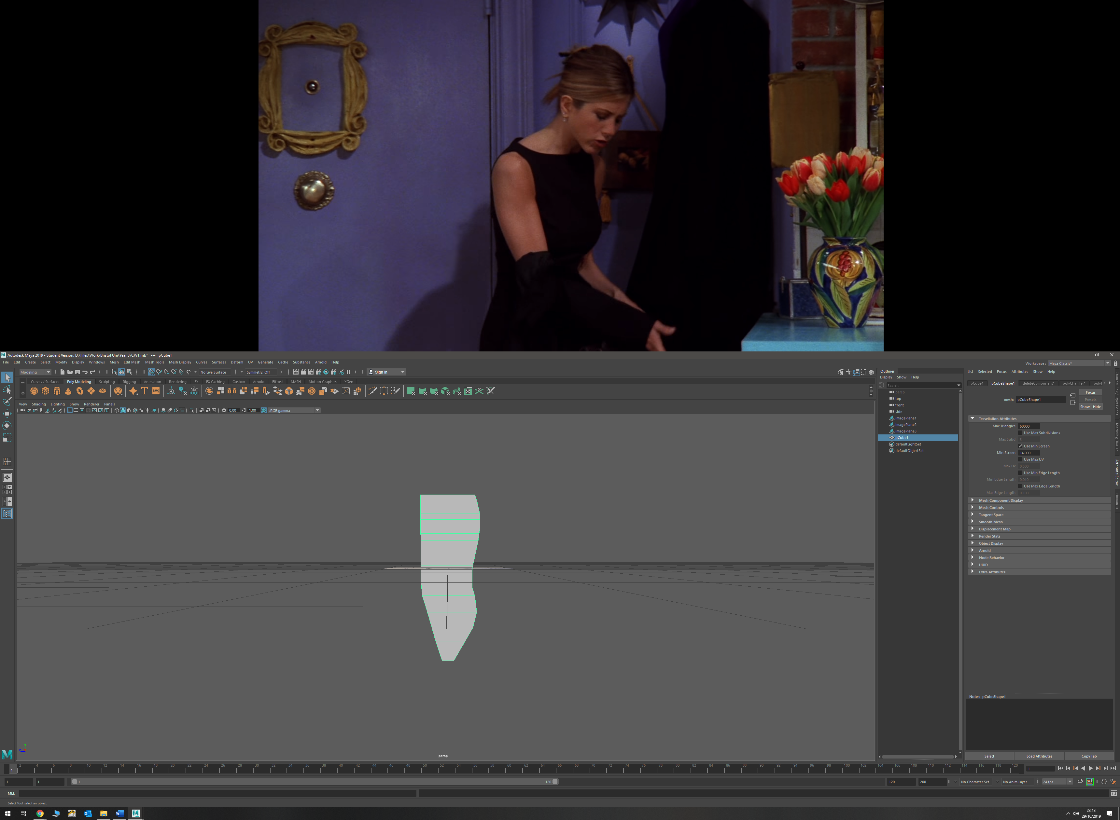

* Bevelled edges using bevel tool to get correct shape. Changed number of bevels to 4

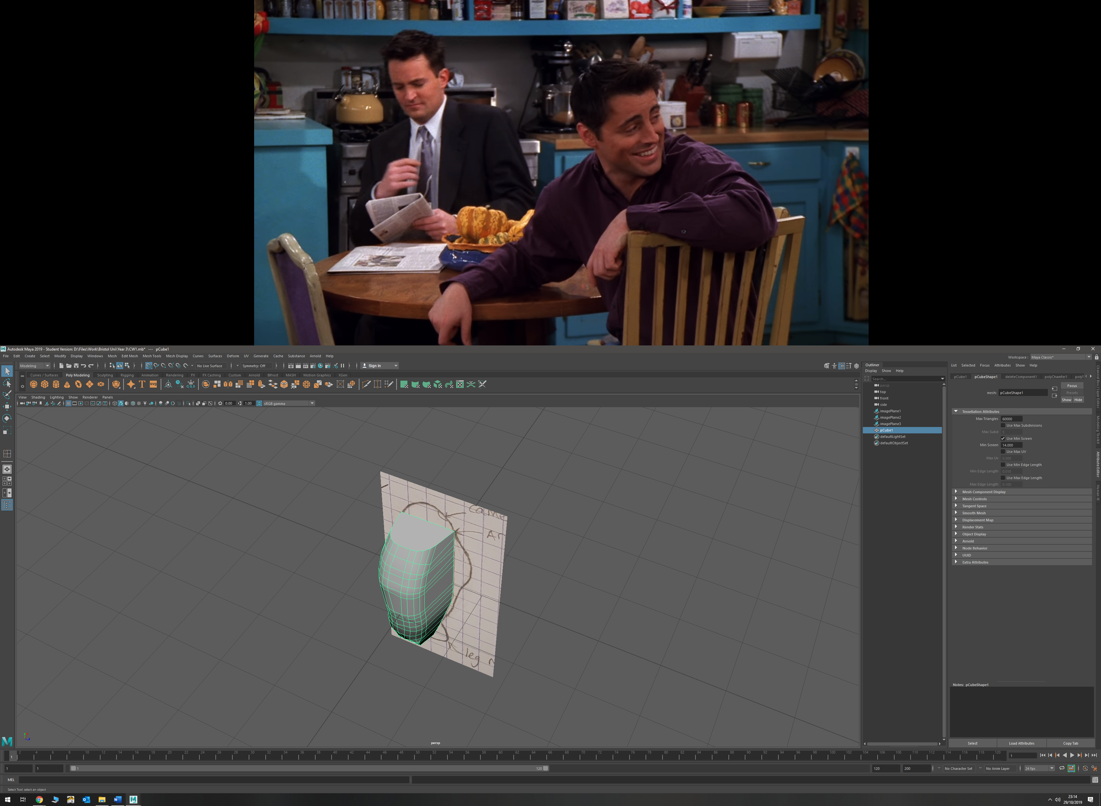

* Bevelled 2 vertices near bottom of model in order to make shape more coherent

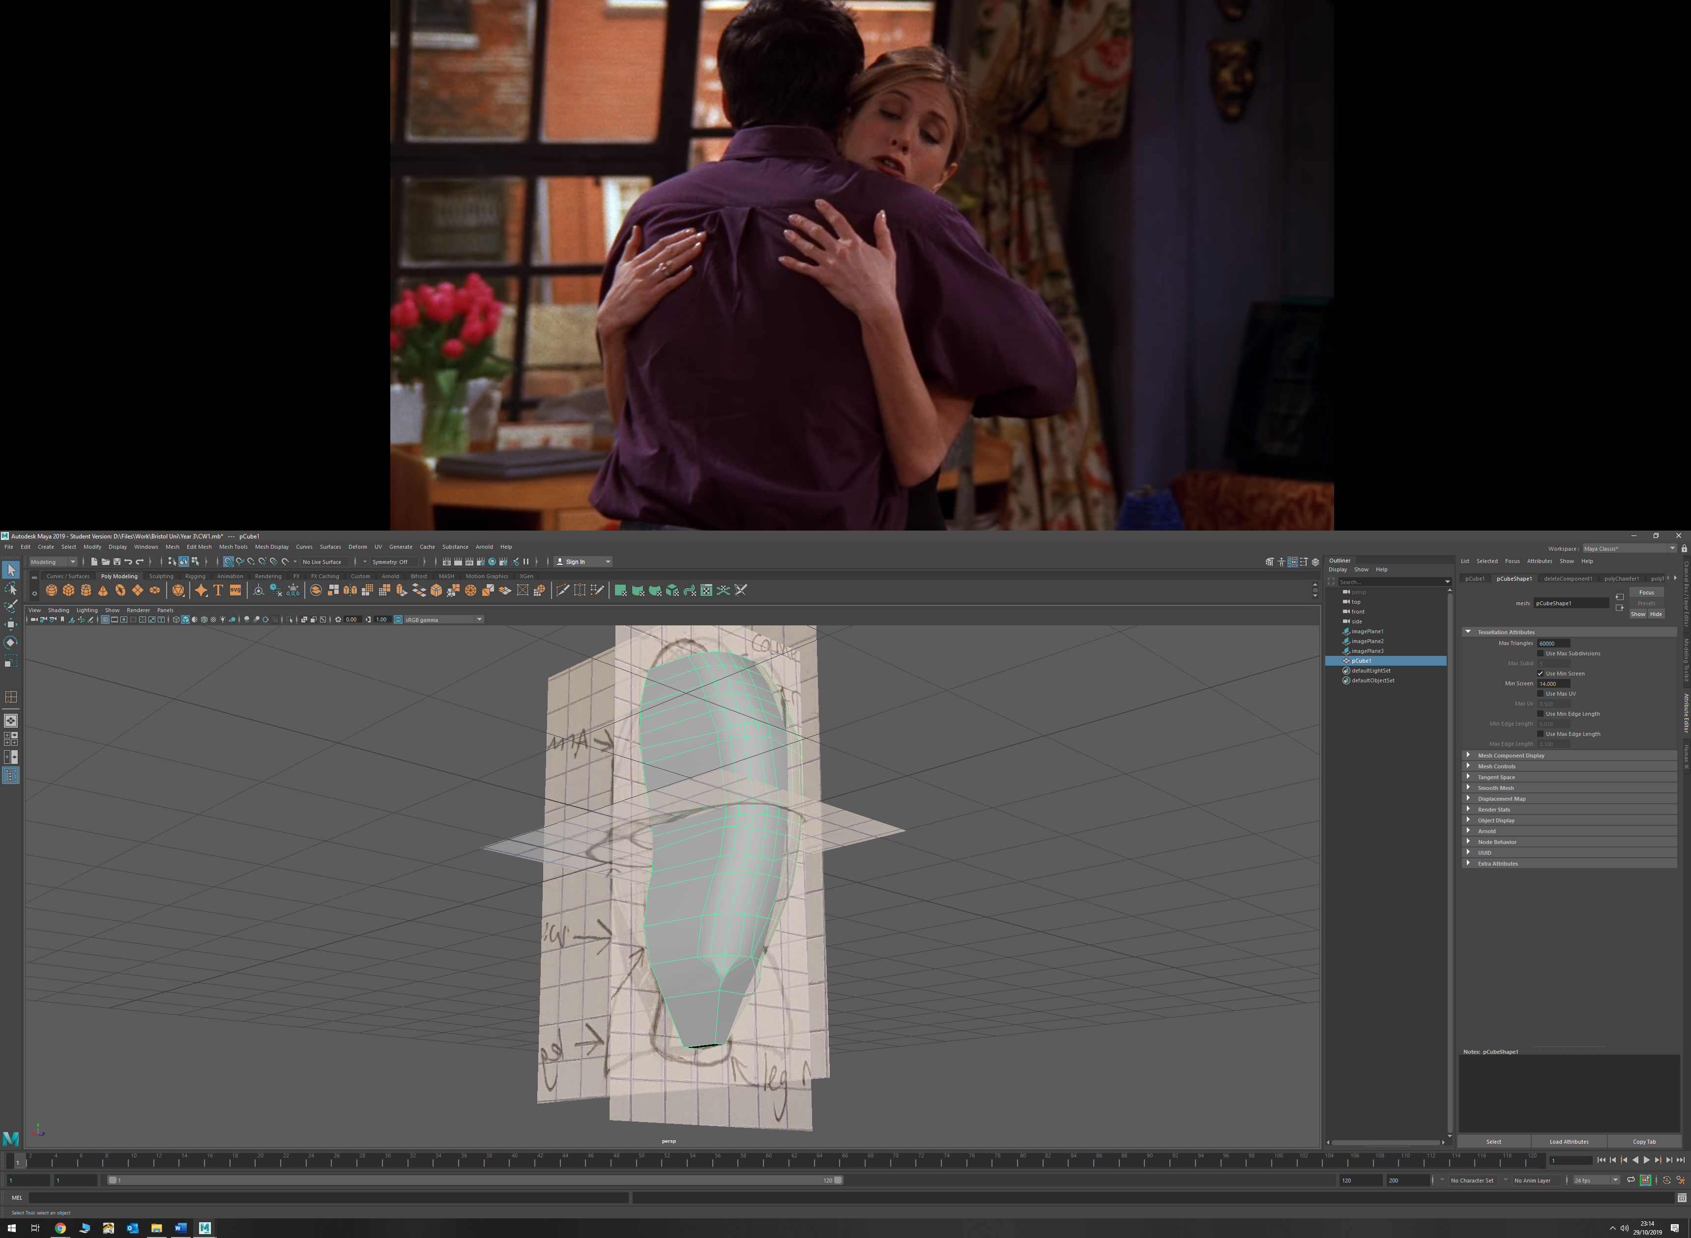

* Drew curve around leg mount to get shape

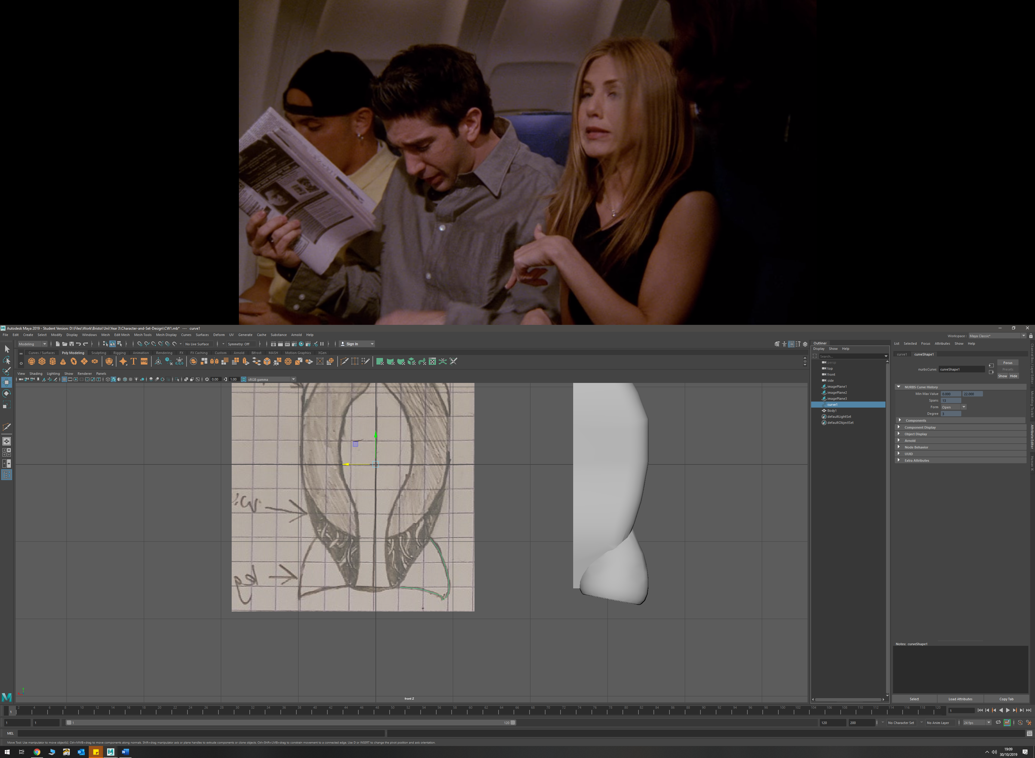

* Used revolve tool in order to create a polygon cone of the correct shape, and used reverse so polygonal mesh was the correct way around

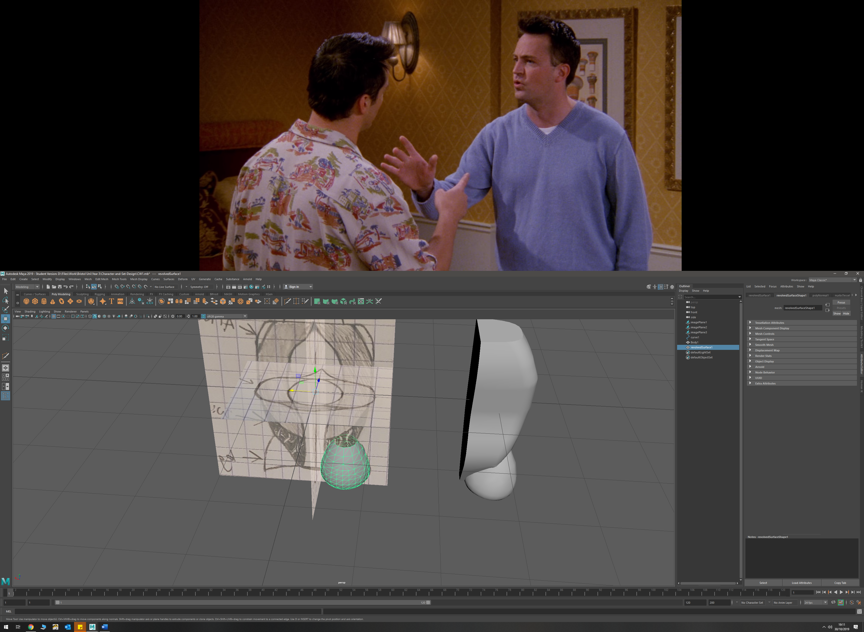

* Extruded edges on top of cone to make correct shape, and a binomial in order to merge the leg mount and body

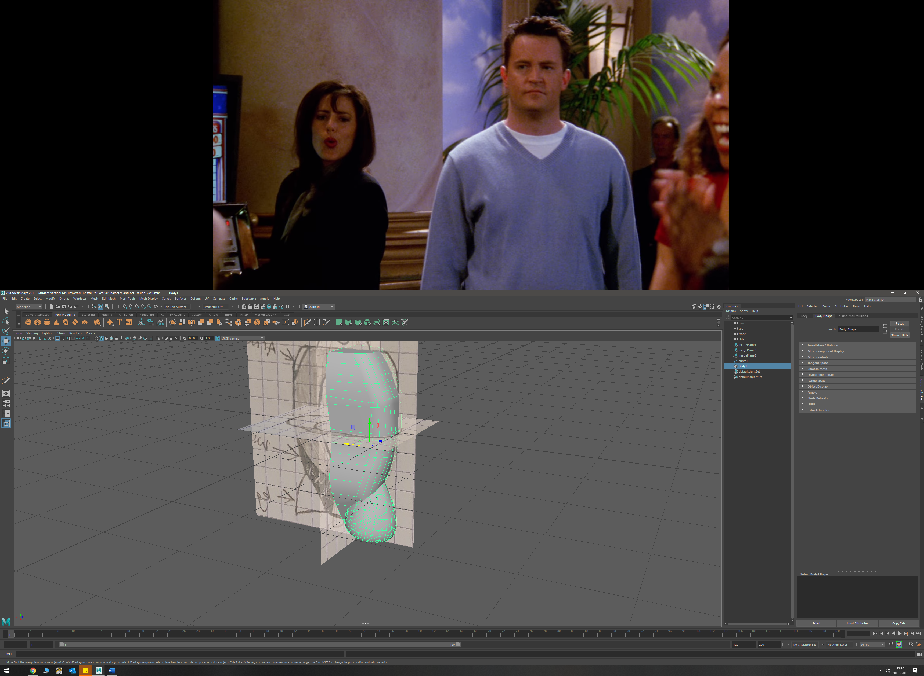

* To make shoulder plates, extruded faces, then merged edges using target weld tool to create smooth transition

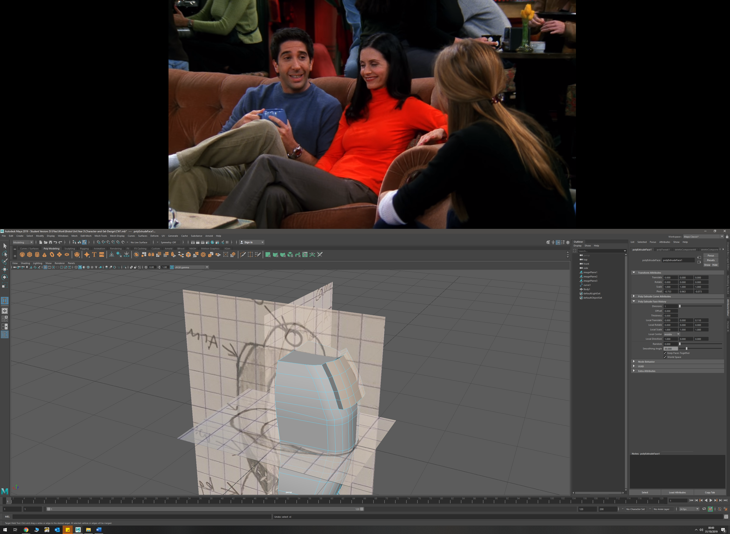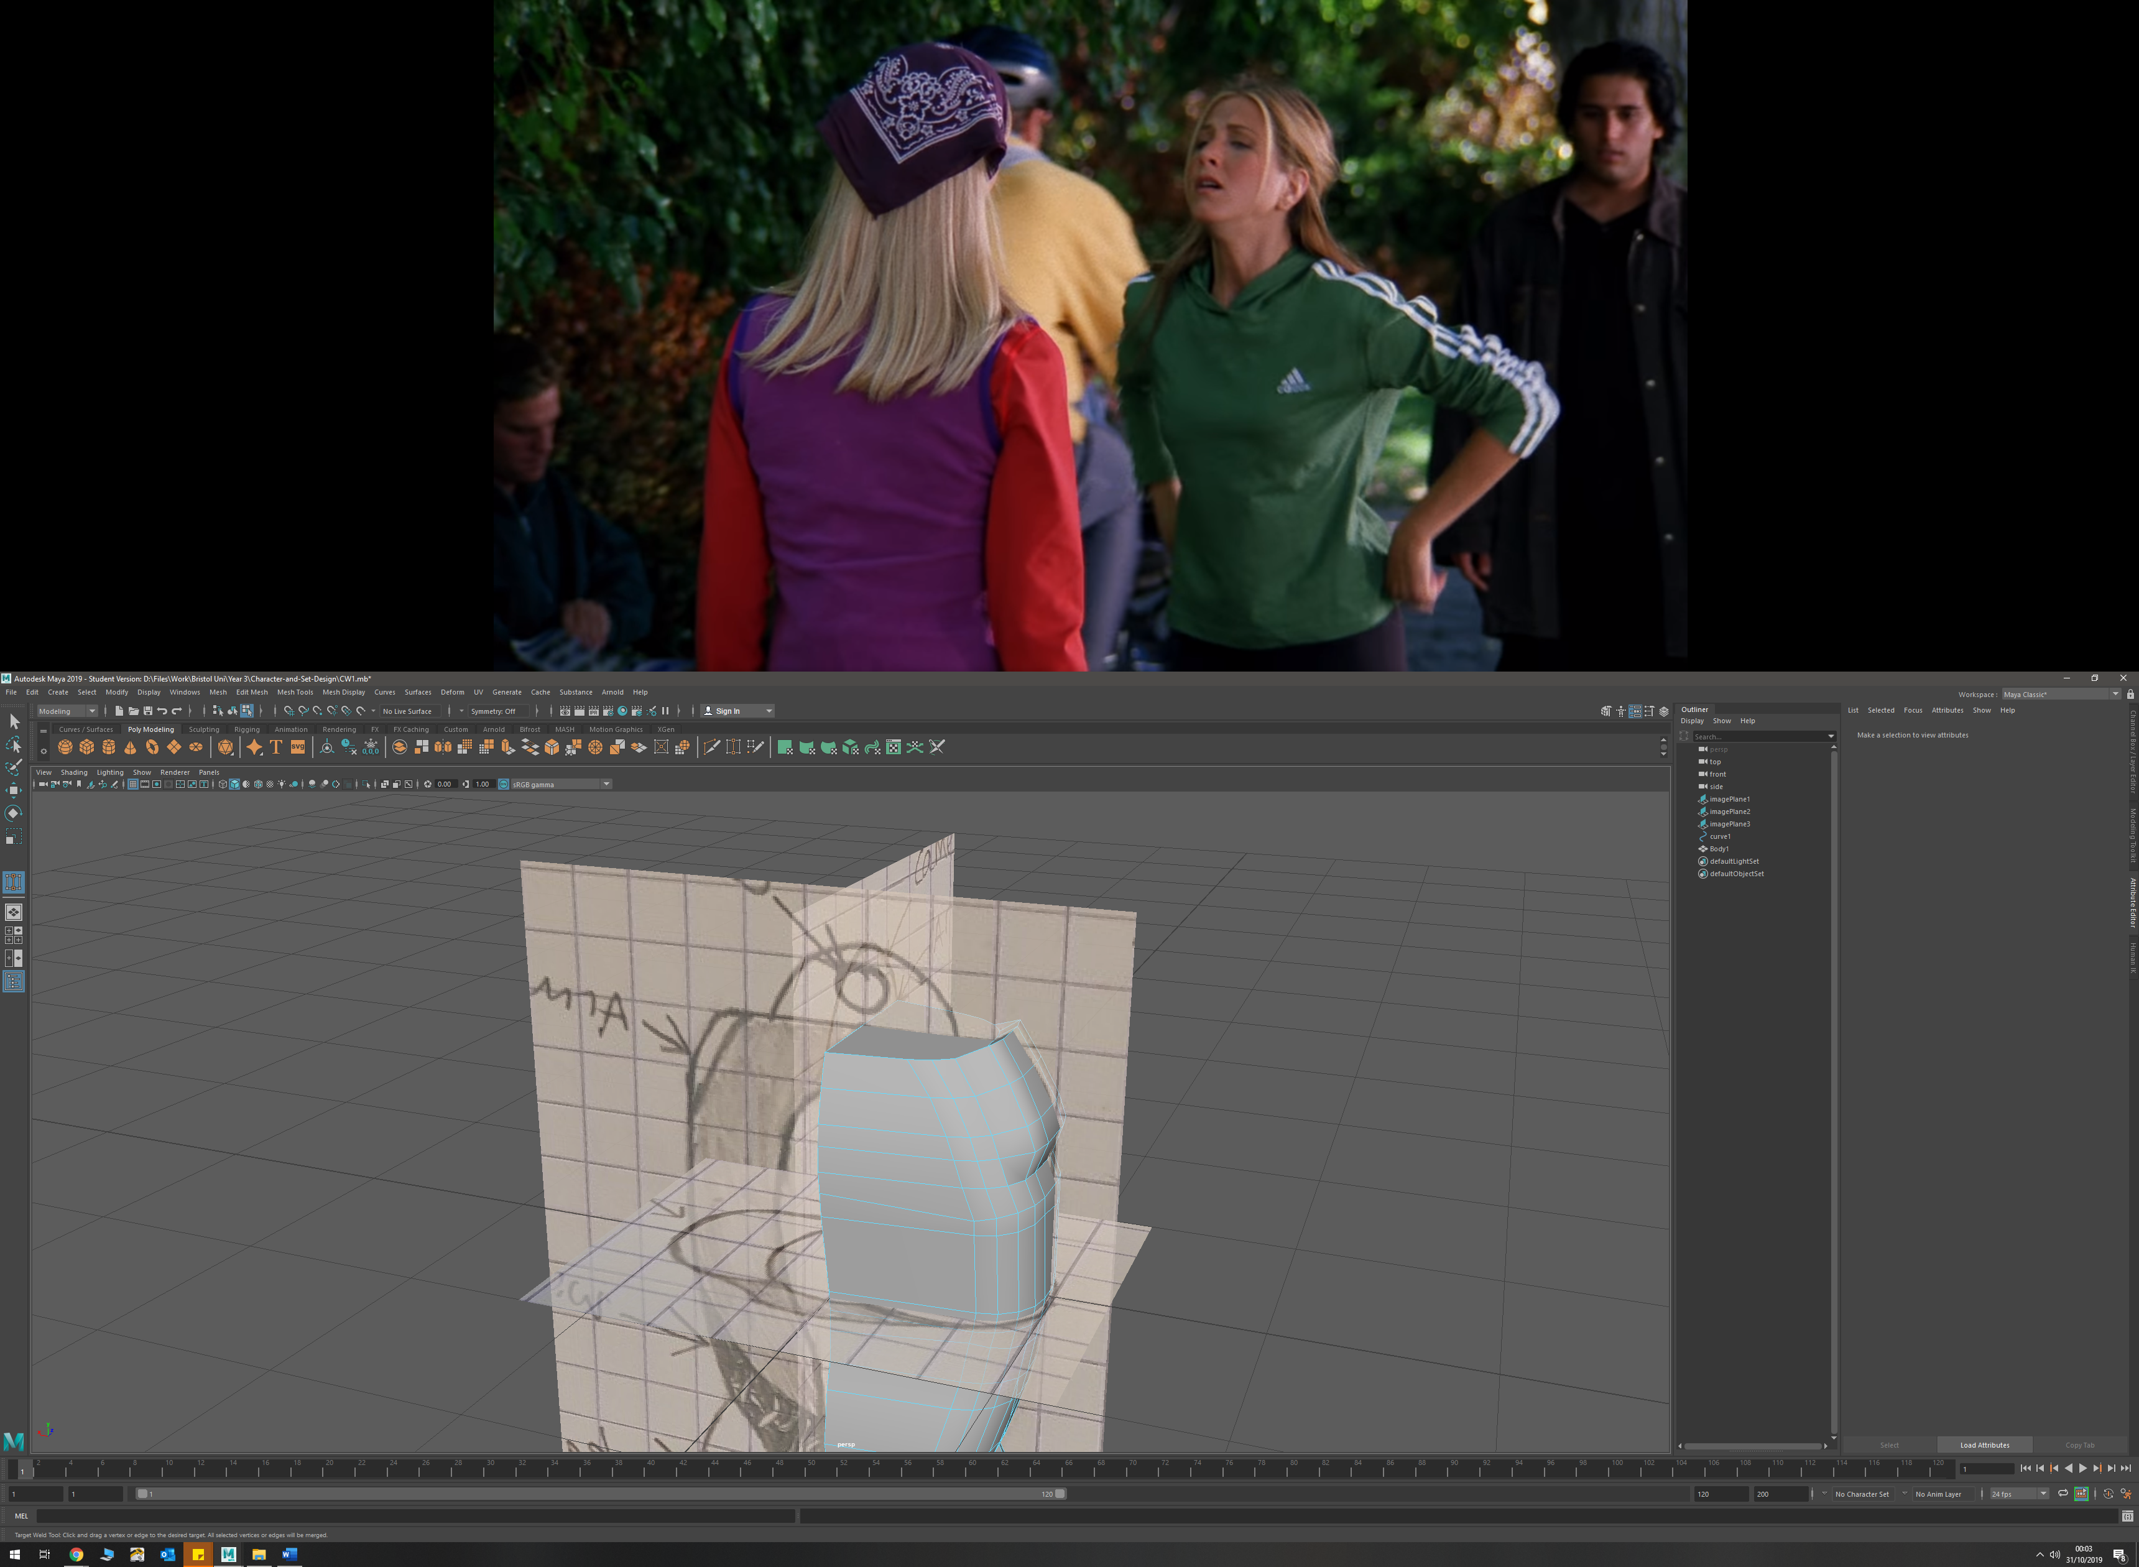

* To create the full body, I used the mirror tool and rotated until as full mesh was created

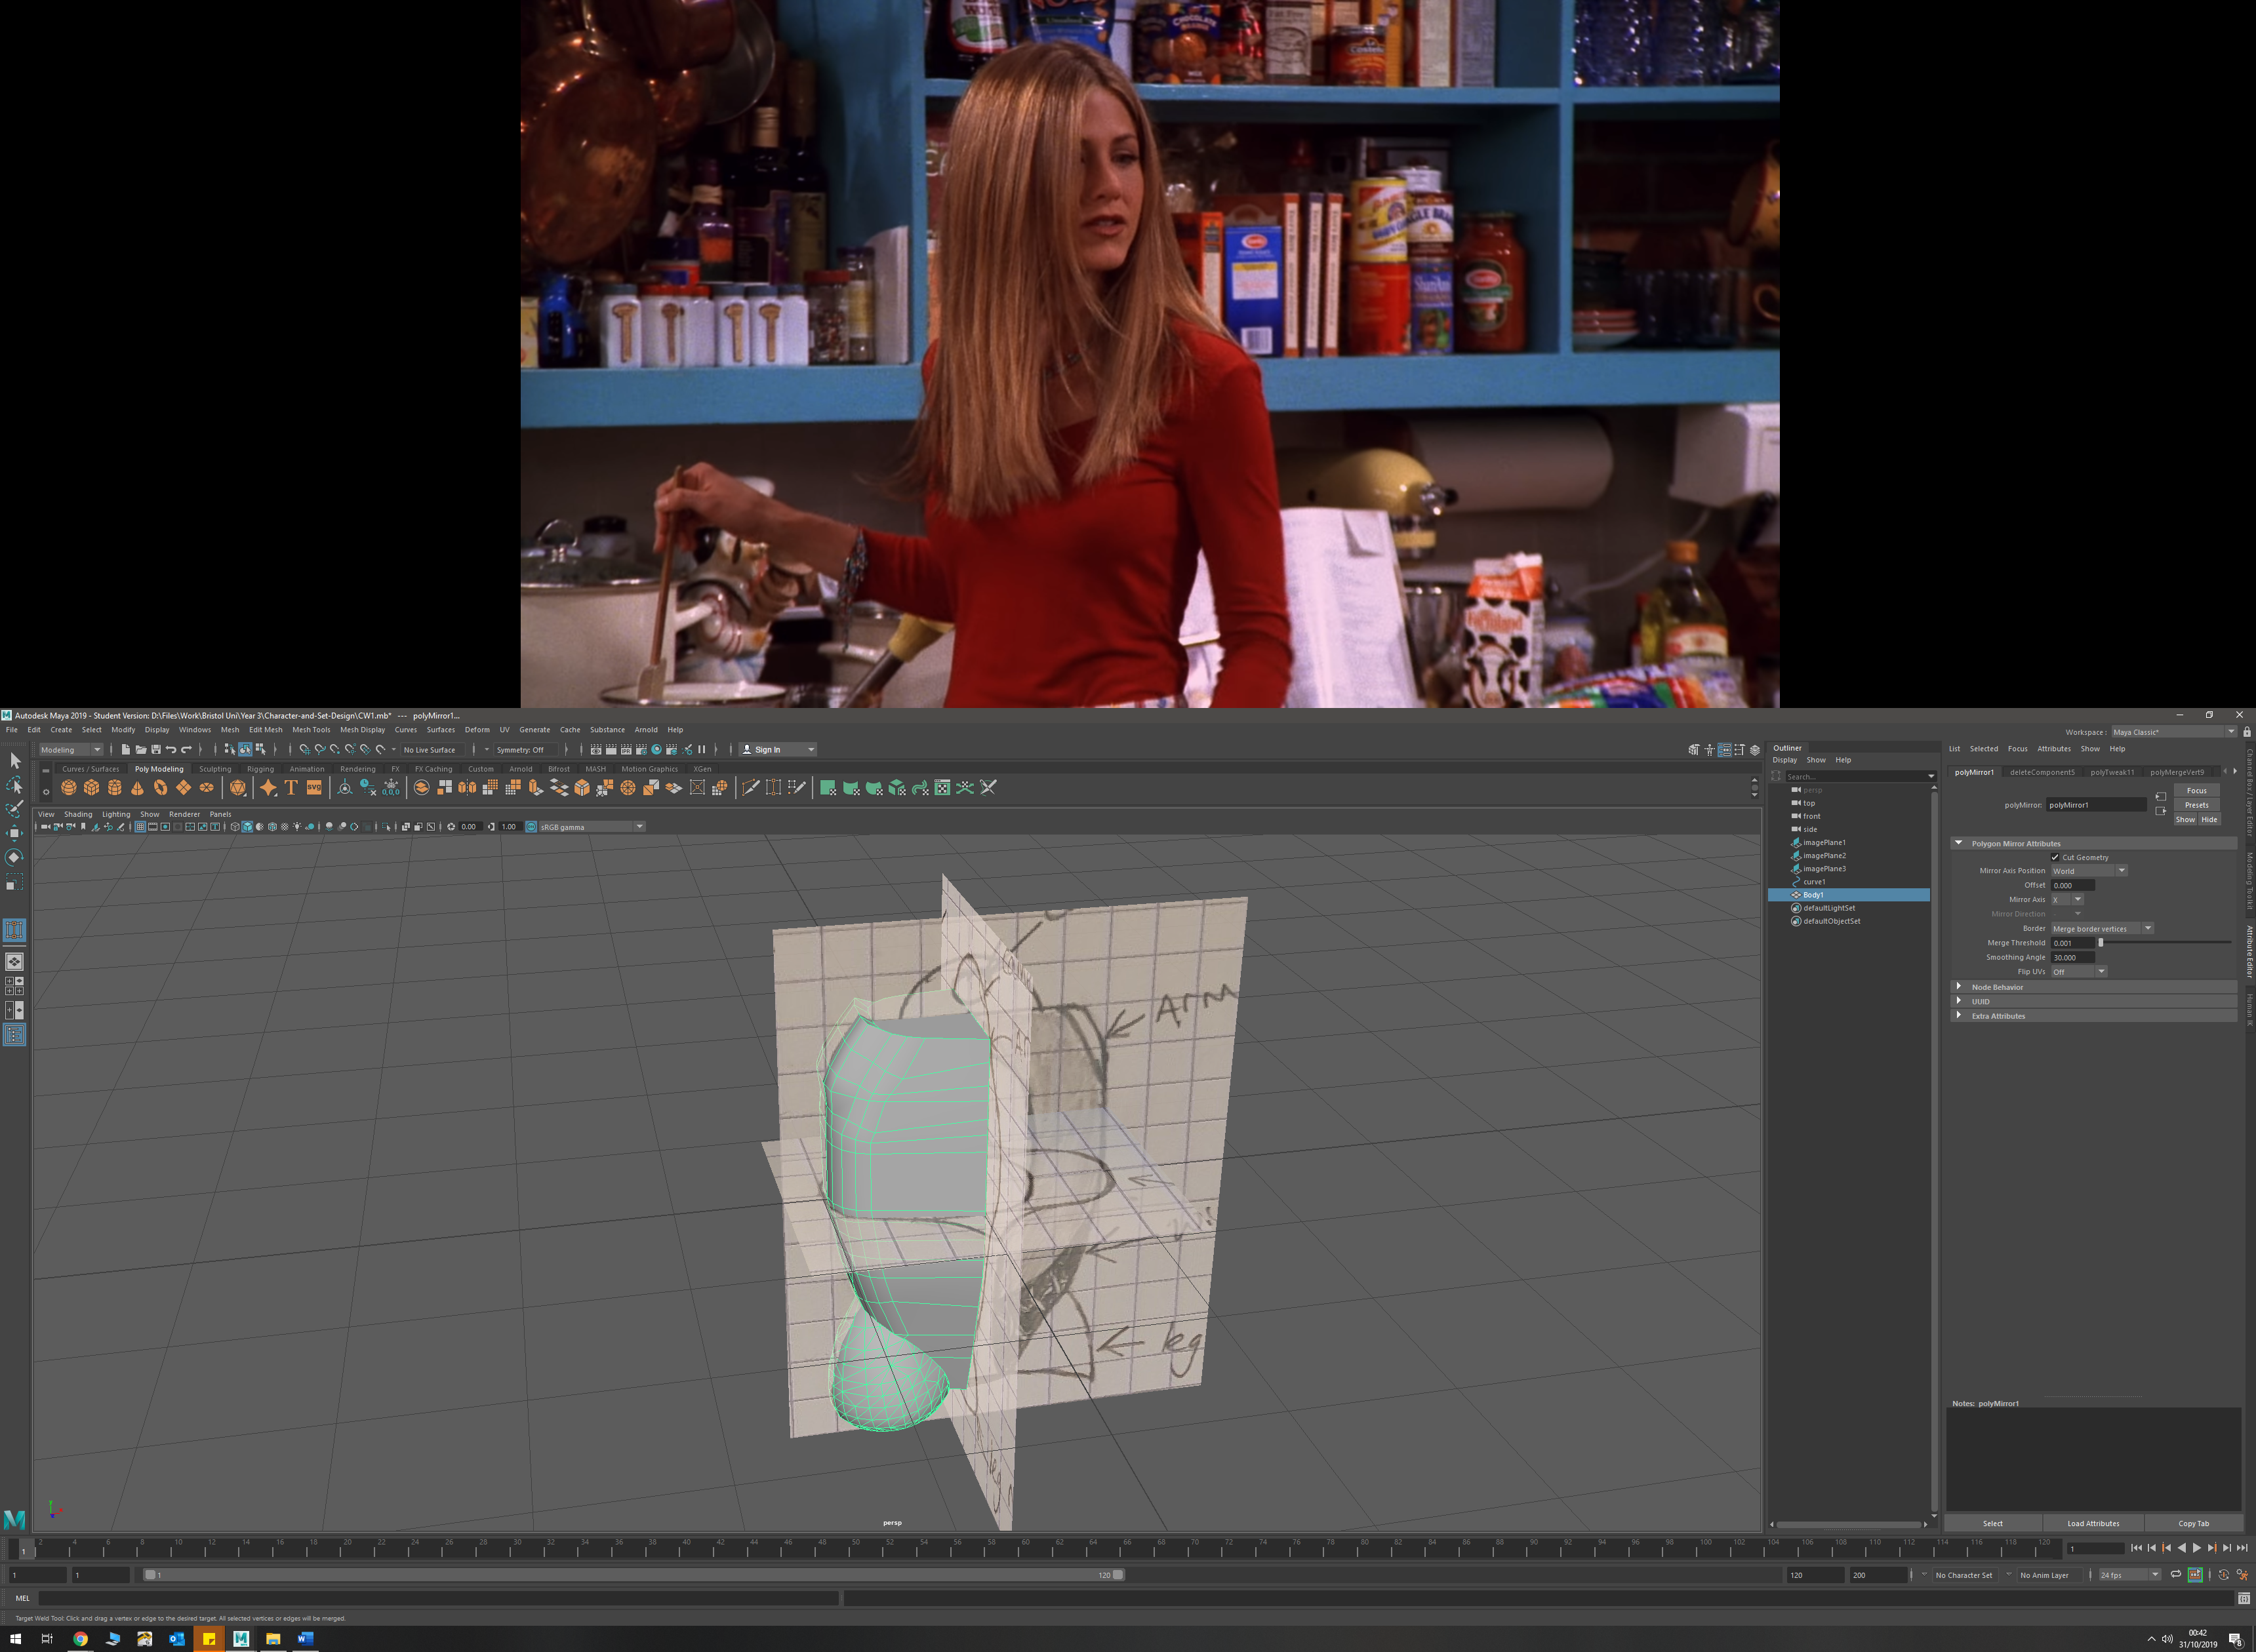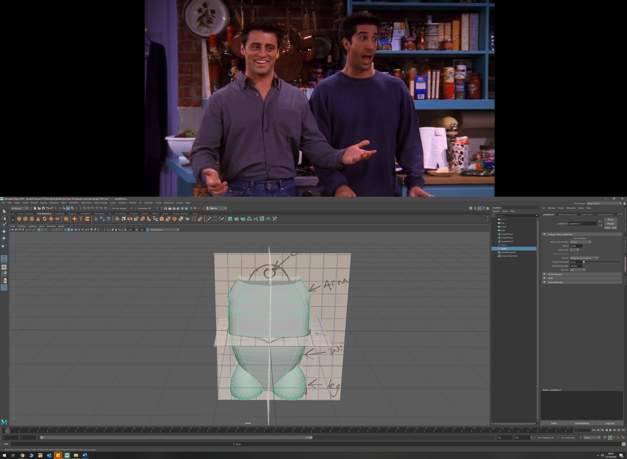

* Body detail was added by selecting faces and extruding them inwards. This will allow me to add inner wiring and cooling vent details once rendered.

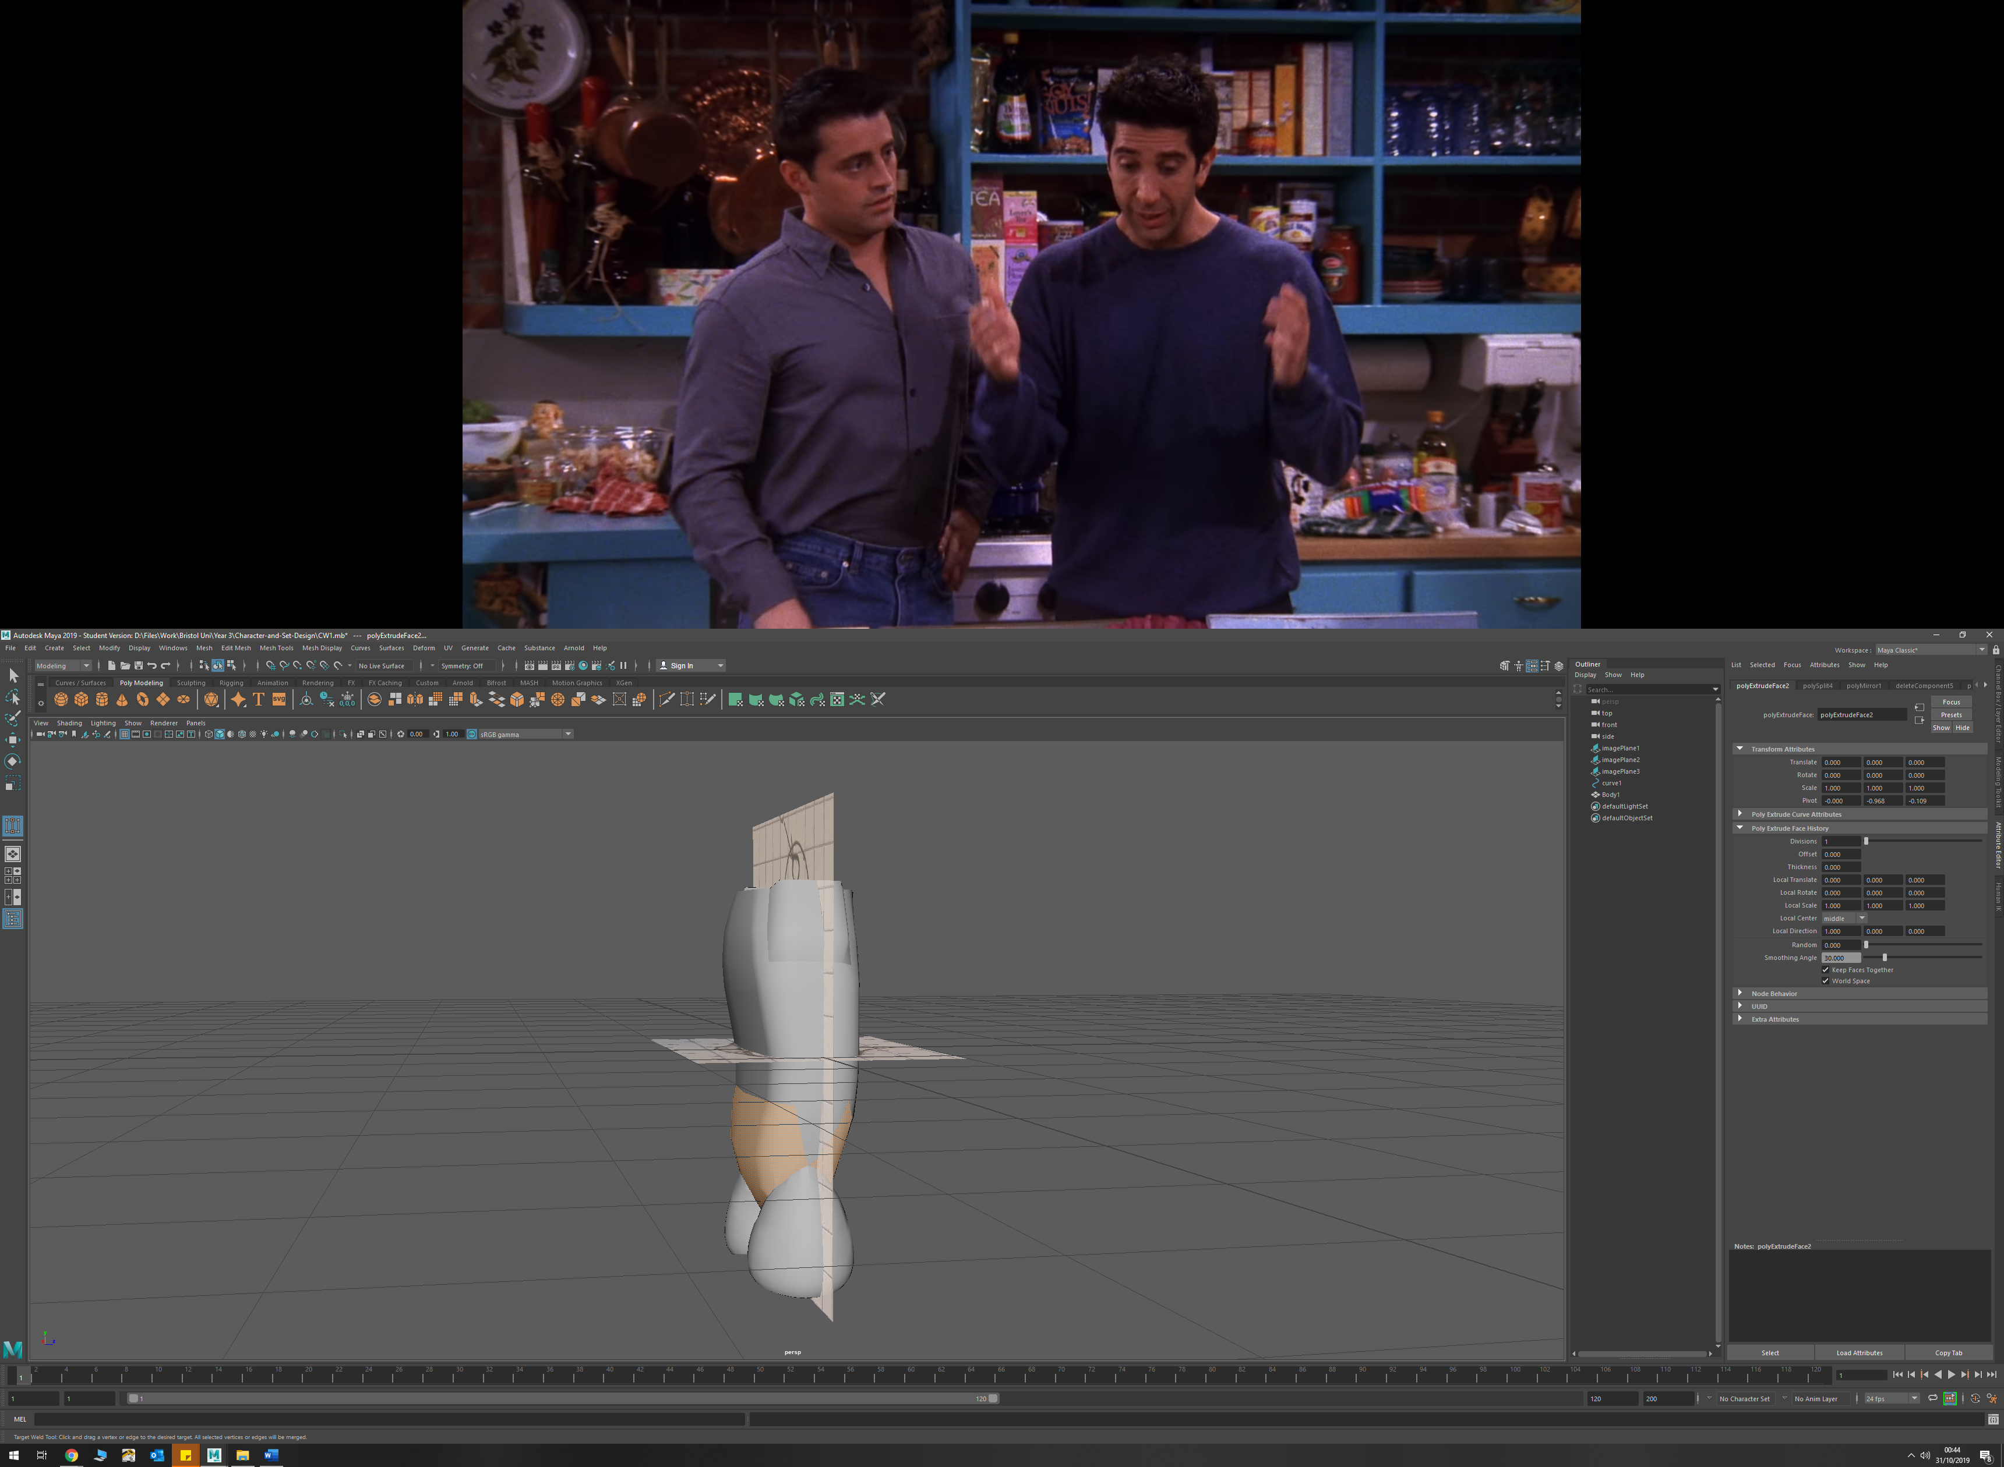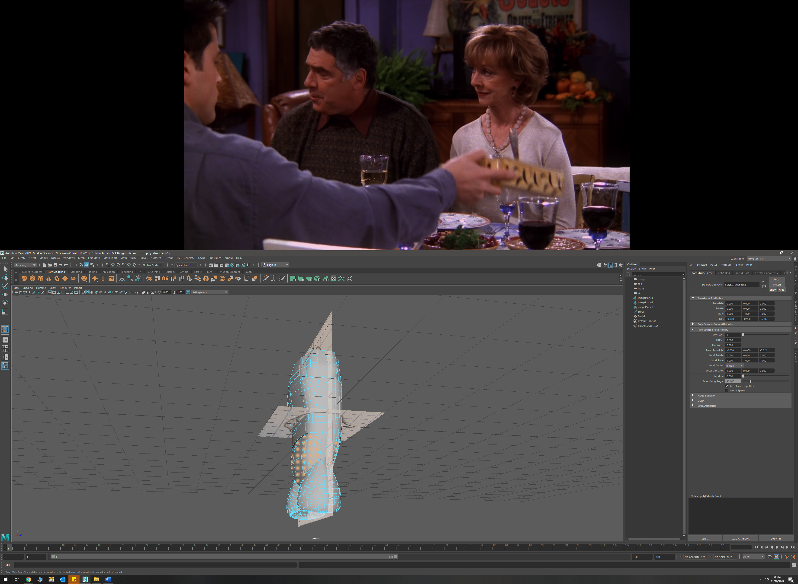

* Created the aerodynamic fin by adding edges to the front of the torso, then selecting faces and extruding them. I then drew a curve to match my sketches of how I wanted the fin to look like from the front, and the side. I then moved vertices to match these curve shapes and create the fin. I also used the target weld tool in order to create the angles I wanted in different sections.

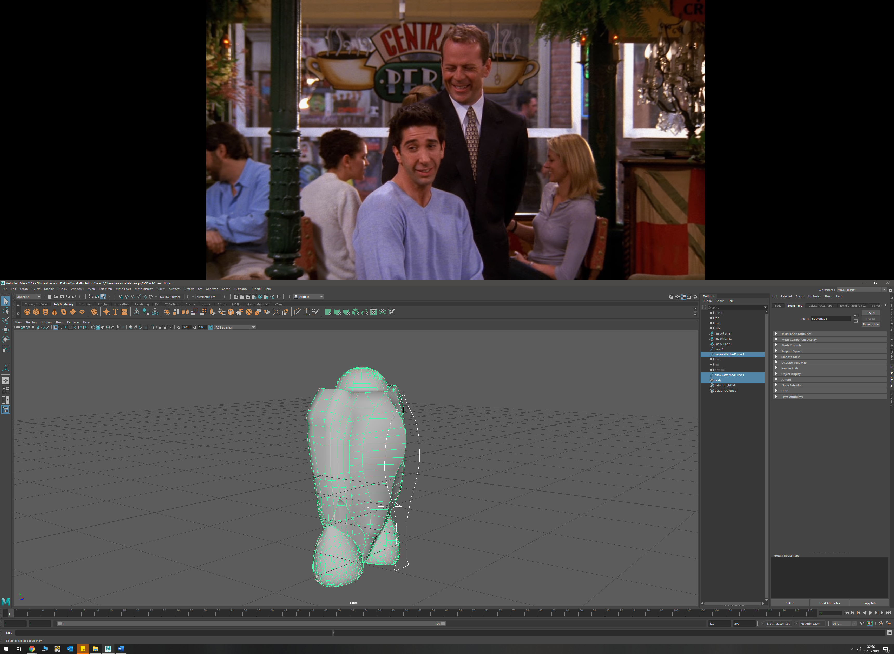

* Used the circularise tool twice, with increased divisions in order to create the camera on the head/dome. I then extruded the outer loop outwards, and the inner circle inwards to create the depth I required

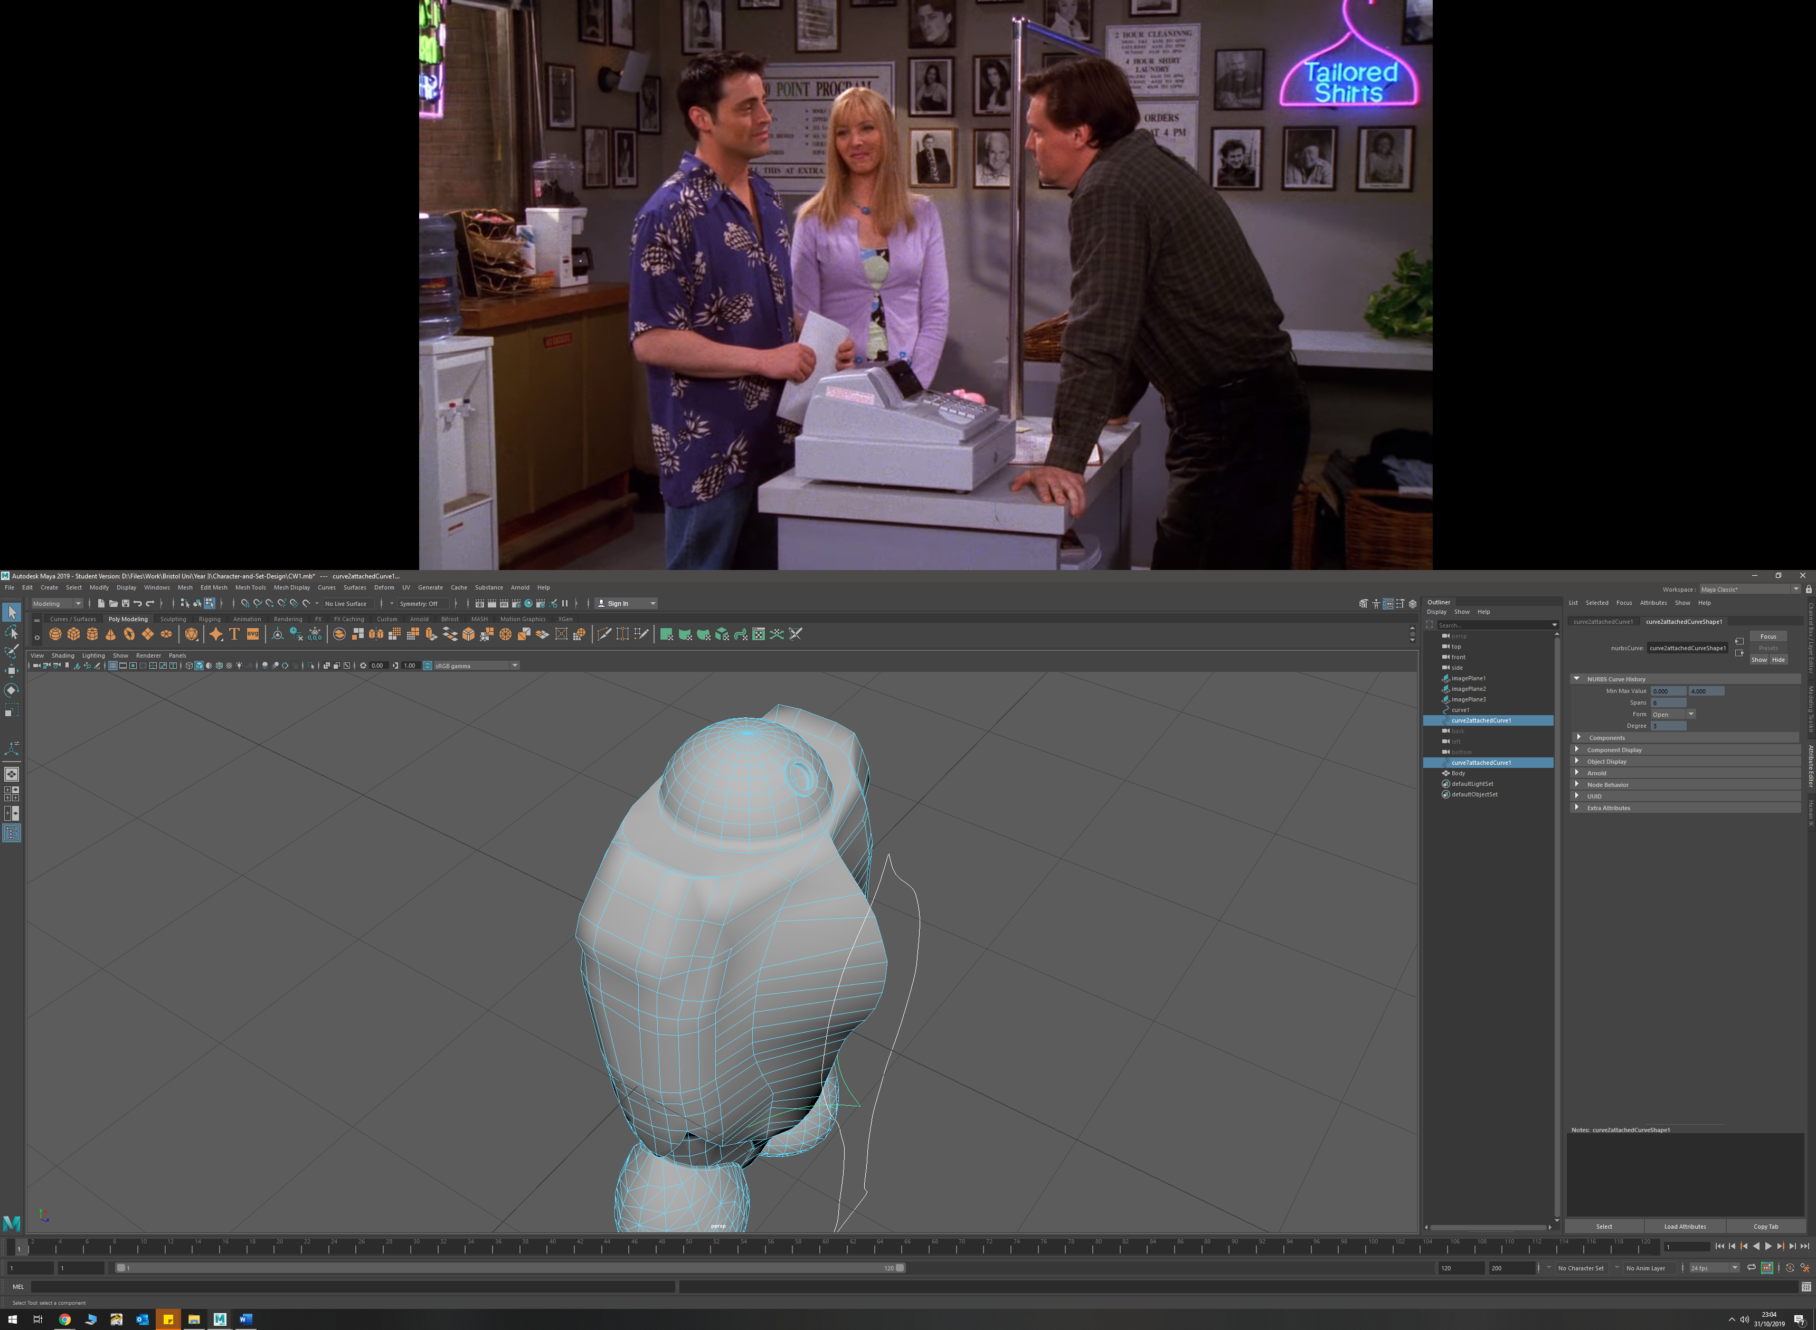

* To create pipe detains on torso, I used a NURBS prefab circle, and drew a EP curve, then extruded a tube by selecting the two. I changed the extrude settings in order to get a rotation in the tube.

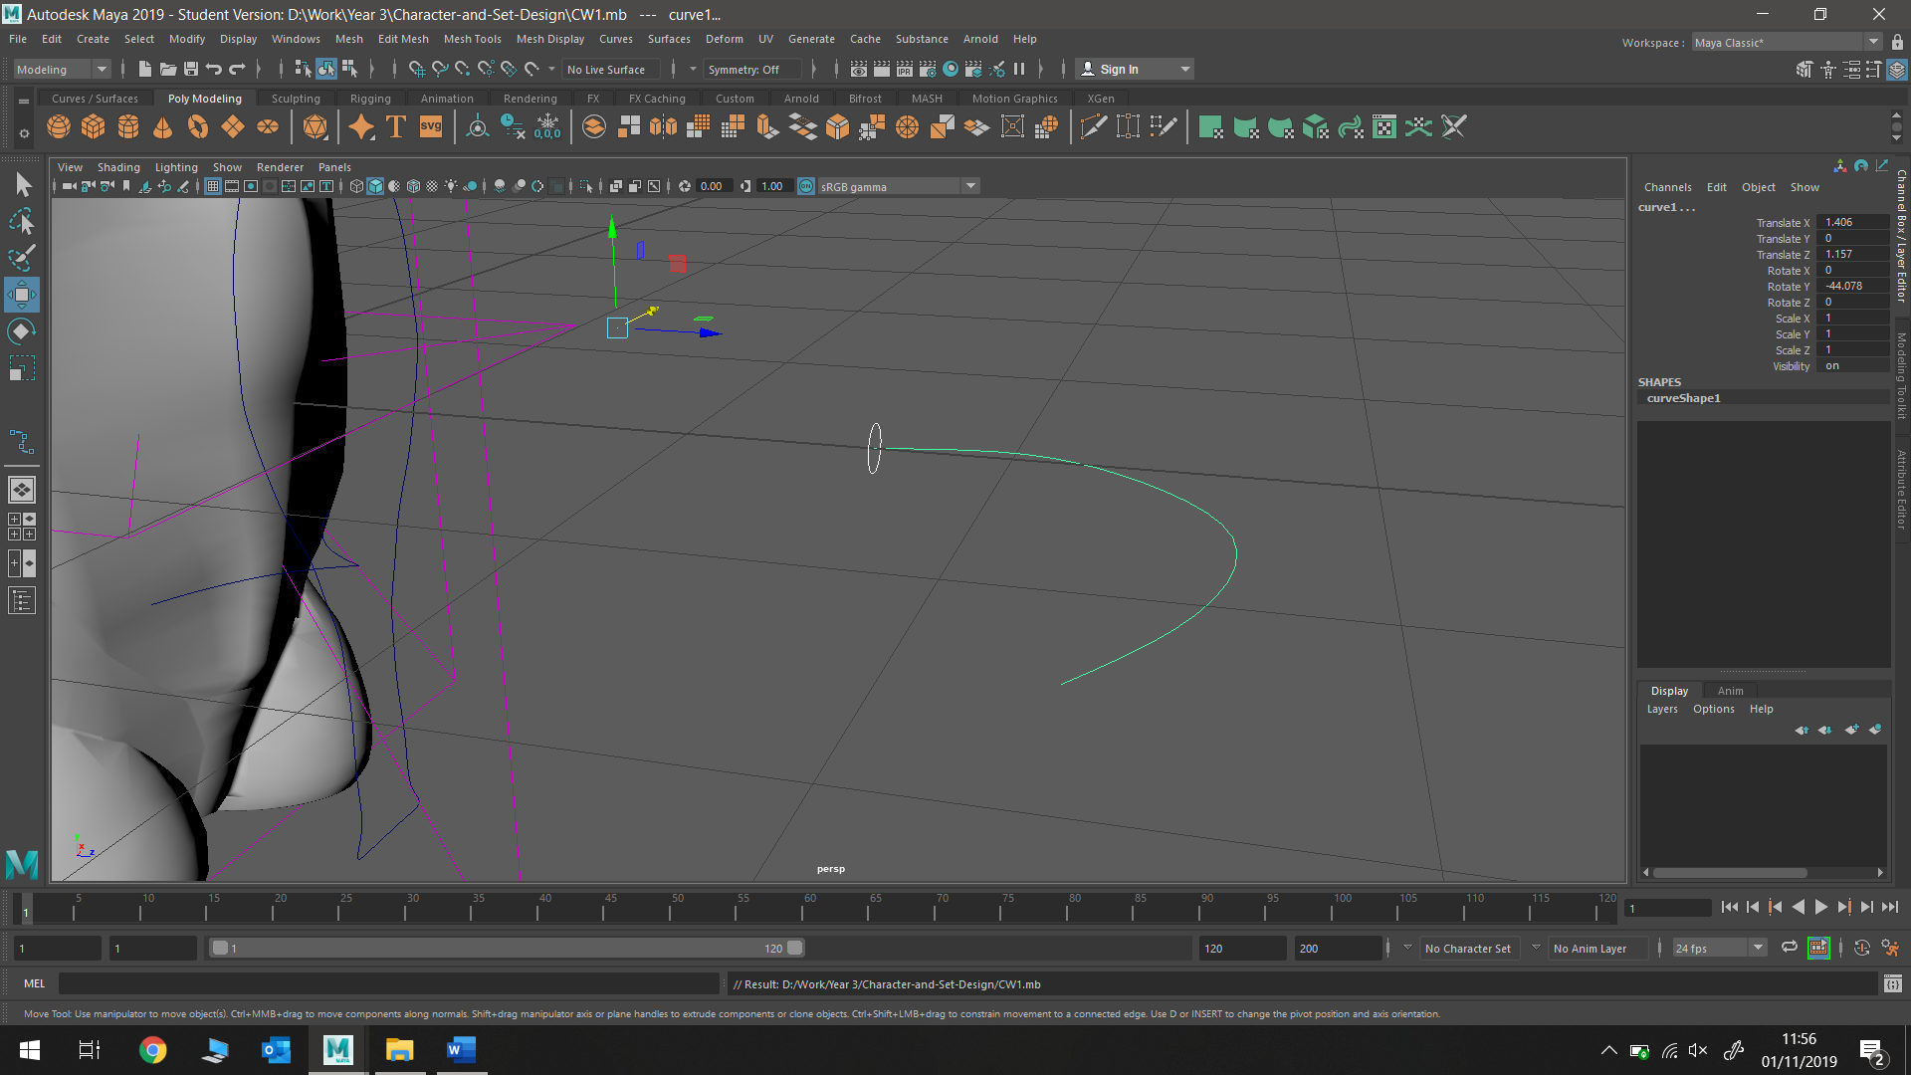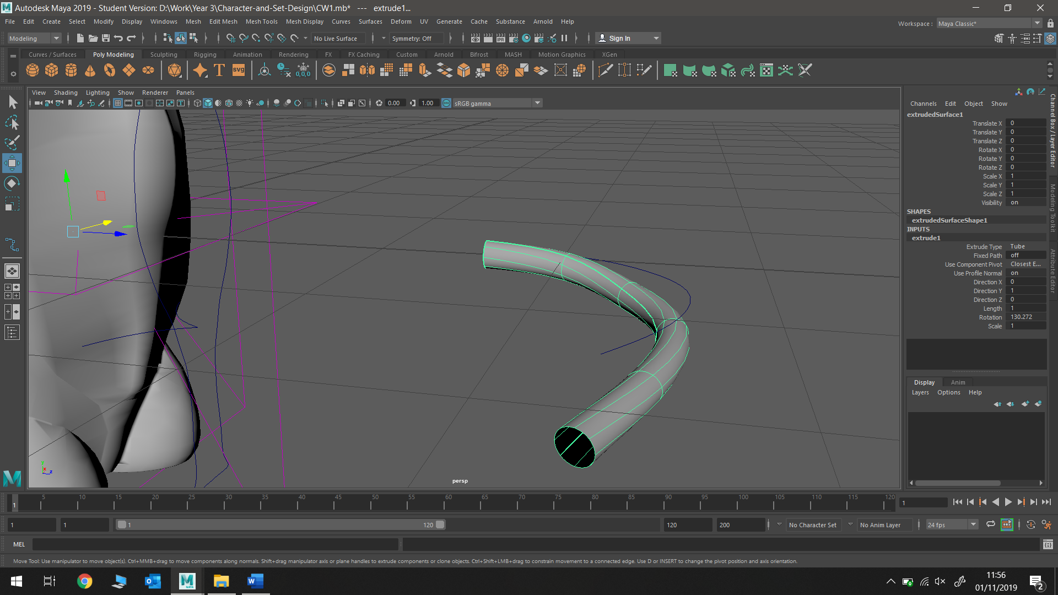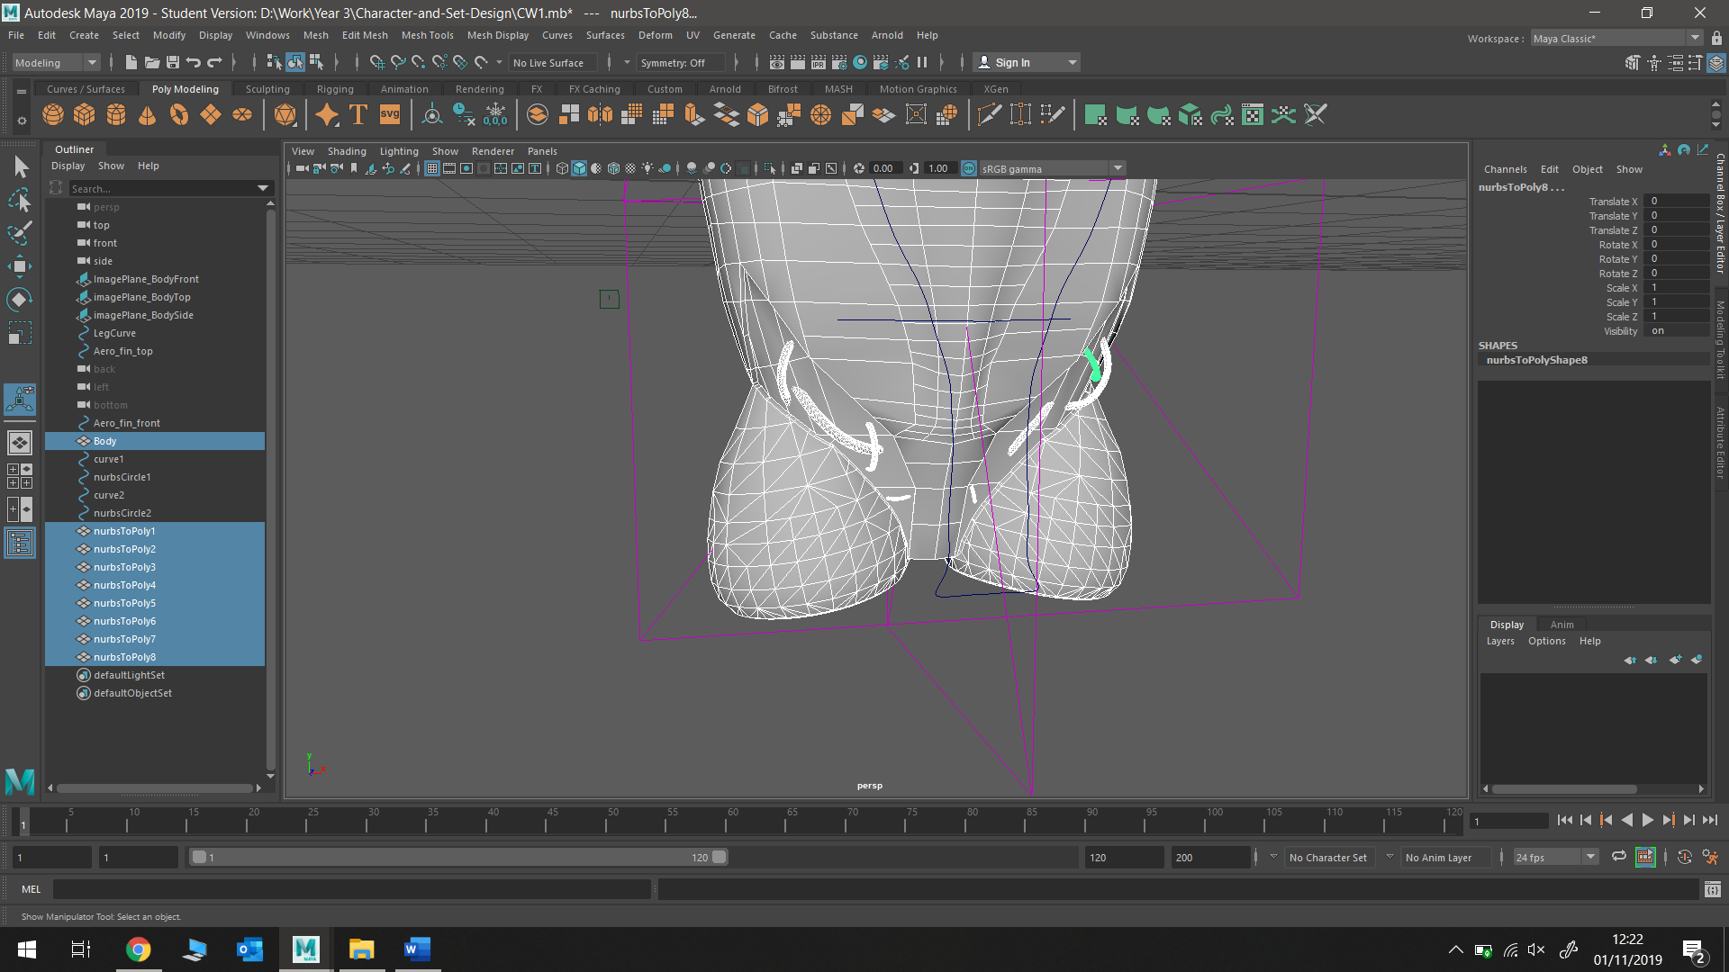

This process was repeated several times to get different tube shapes, thicknesses and paths

**Badminton Racket**

* Badminton racket head was made by tracing round an image of the racket with an EP curve, then extruding a NURBS circle along this path. The polygon was then duplicated, and a Boolean was used to join the two halves together.

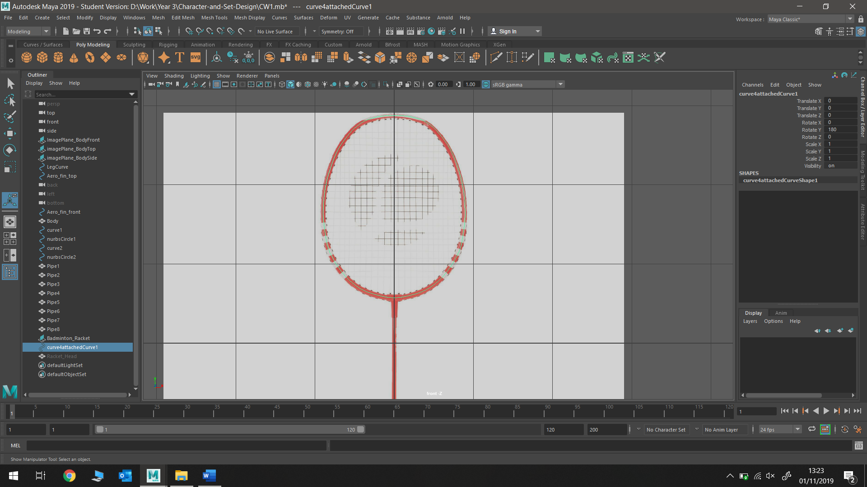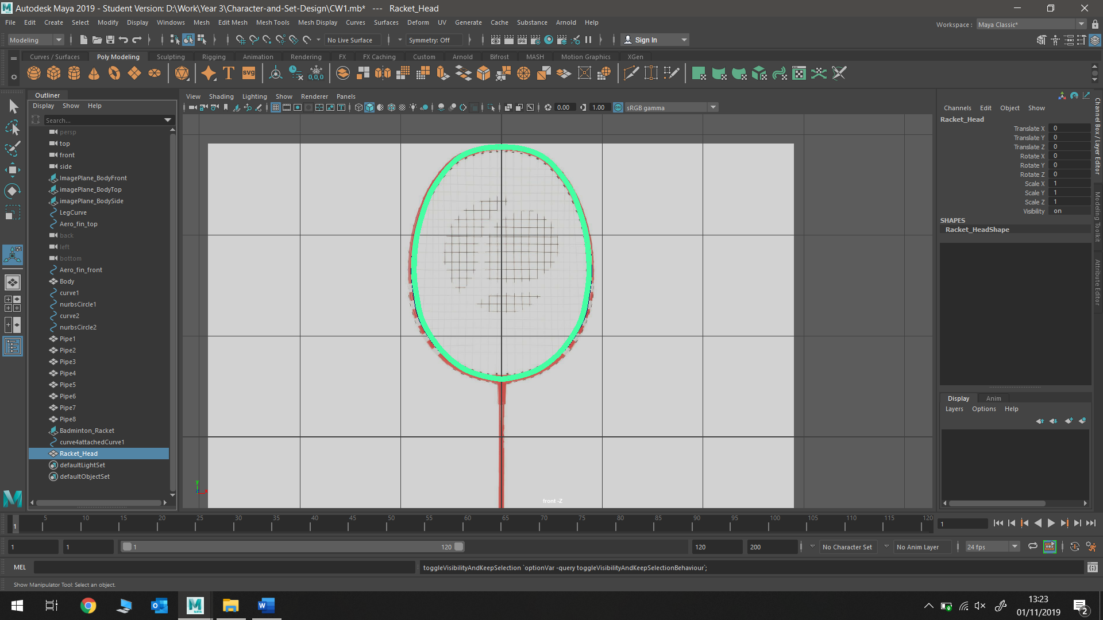

* The rest of the racket was constructed using polygon cylinders that I manipulated to fit the correct shaped of the racket handle; extruding faces and altering face size

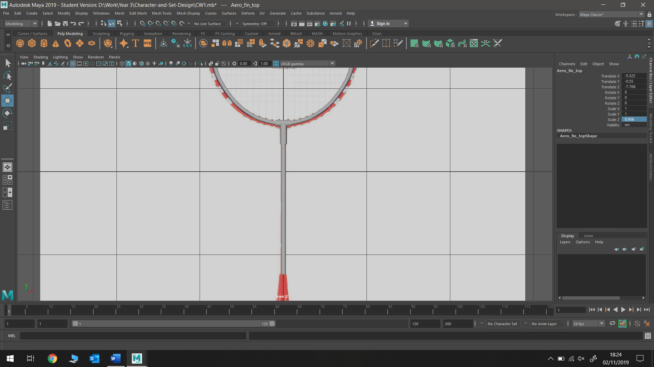 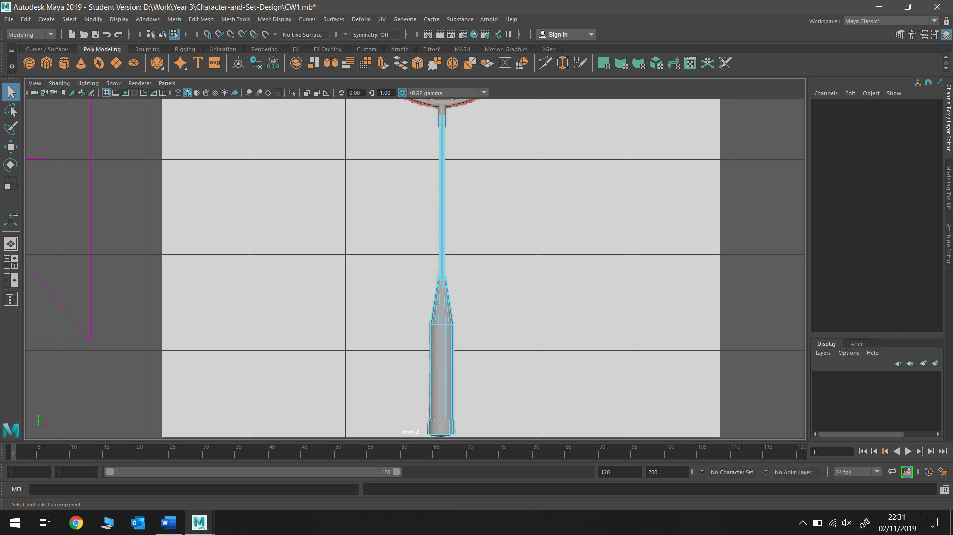

* Badminton racket mesh was created by duplicating a polygon cylinder multiple times to fit frame

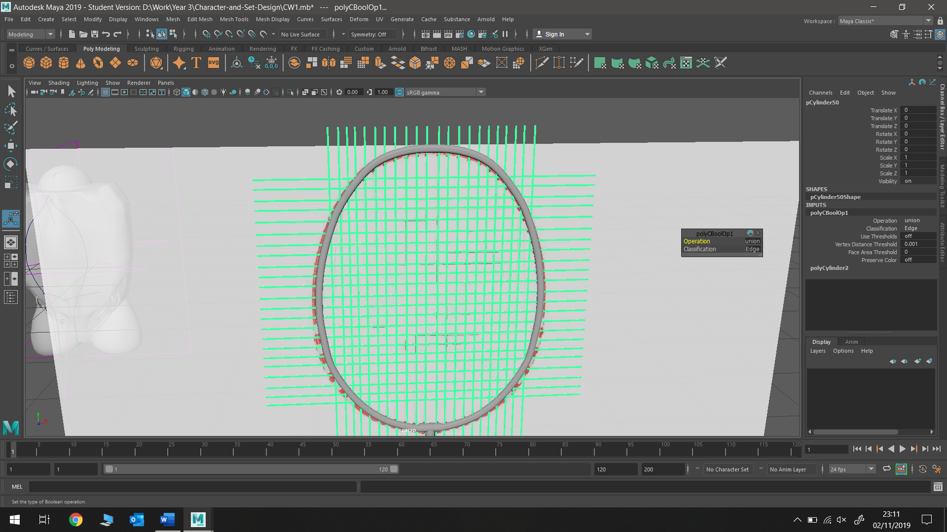

Used a duplicated racket hoop (made larger) to apply Boolean to mesh in order to cut off points of mesh not inside hoop

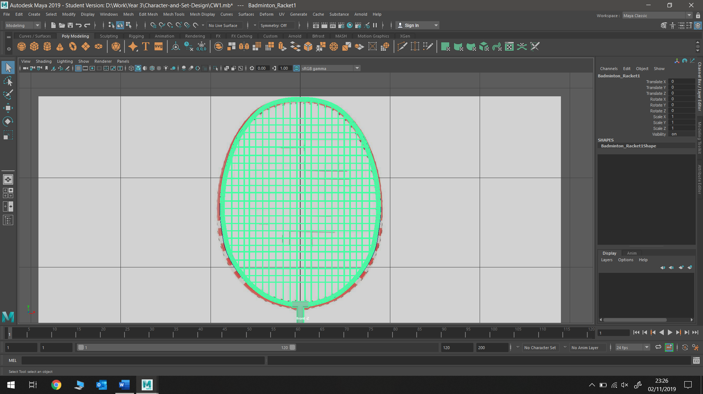

Used separate in order to separate the wanted and unwanted sections of the mesh, and then simply deleted the unwanted (outside the hoop) part of the mesh

**Arm**

* To make shoulder plate, I drew around half my sketch, and duplicate this to get a perfectly symmetrical curve

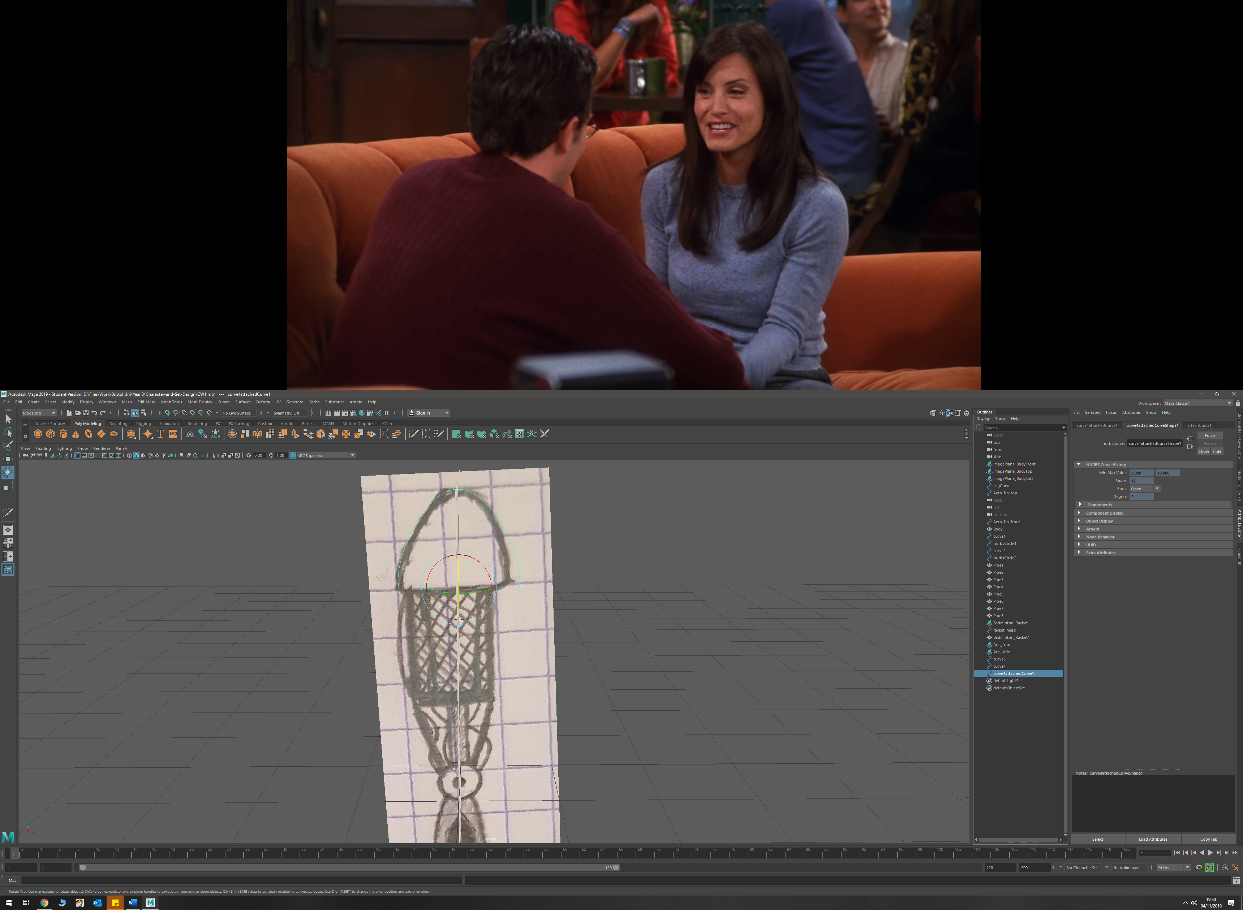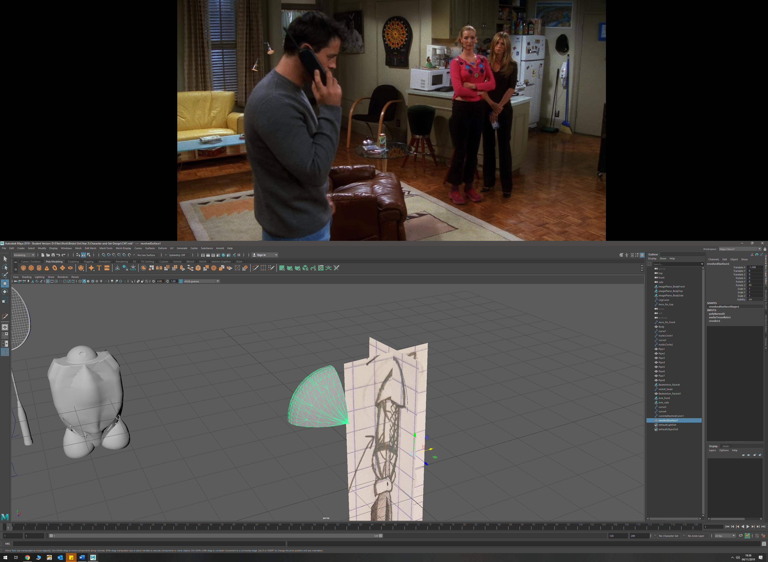

I then did a 90 degree revolve about z to get the correct shape

After this I tidied up the lower geometry by deleting faces

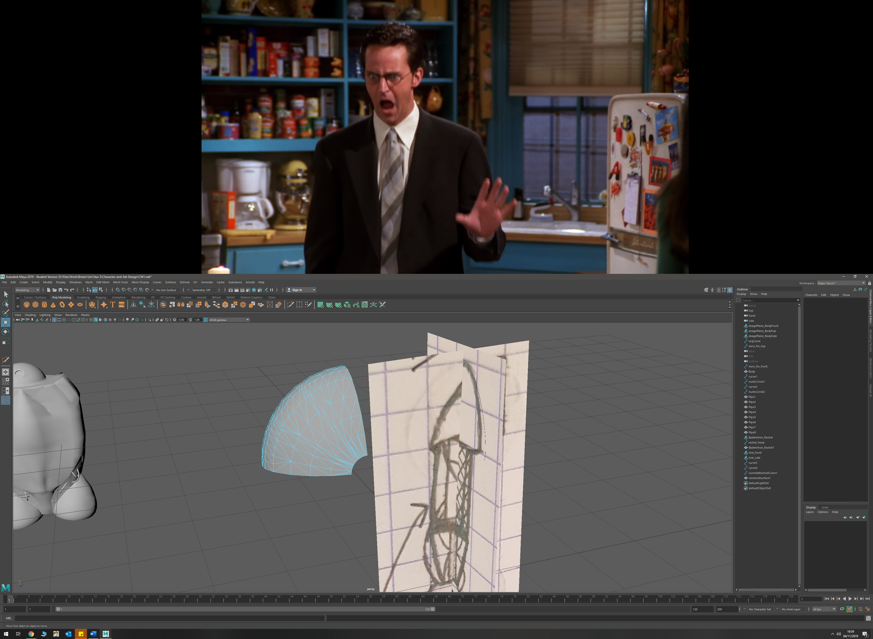

* Created connecting stems by using the circularising tool on 4 faces, then extruding these new circular faces outward

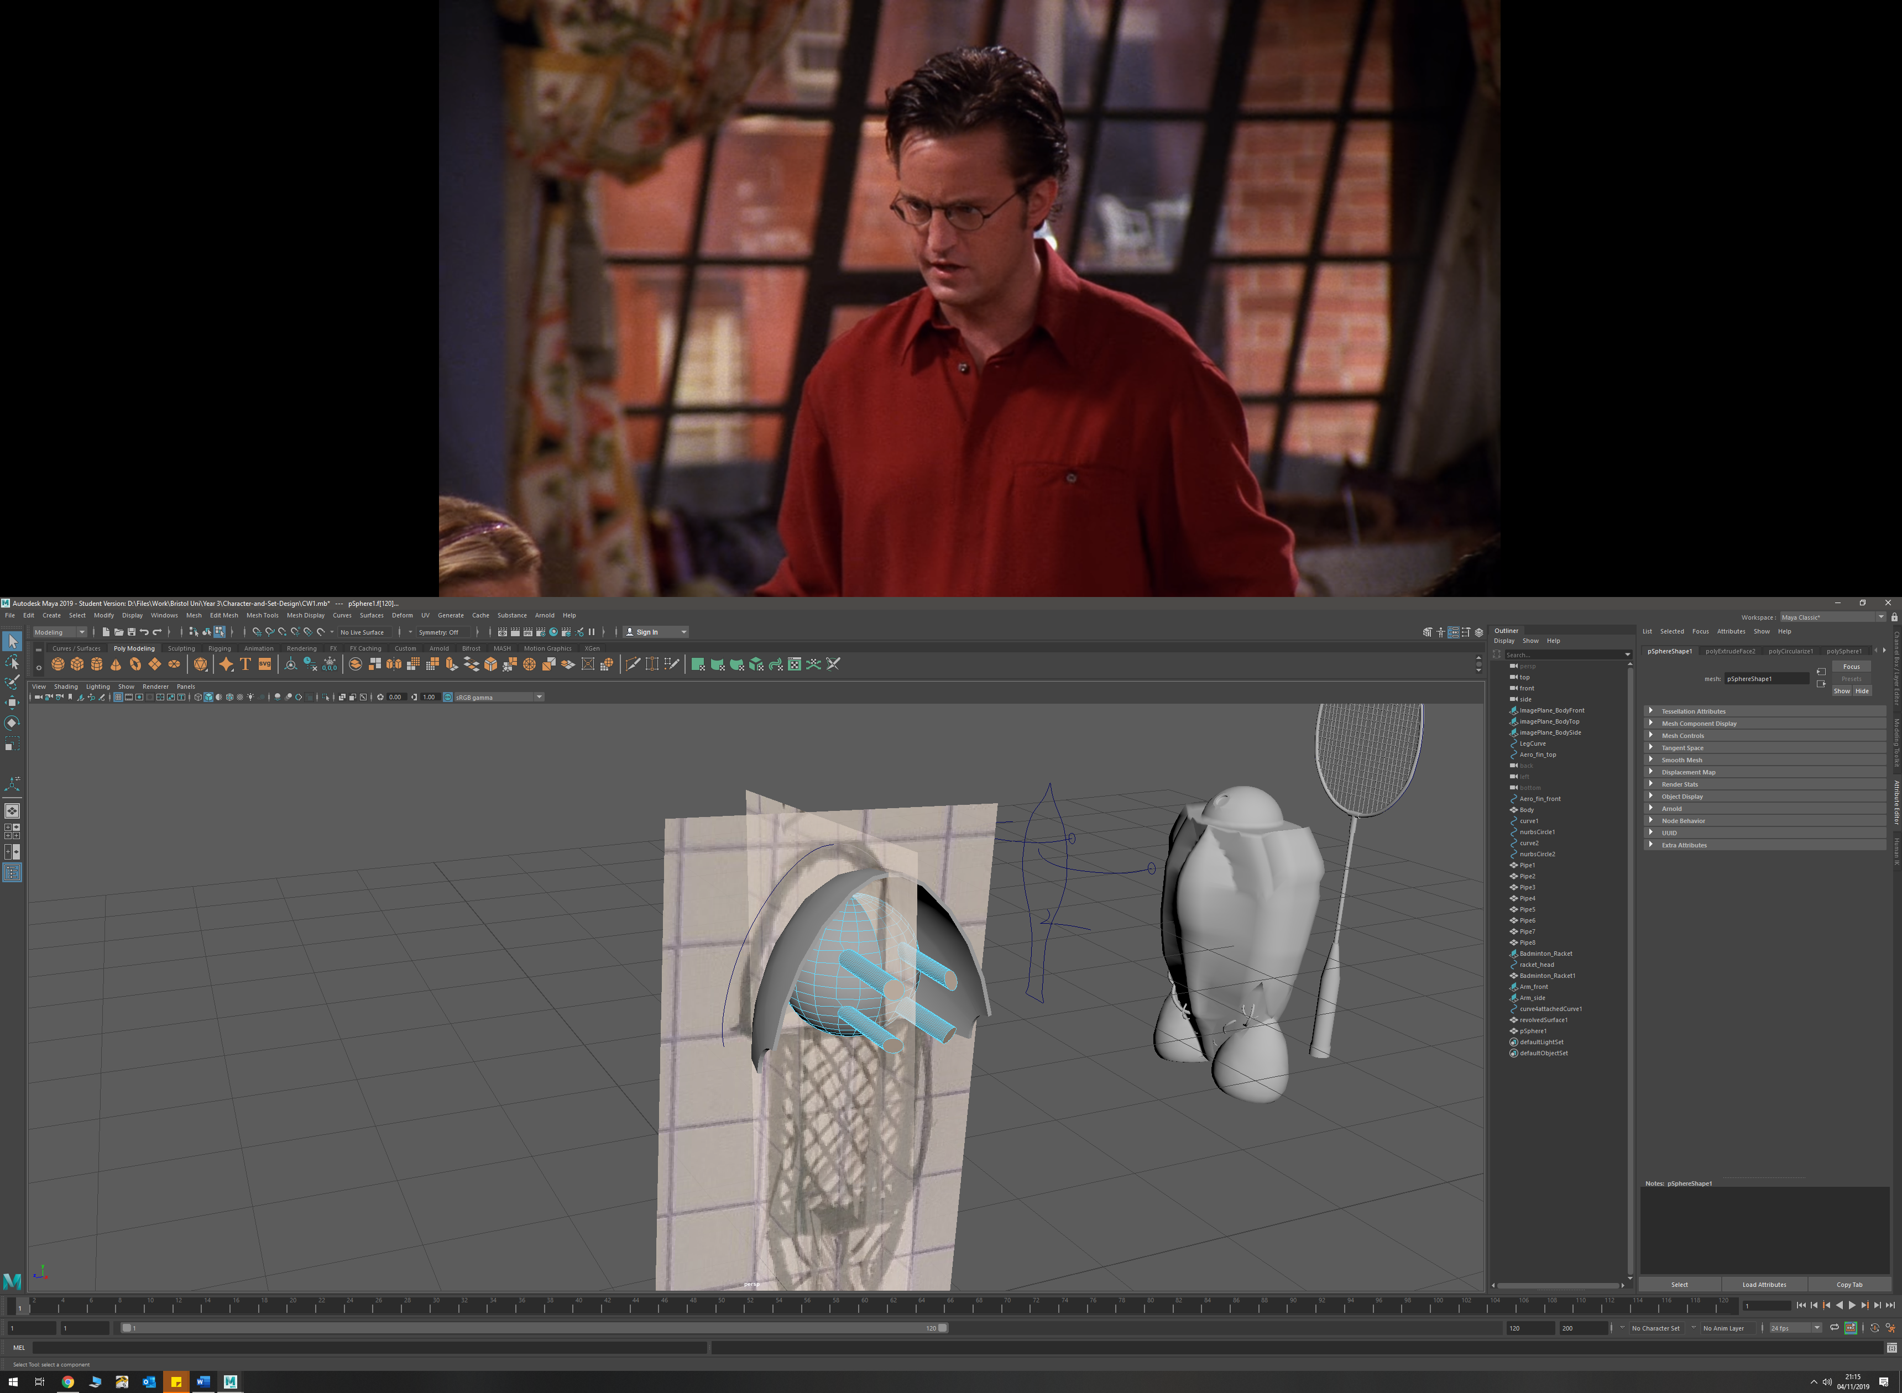

* Created upper arm using cylinders and then manipulated and extruded certain faces to get the desired shape

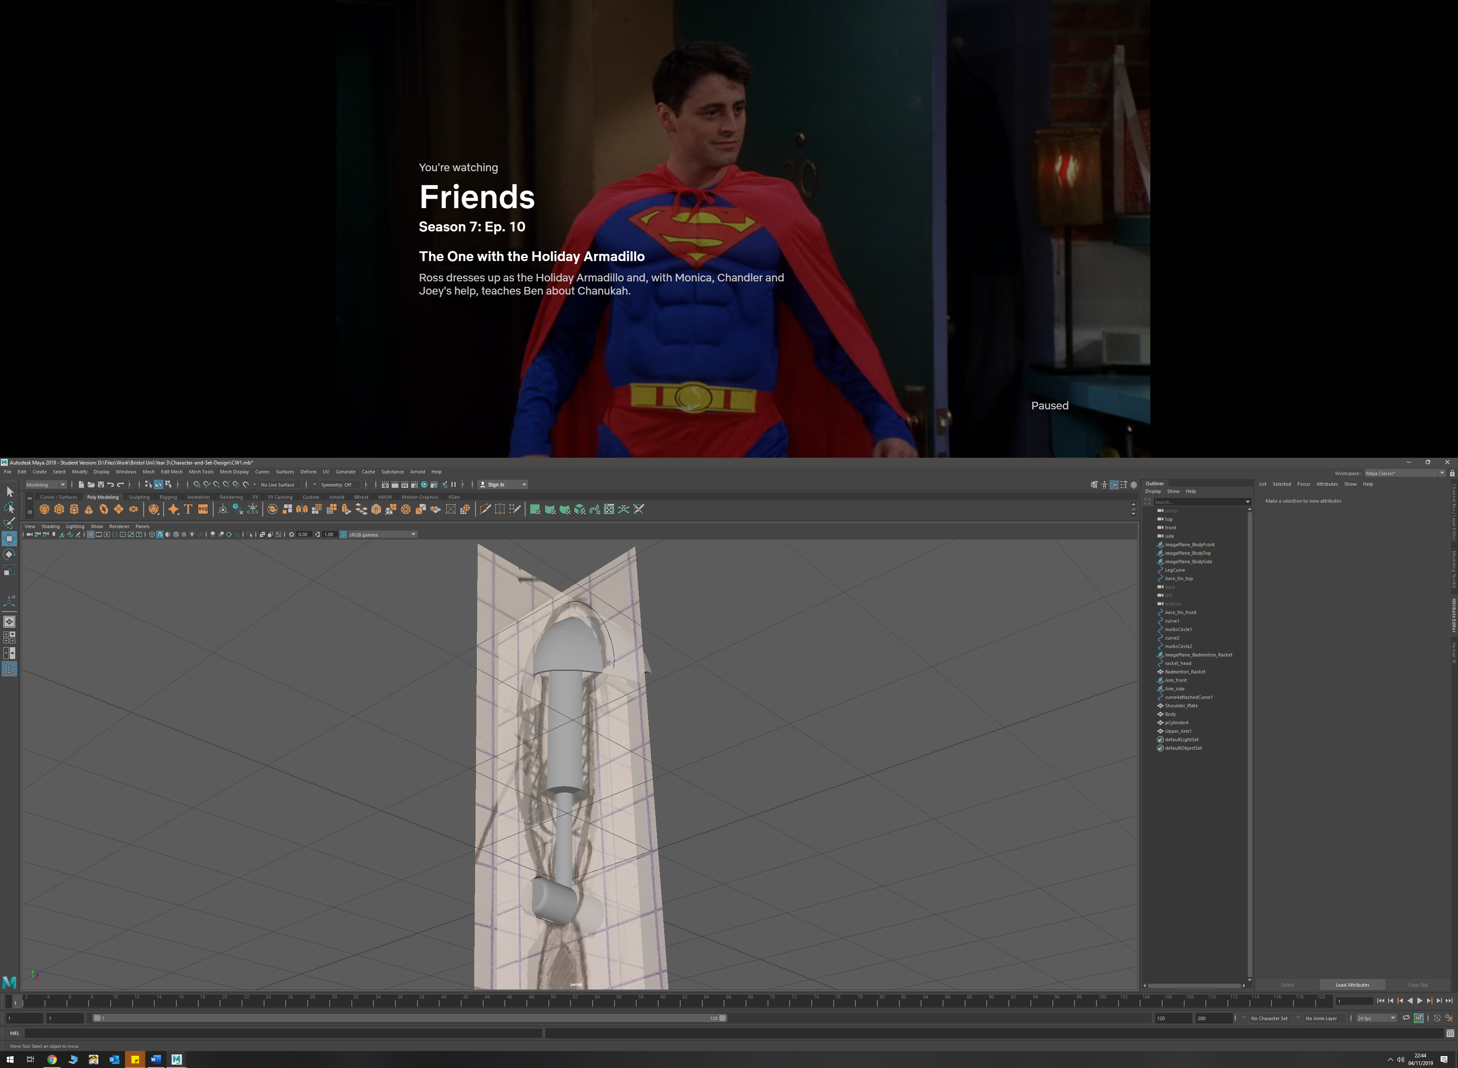

* Upper arm casing made by using 2 NURBS prefab circles with 8 linear sections in order to give it a octagonal style shape. Then duplicated this NURBS and used a loft between the two

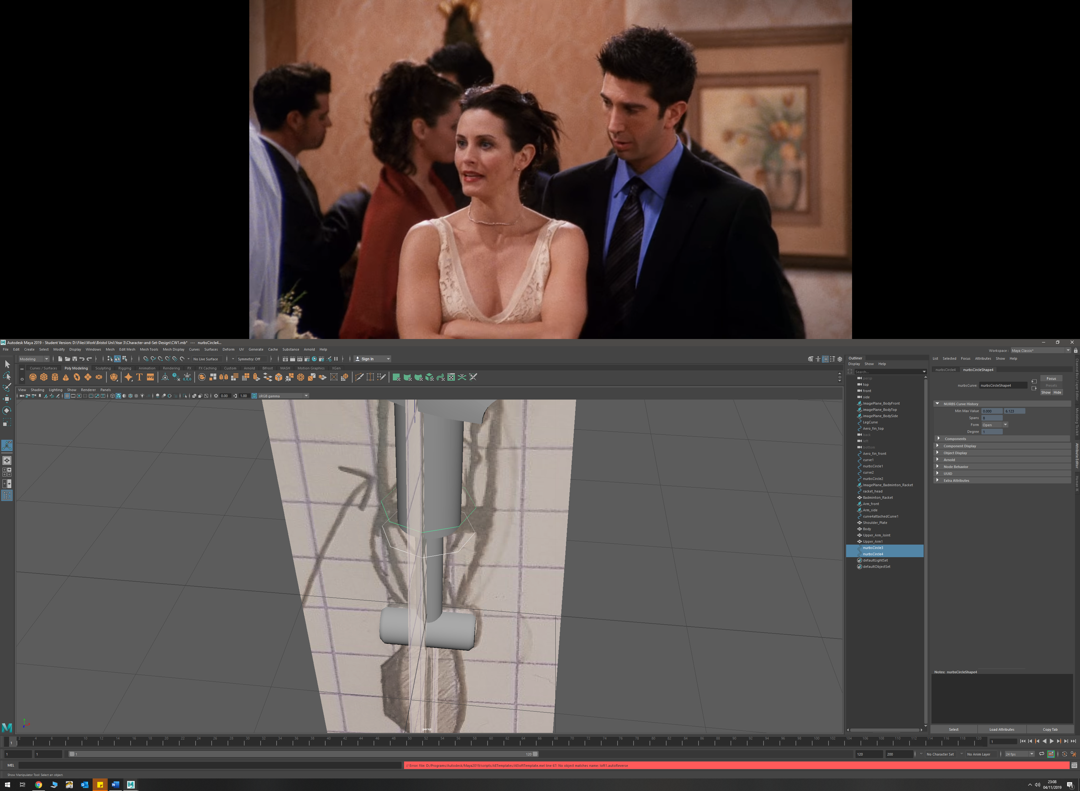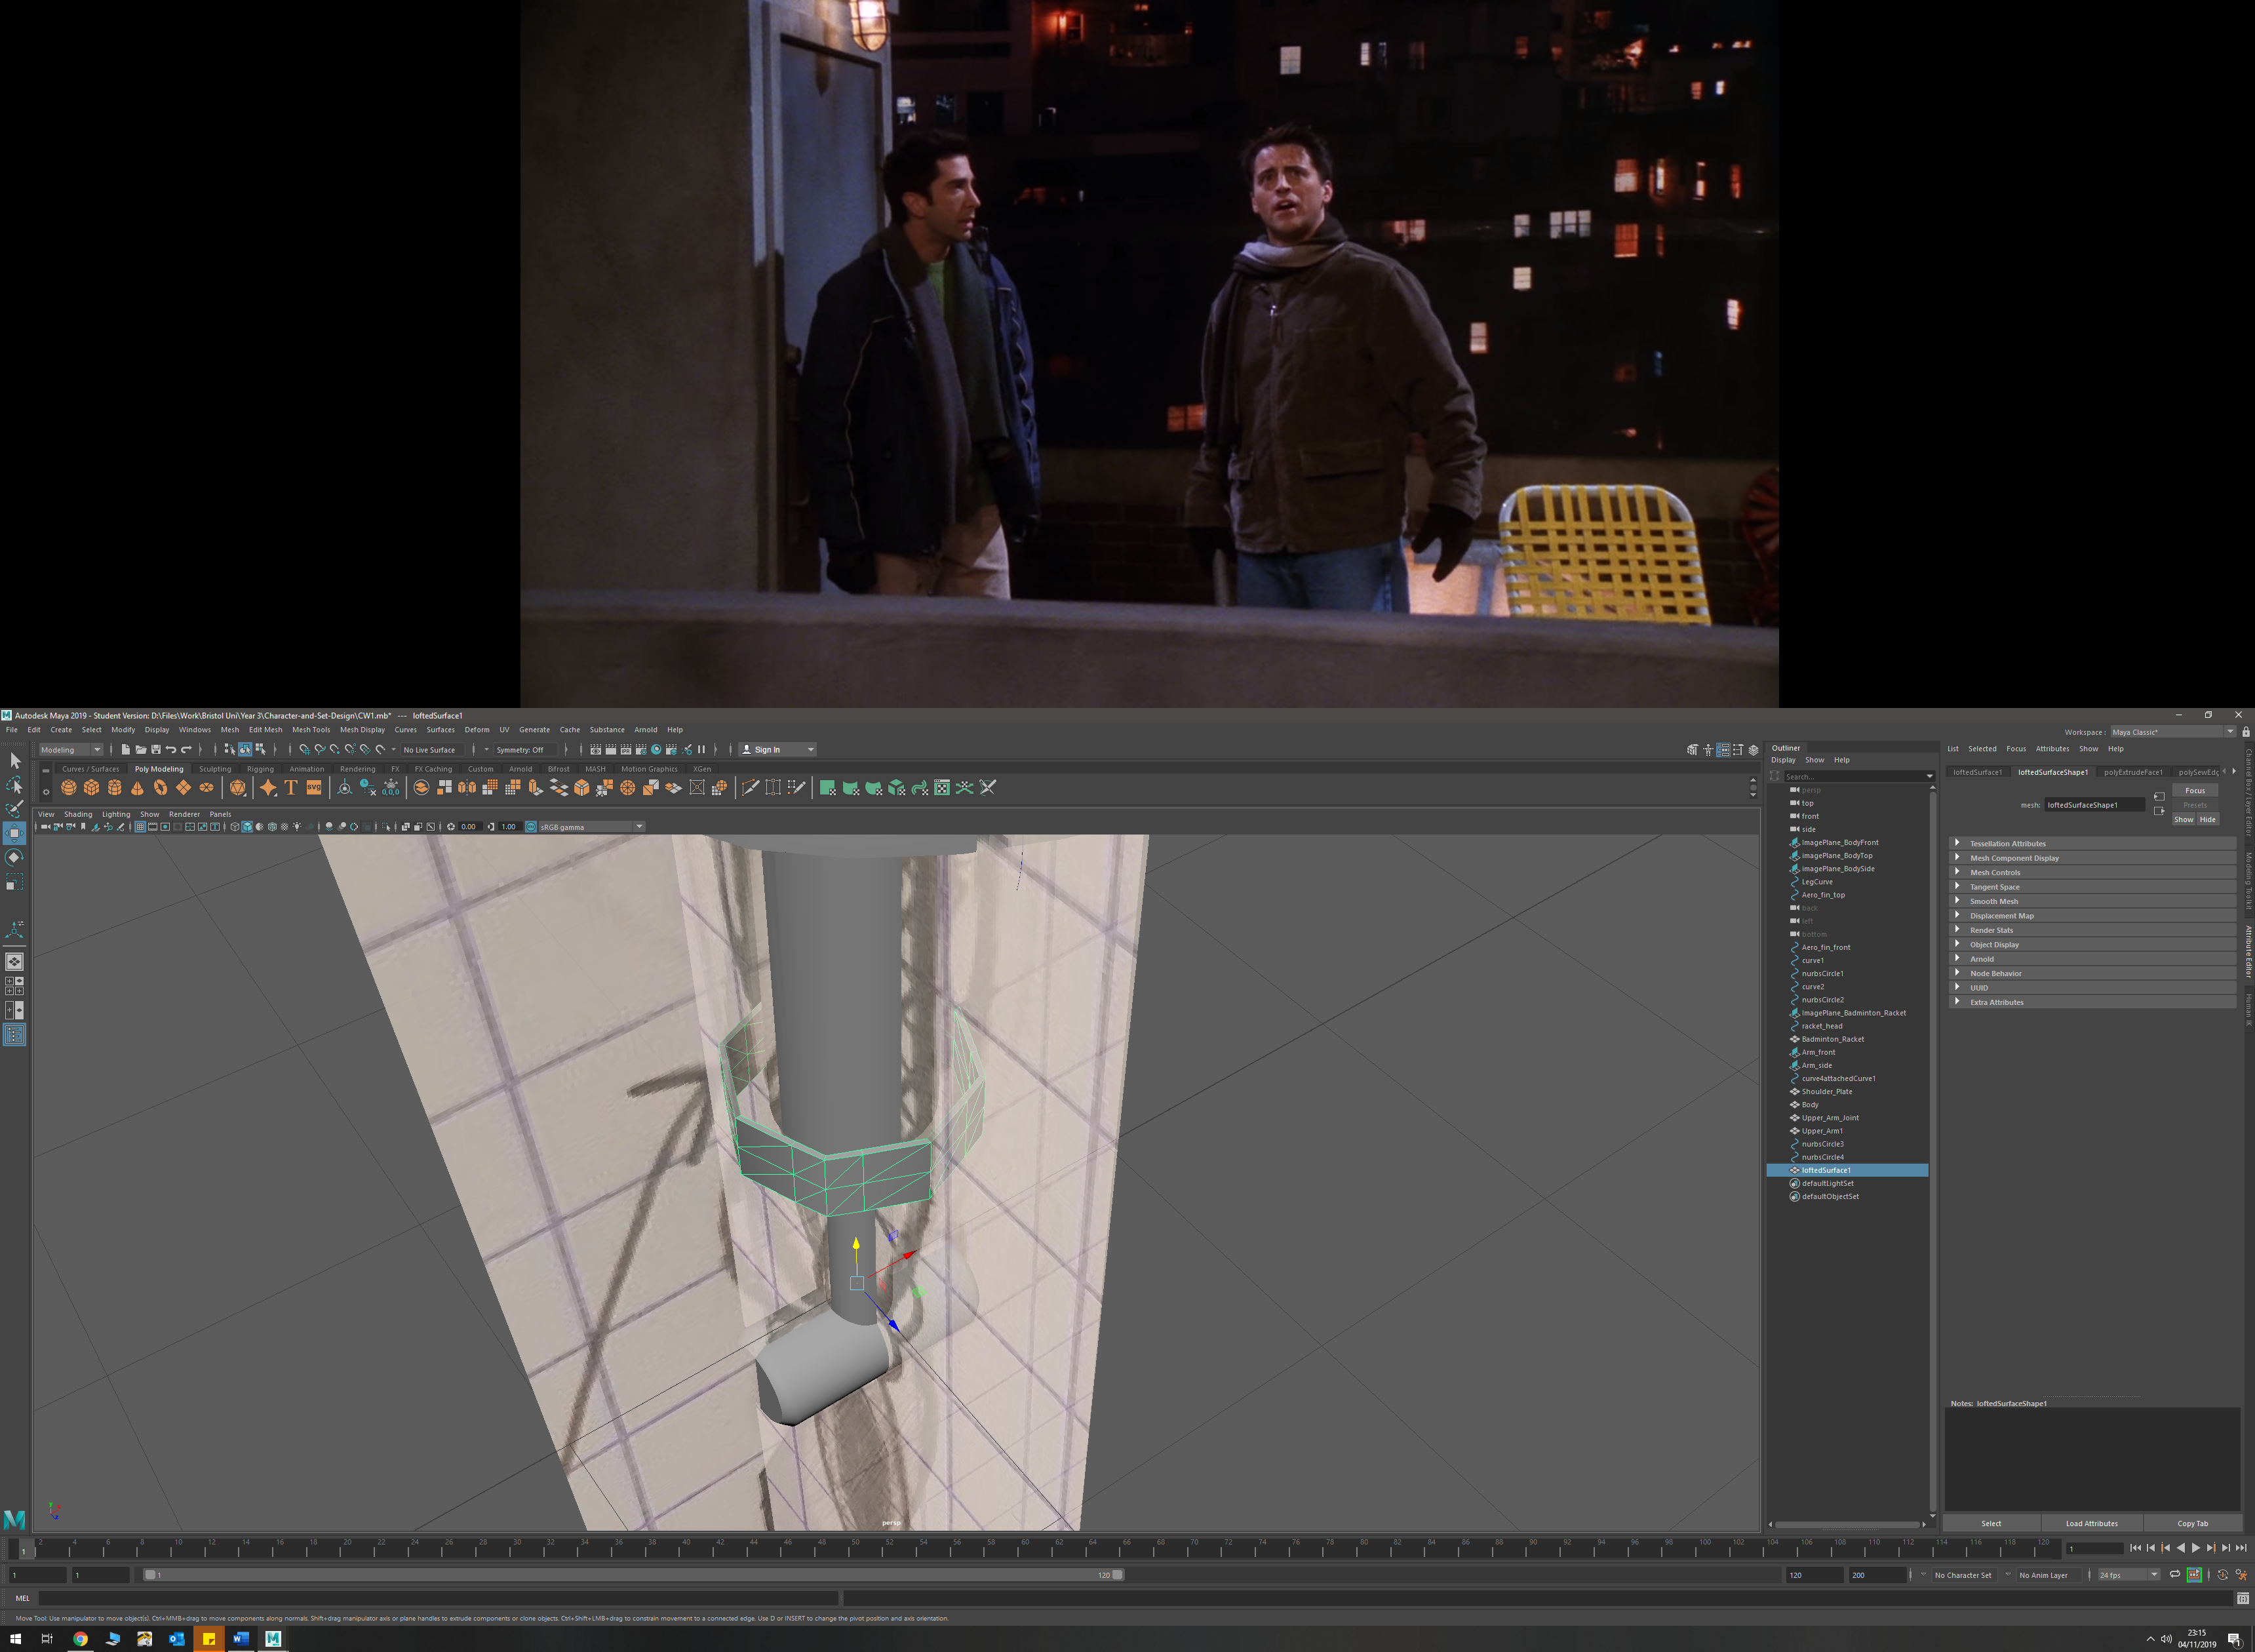

I then extruded the octagonal lofted ring in order to give it depth

* Next I extruded up select faces of the octogen in order to create the connecting beams with the shoulder joint

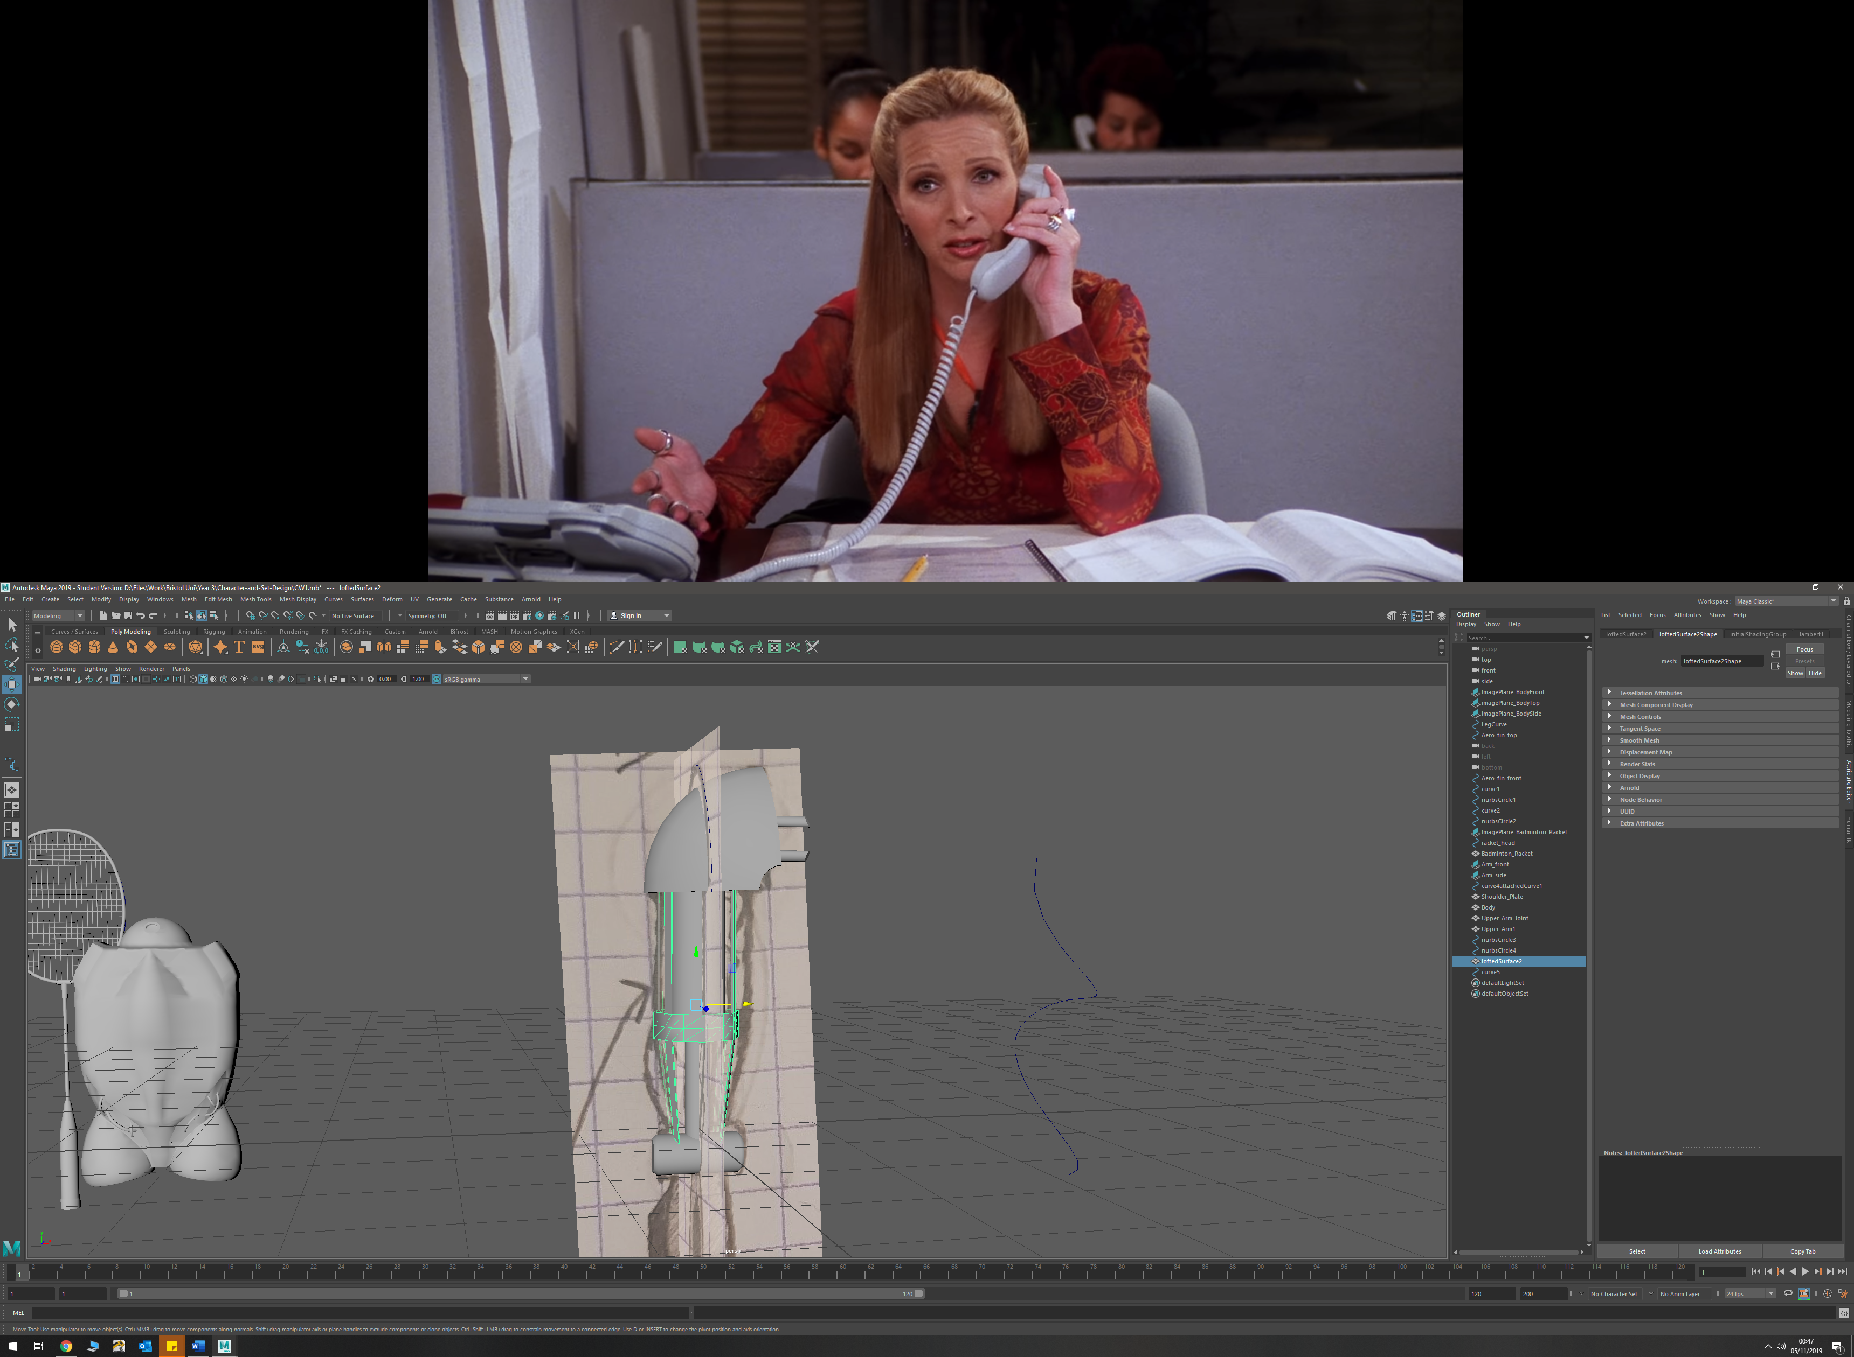

* For wire detail, I created an overlapping, flat EP curve and then manipulated the curves points to make it into a spiral shape. I made this fit around the inner arm. I then used a NURBS circle and extrude to create a thin pipe/wire

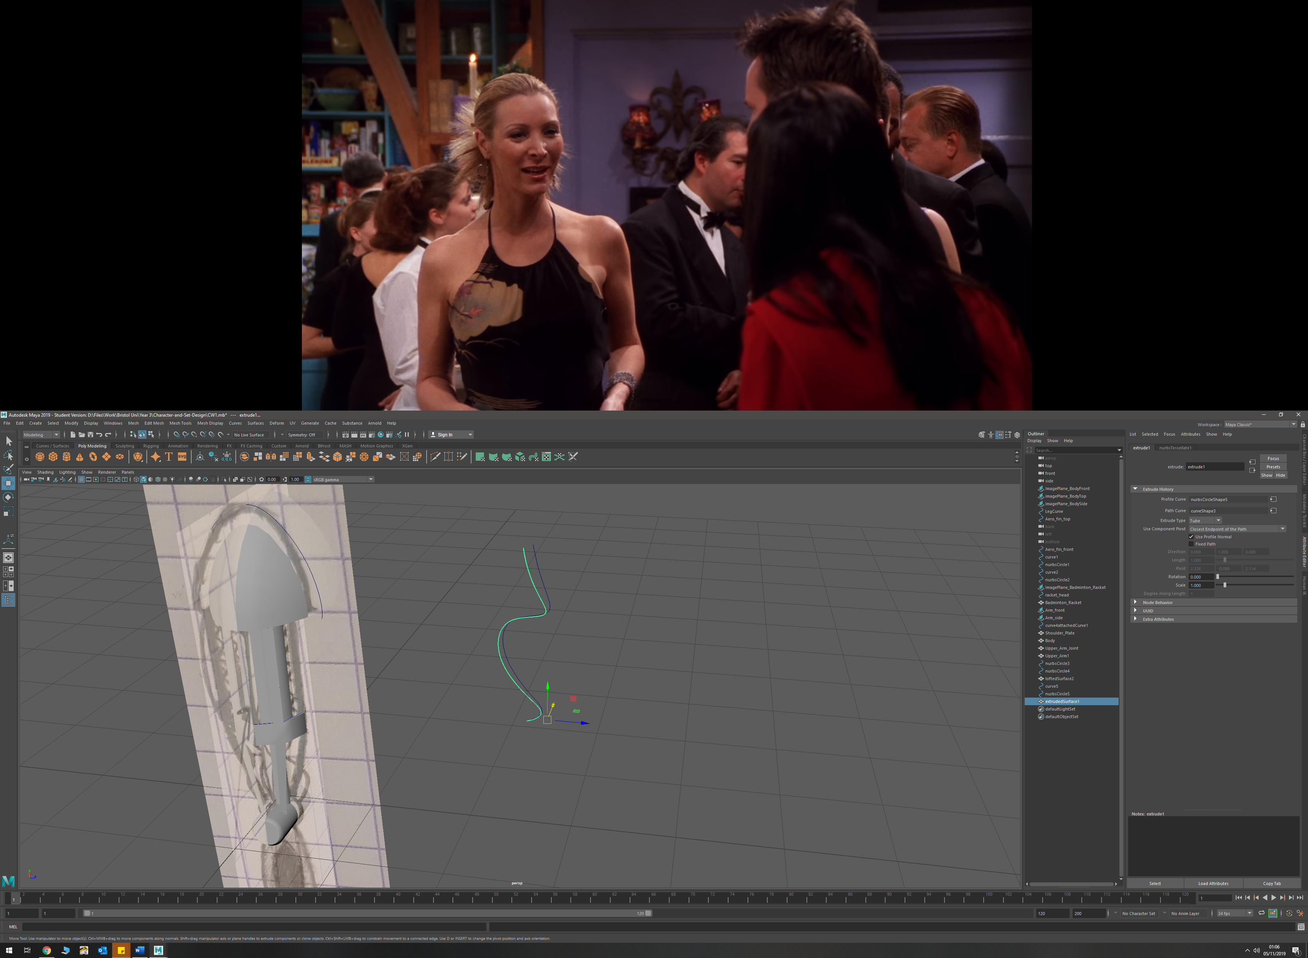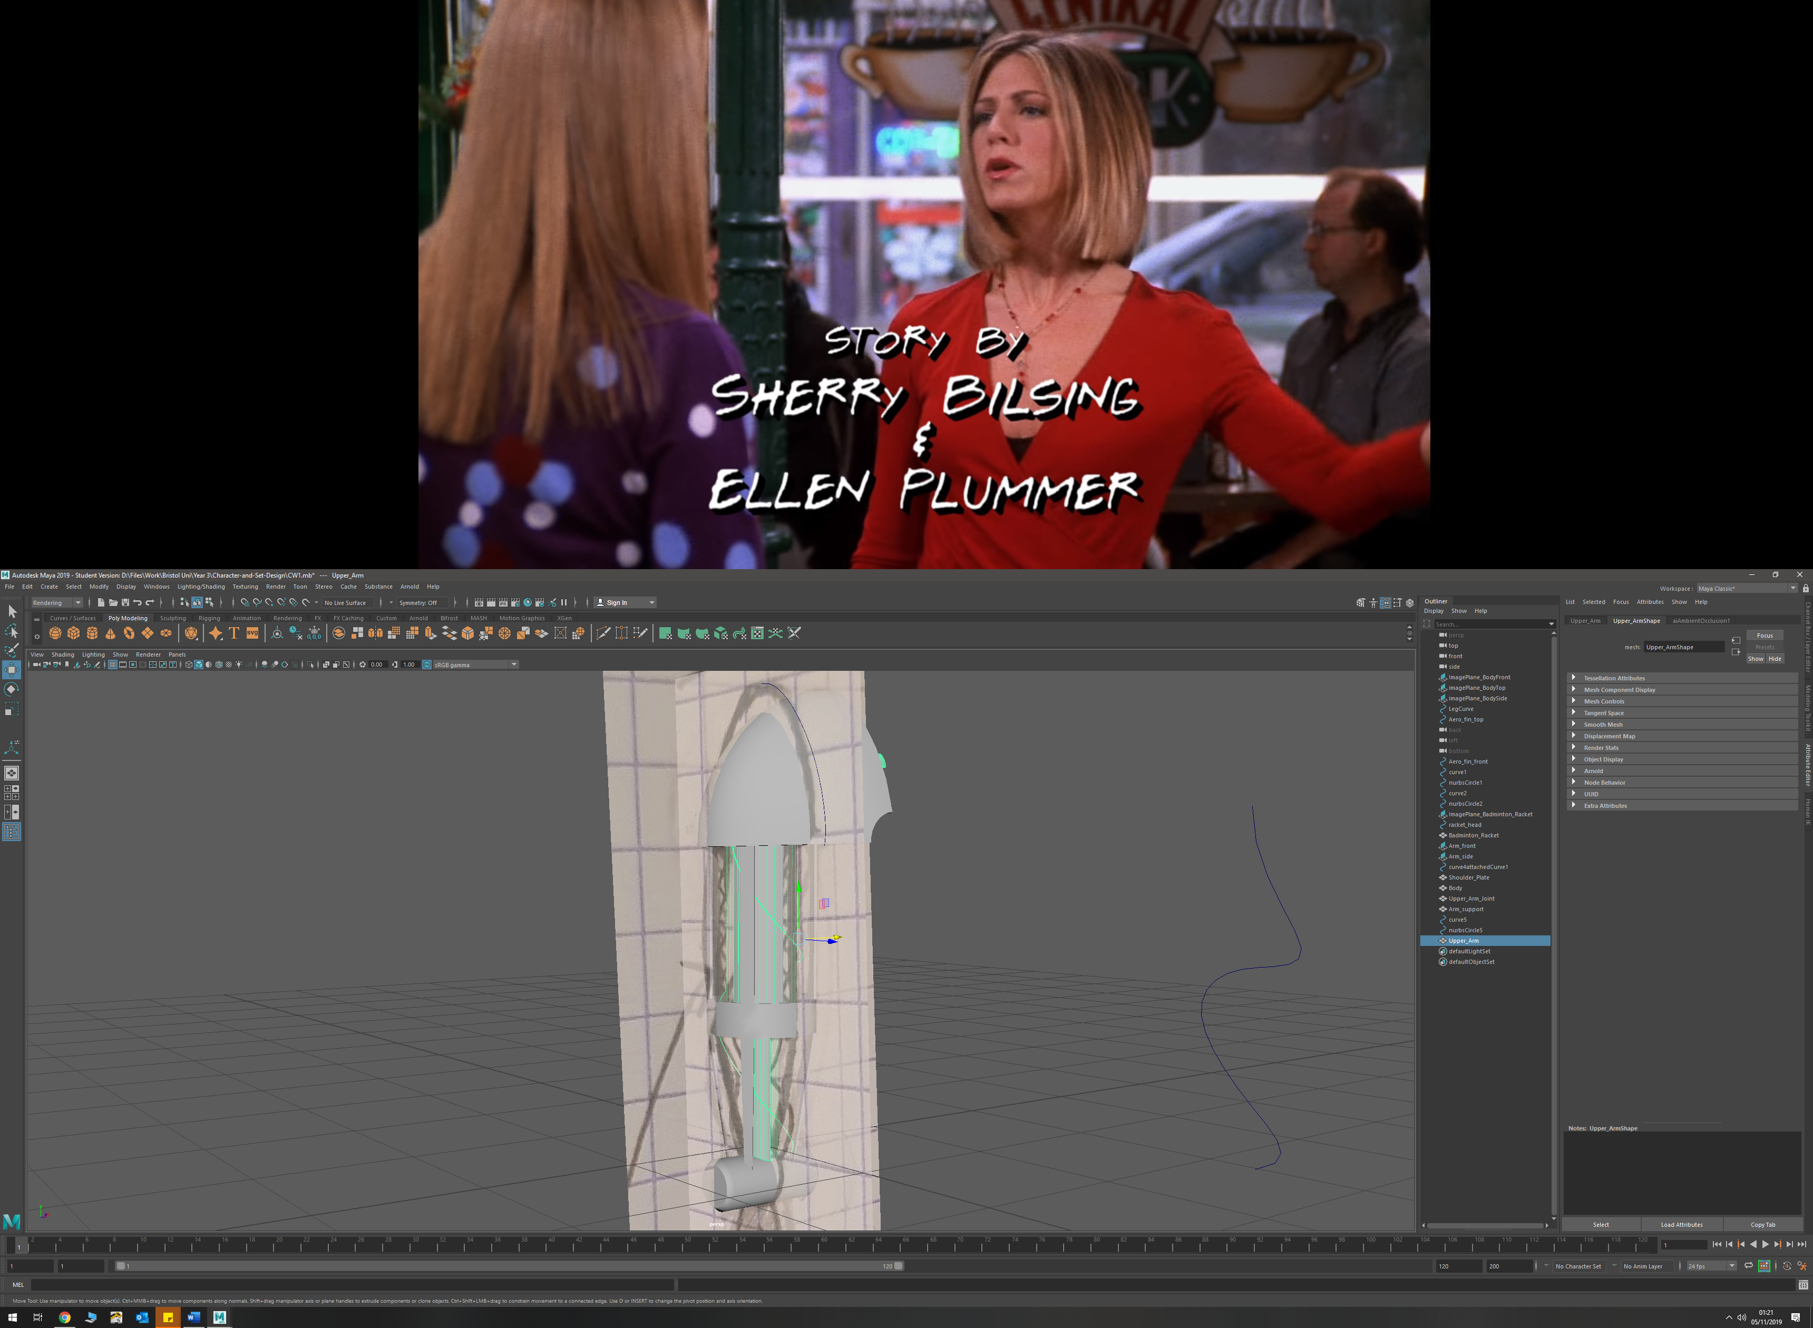

* The Forearm was created with a cylinder and was shaped by extruding faces and reducing face sizes. The whole object was then smoothed to match the sketch design

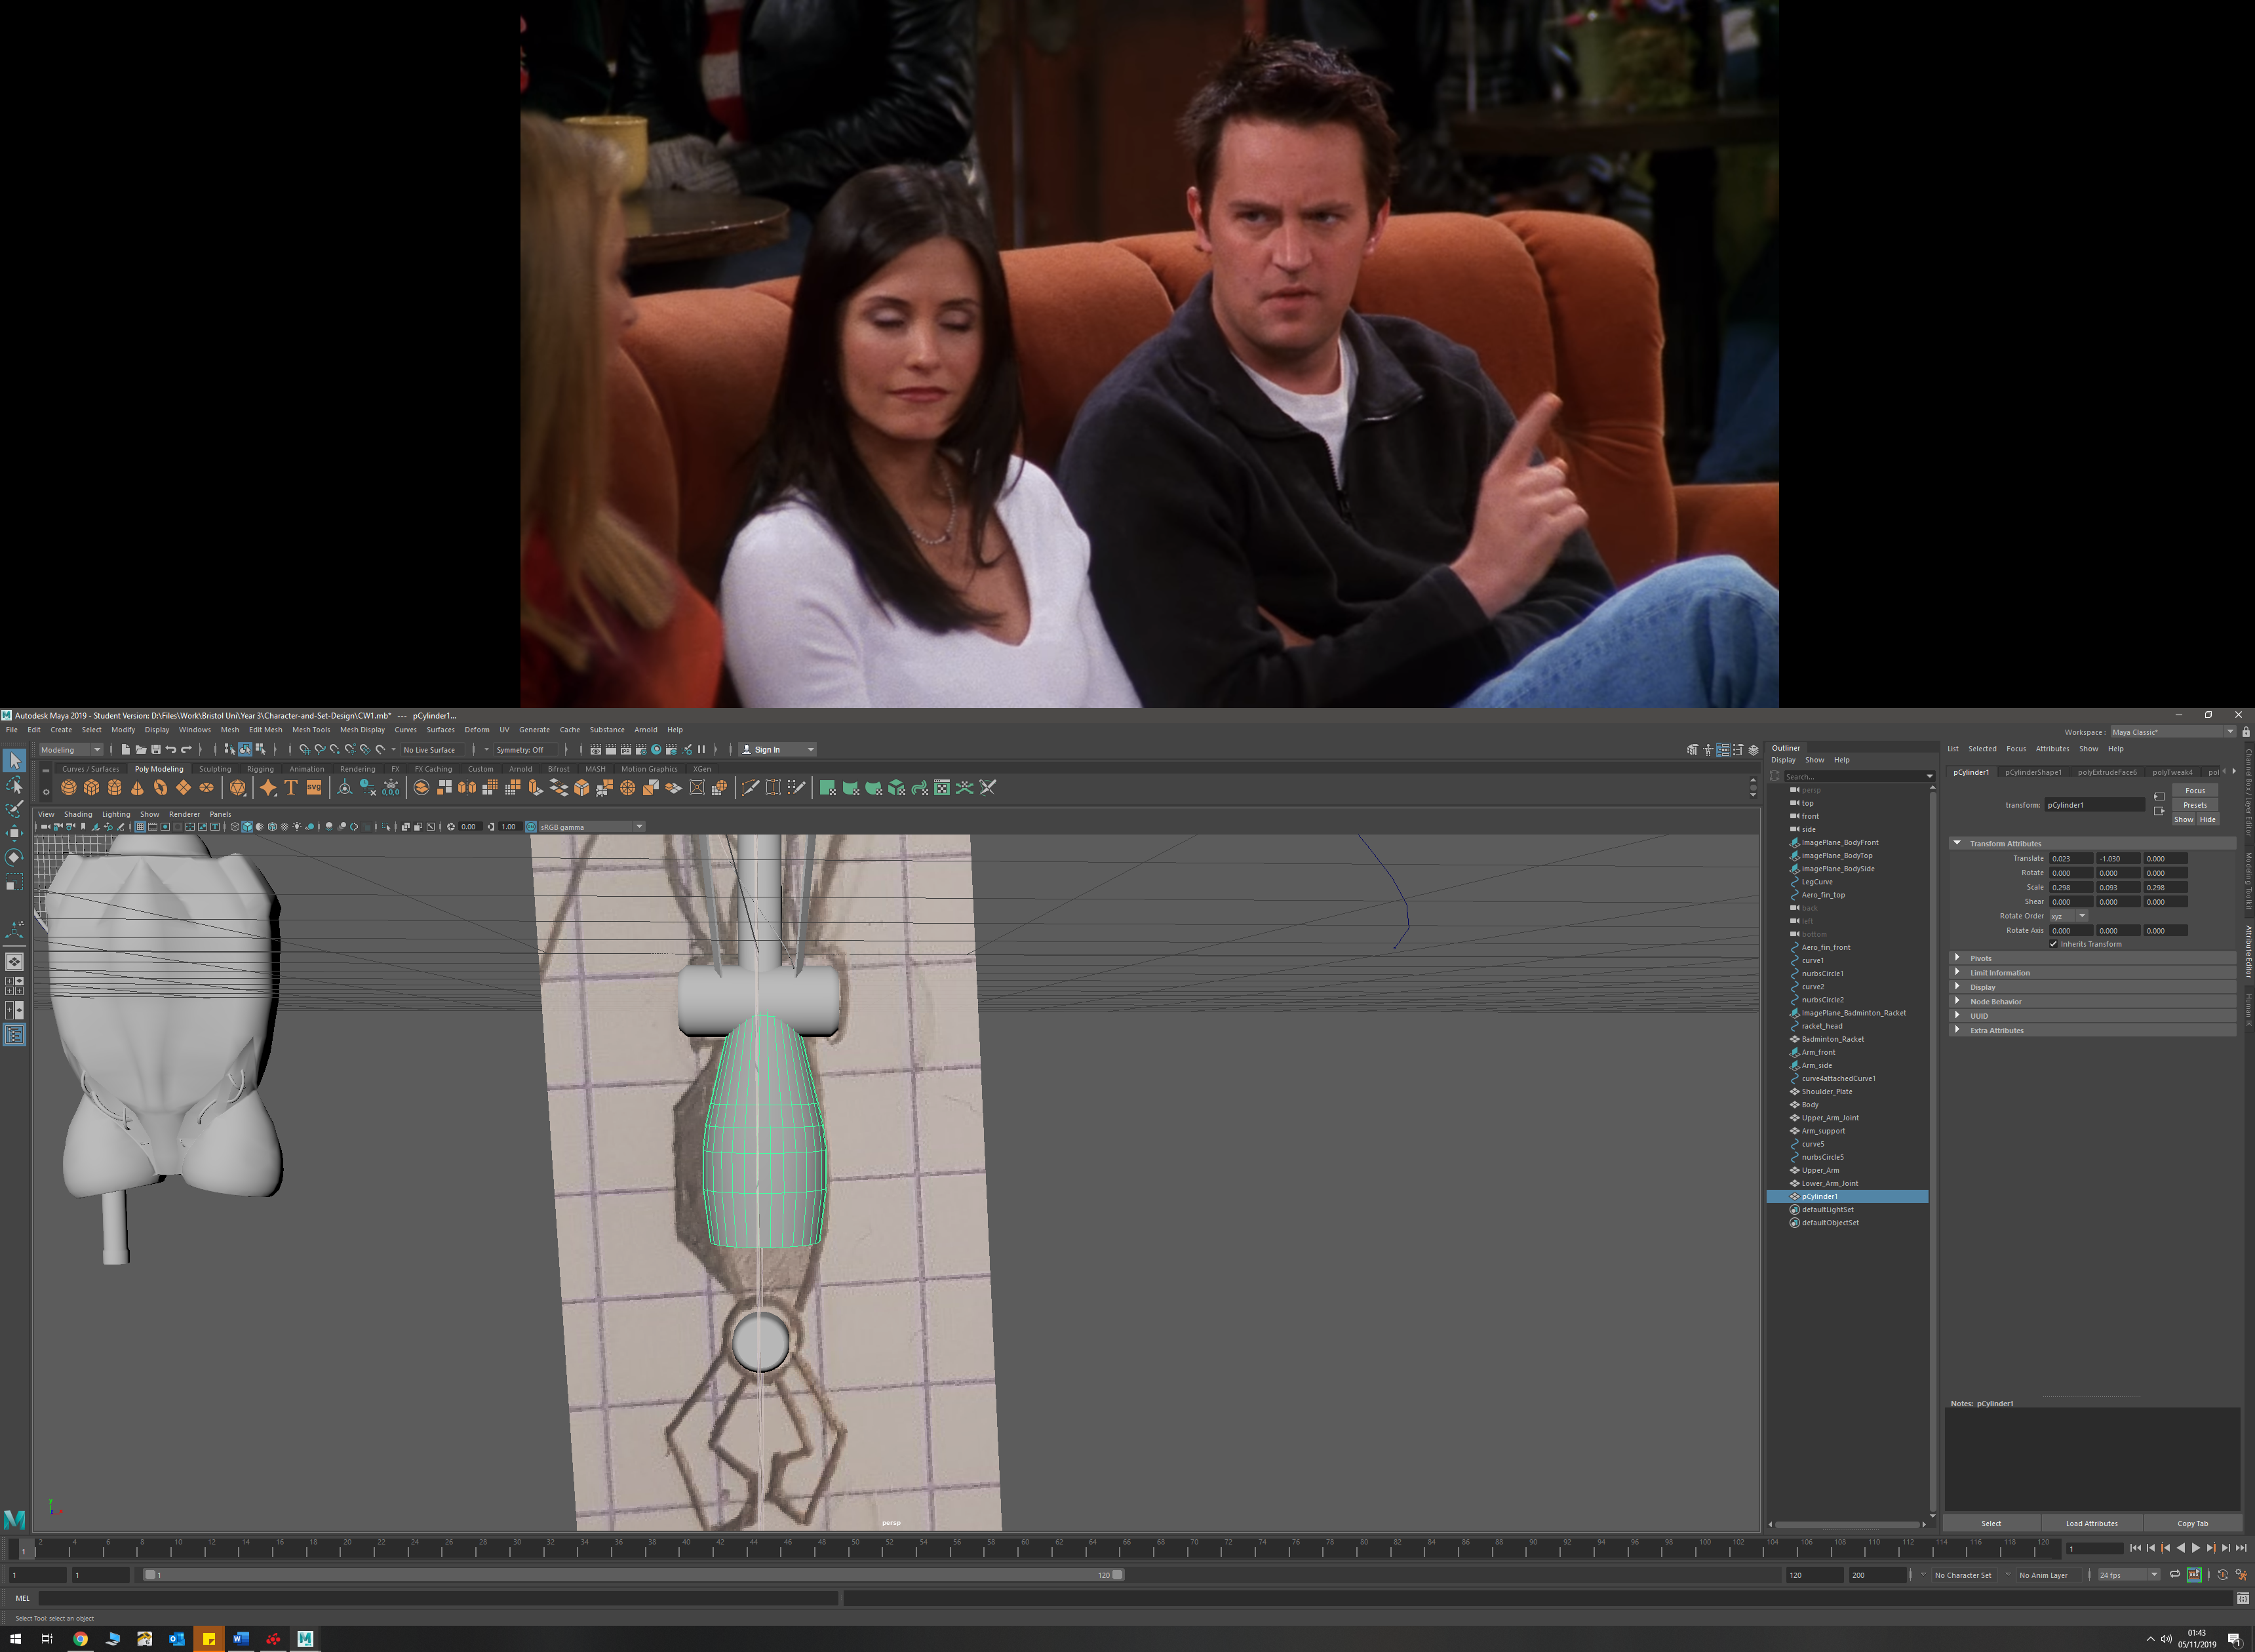 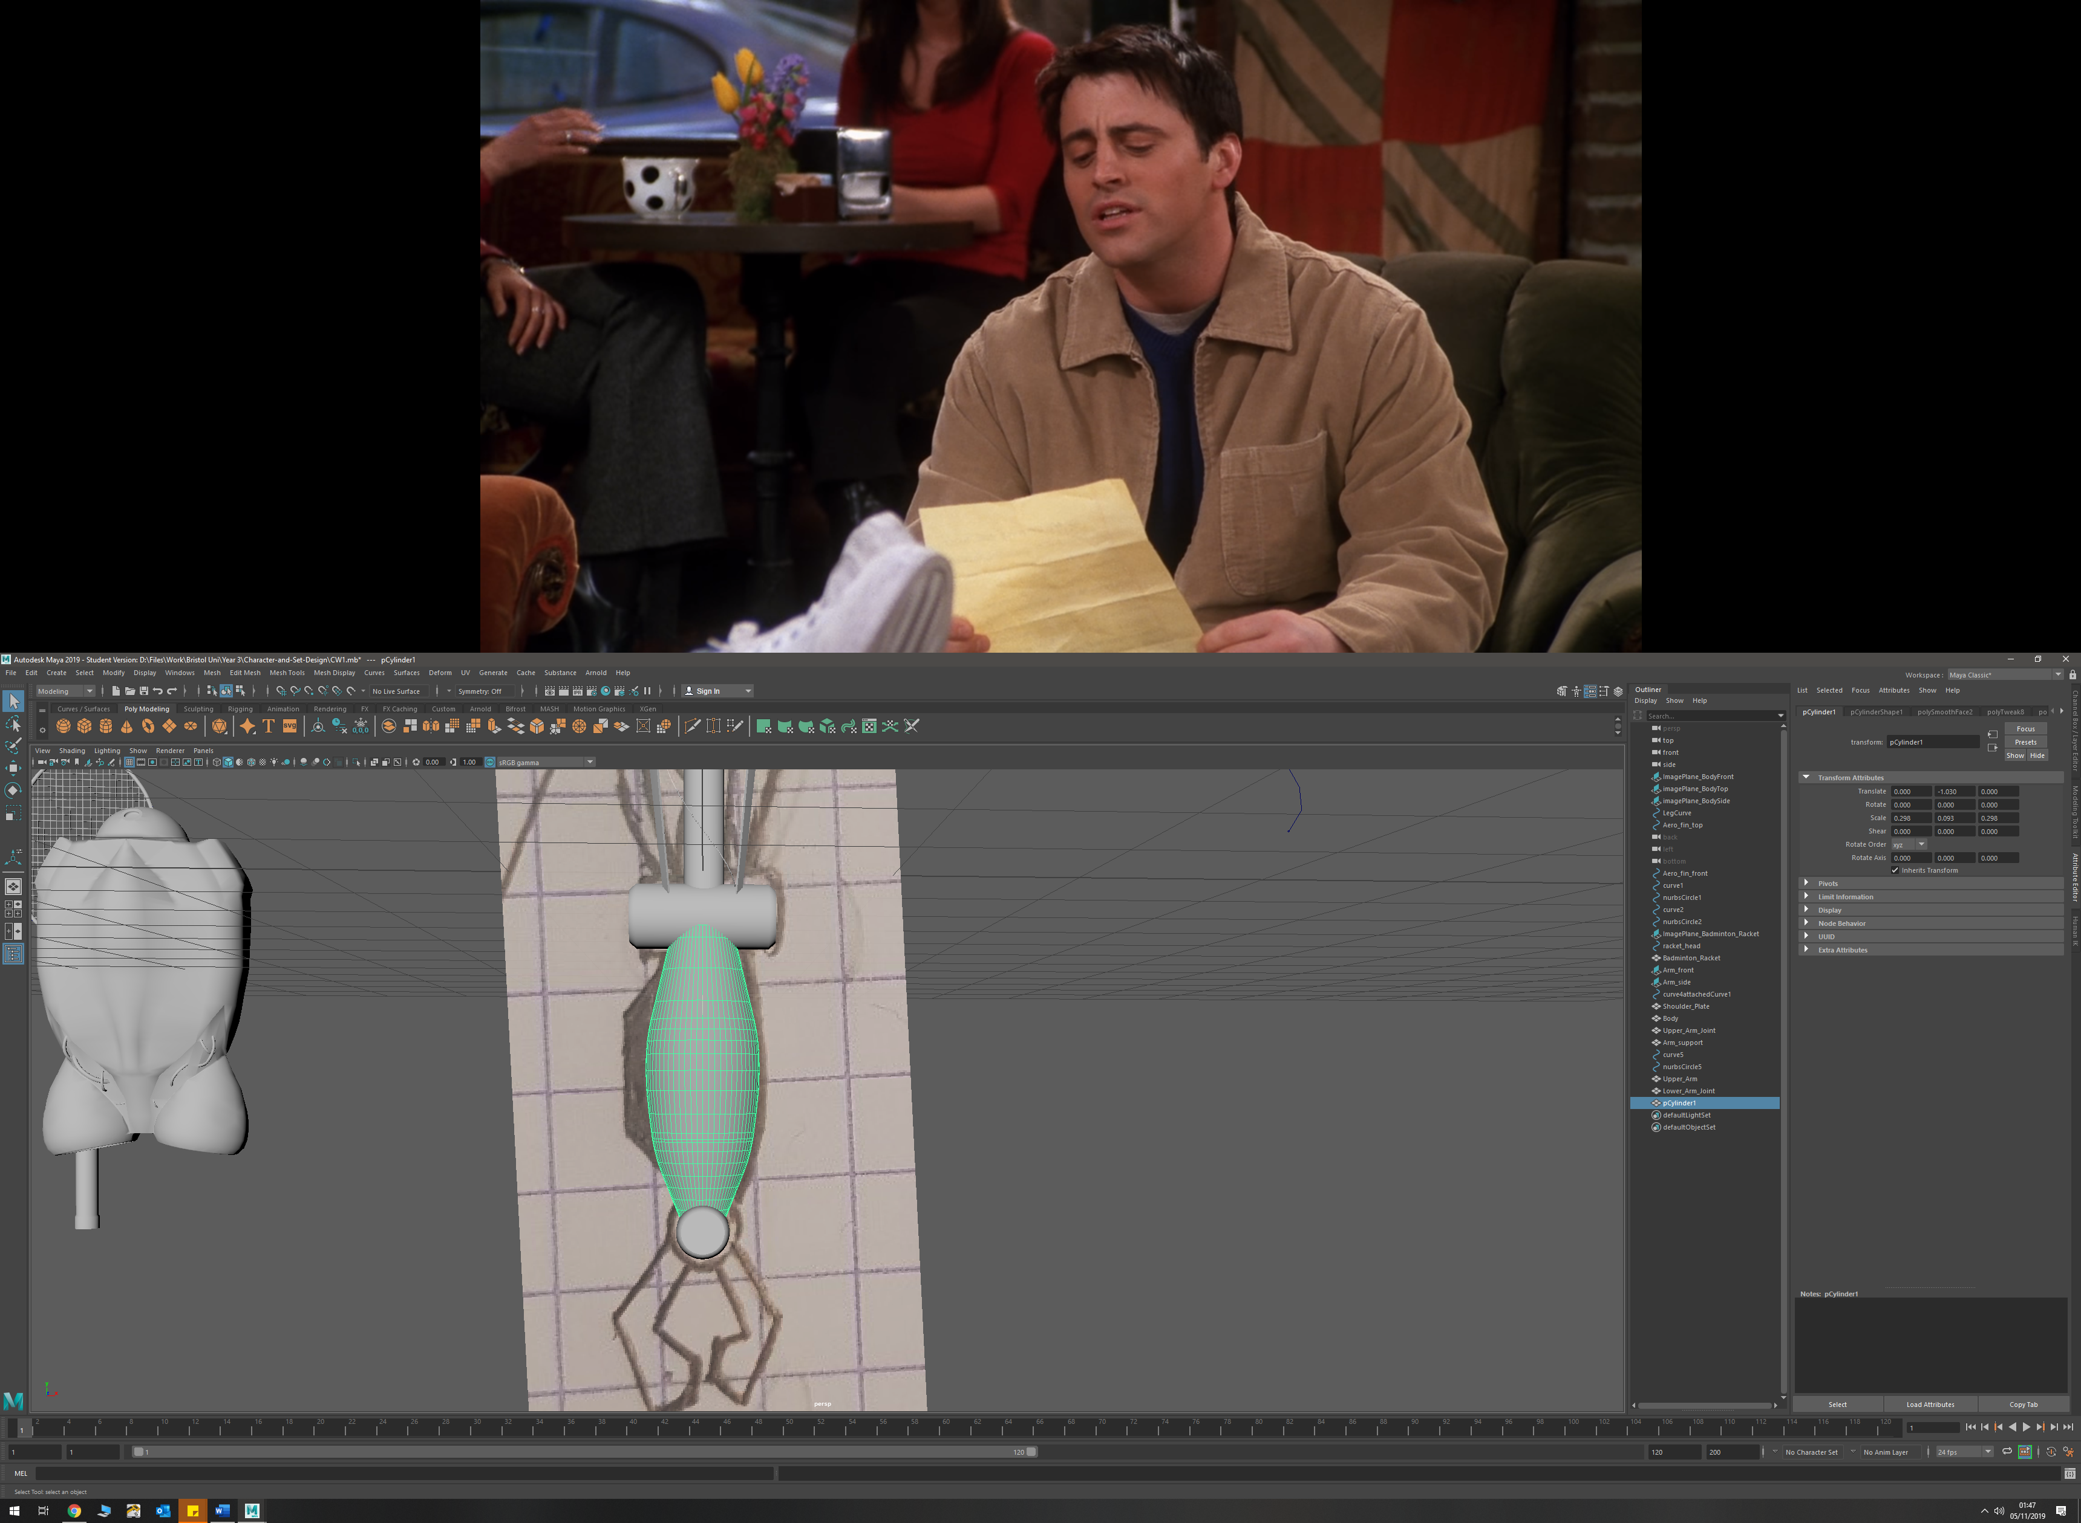

Forearm detail was made by moving edges on the forearm

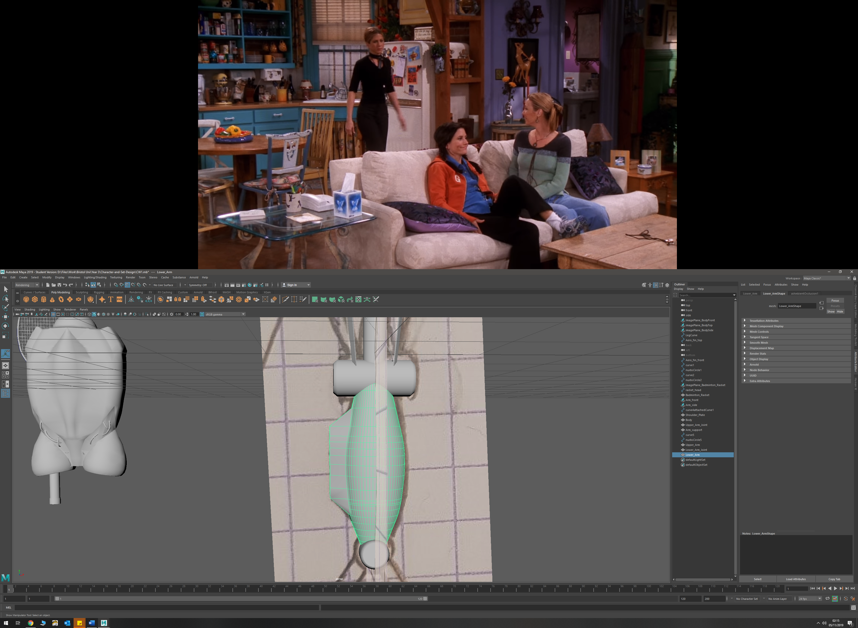

* To create the claw, I used poly extrudes, and added edge loops to create the general shape. I then bevelled the claw tip to create the correct shape

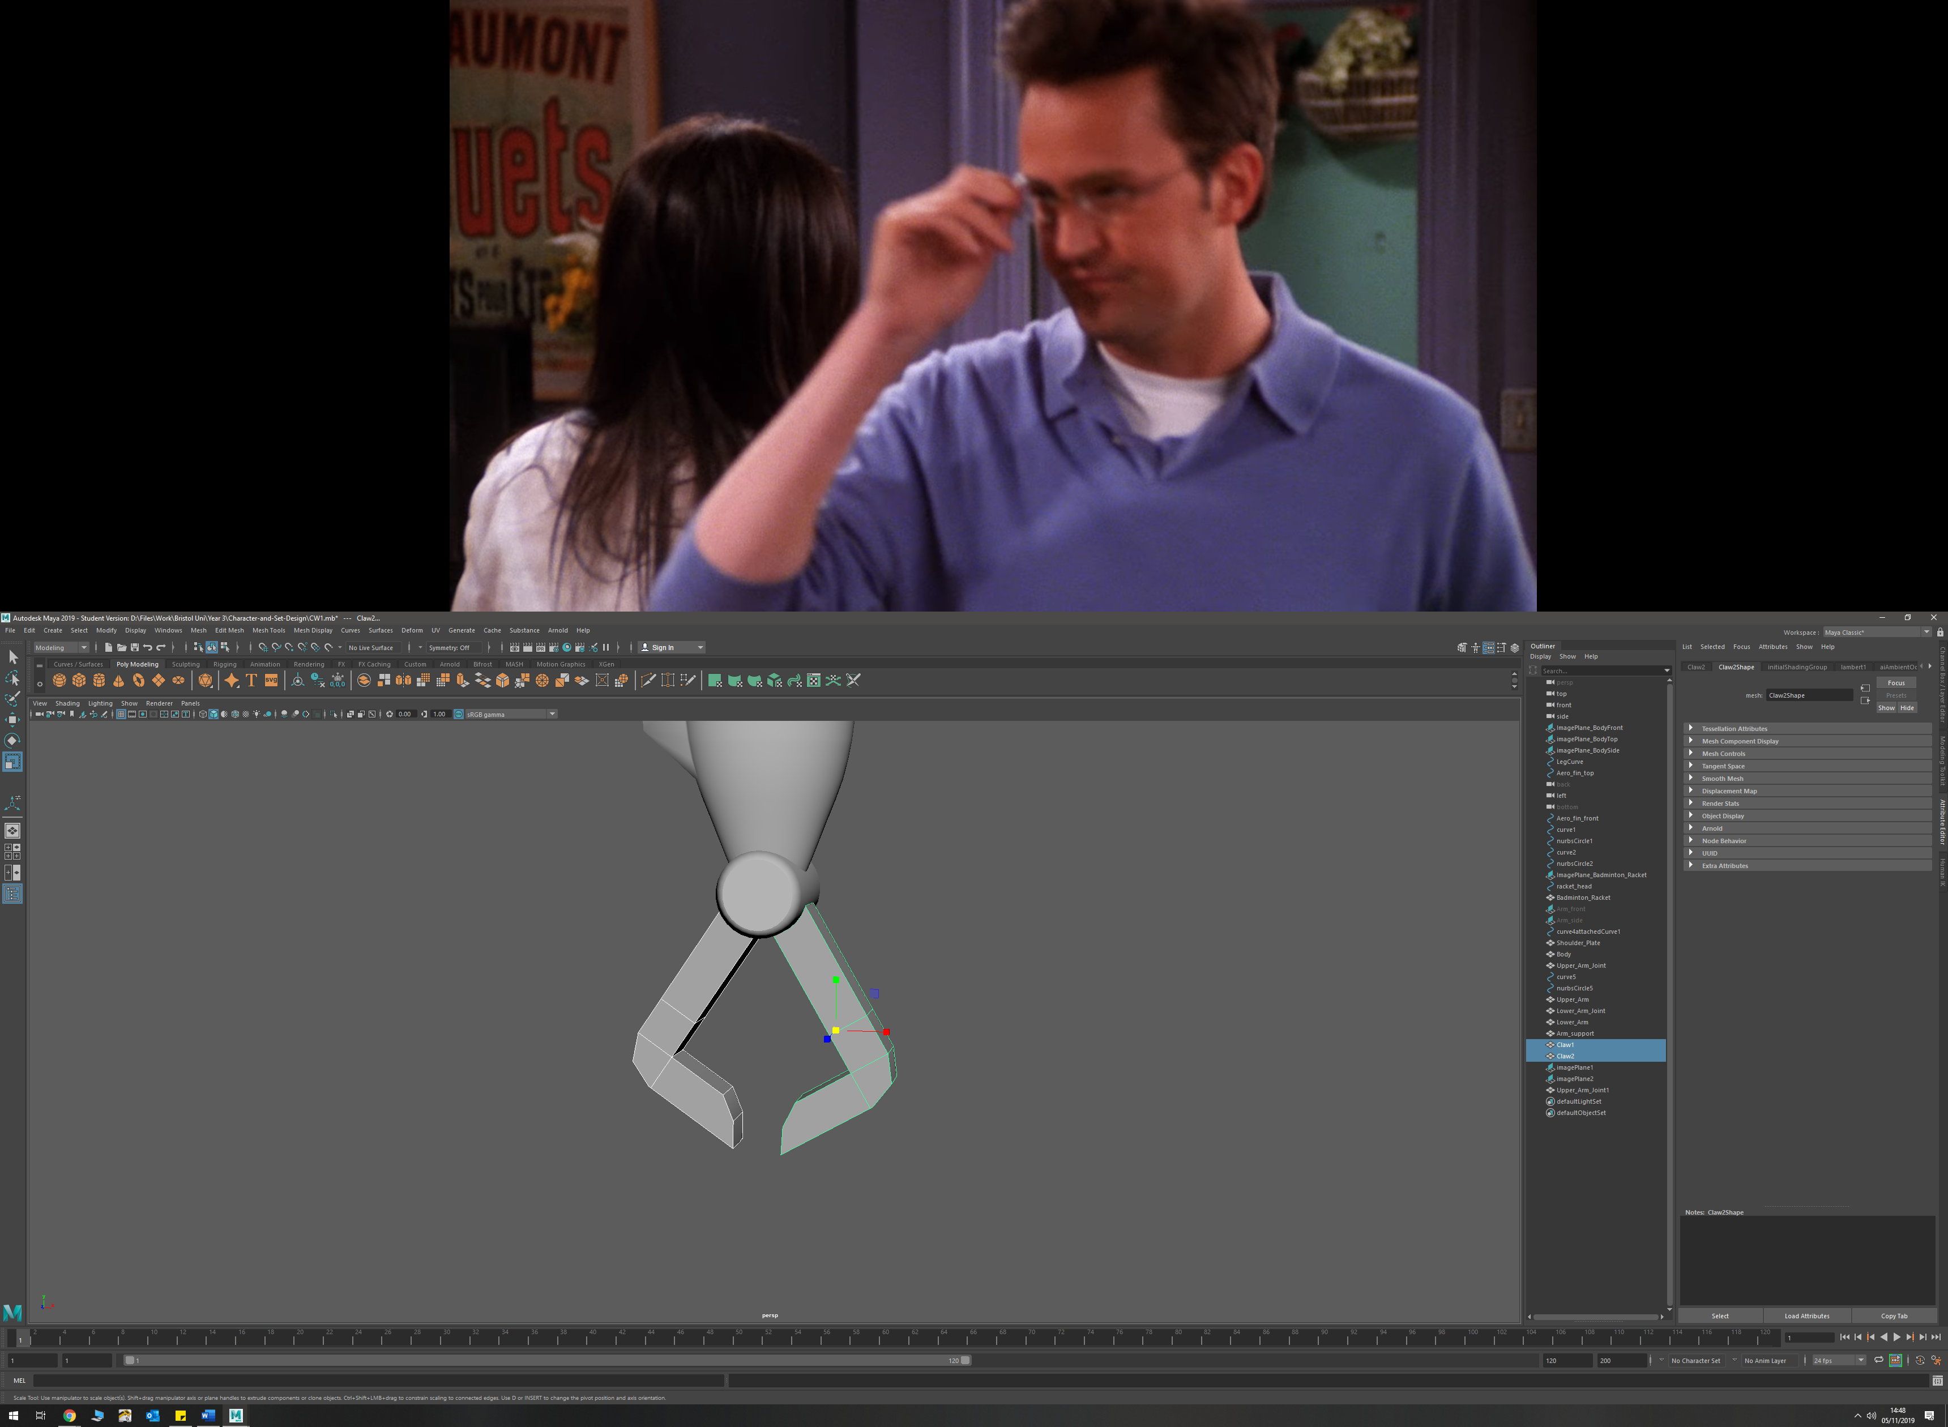

**Leg**

* Lower leg made up of circle that was chopped in half, and then extruded upwards

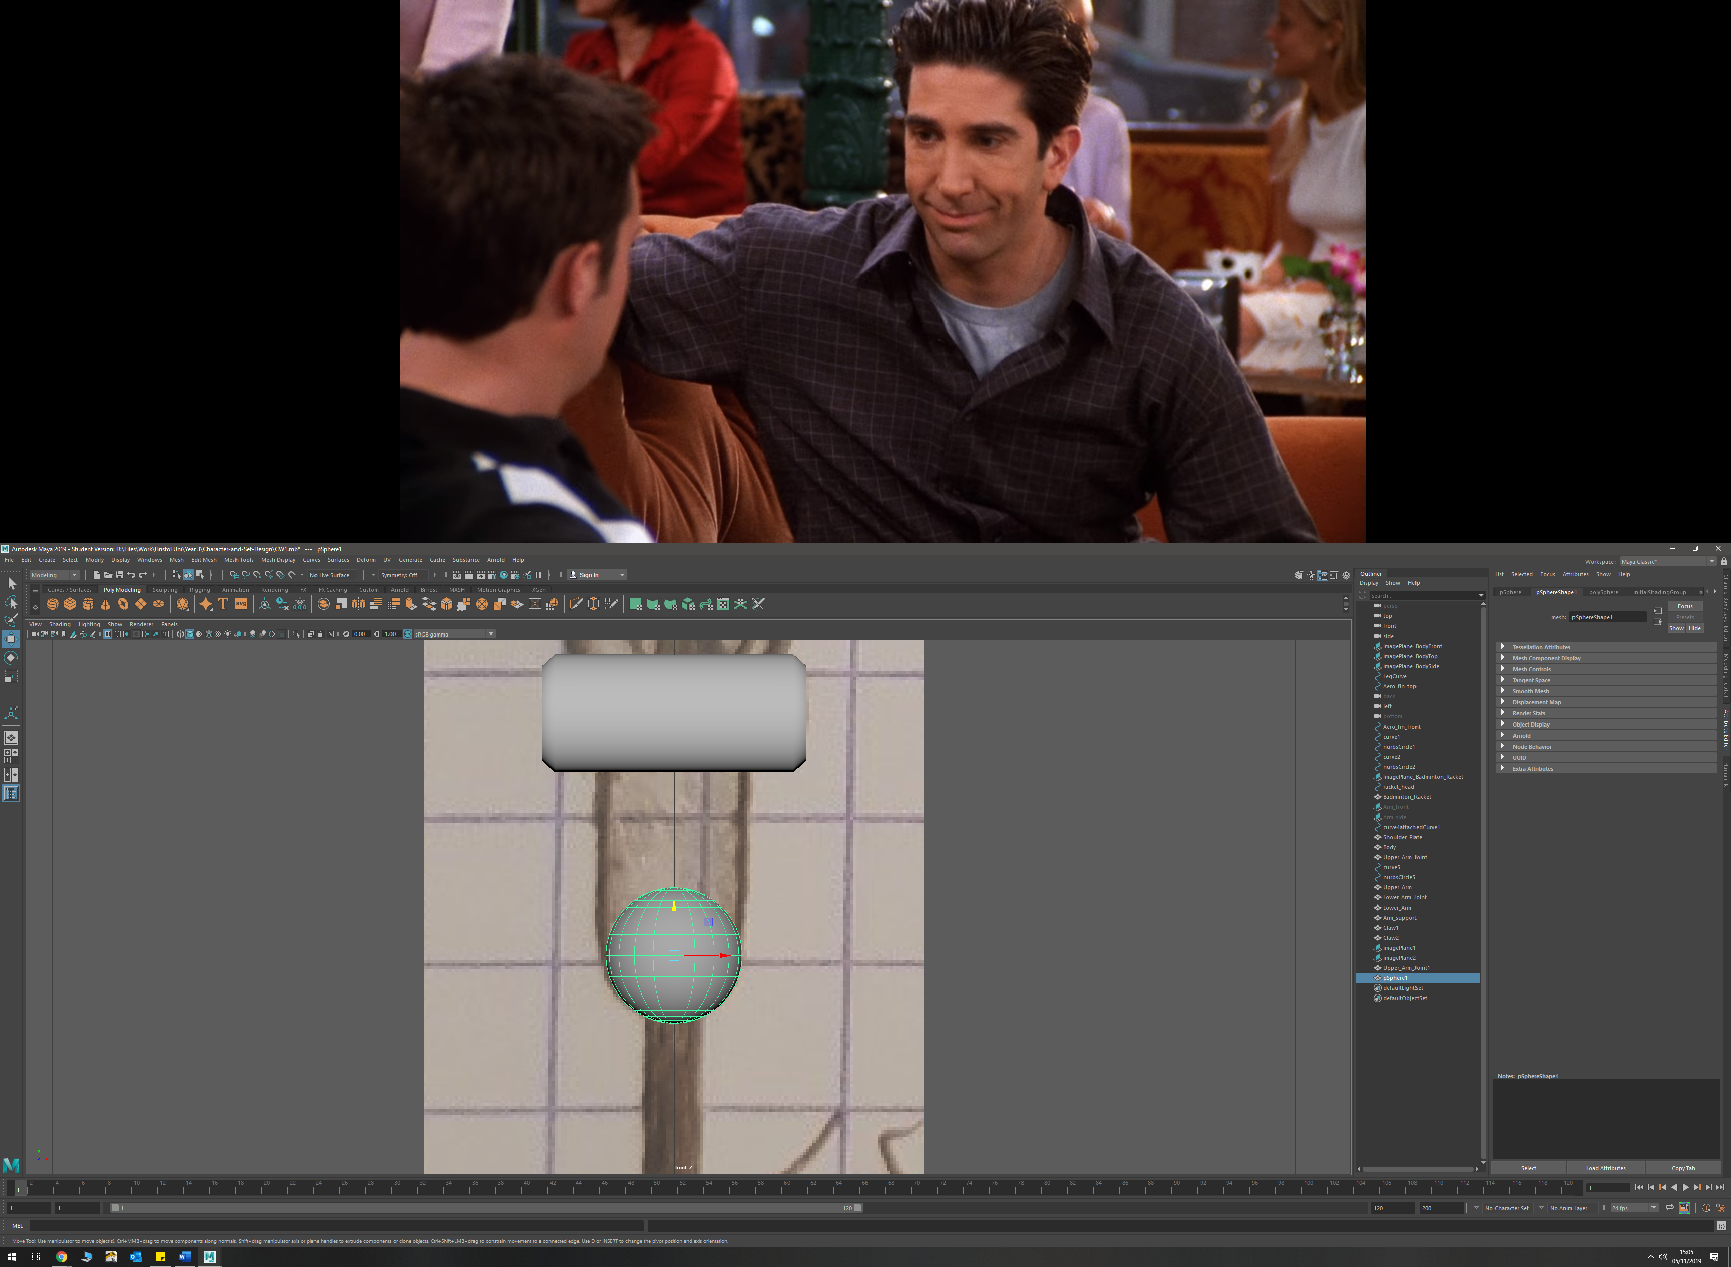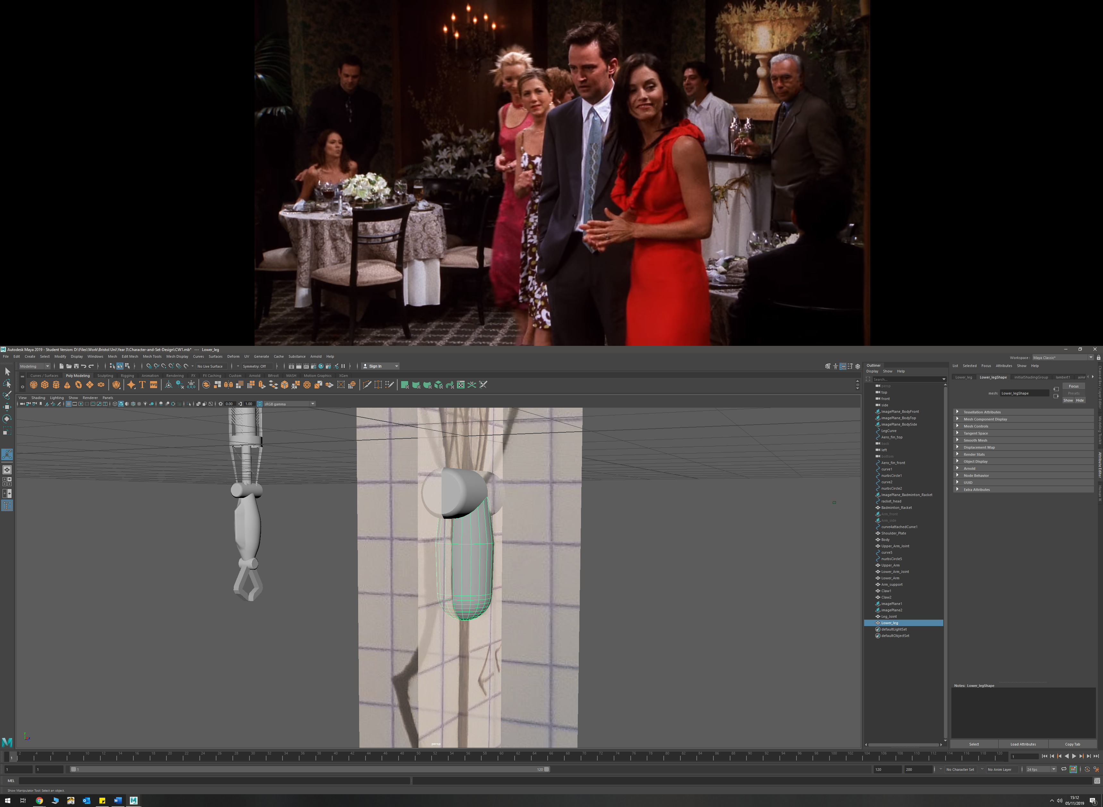

* Performed a union Boolean to attach the back-leg mount

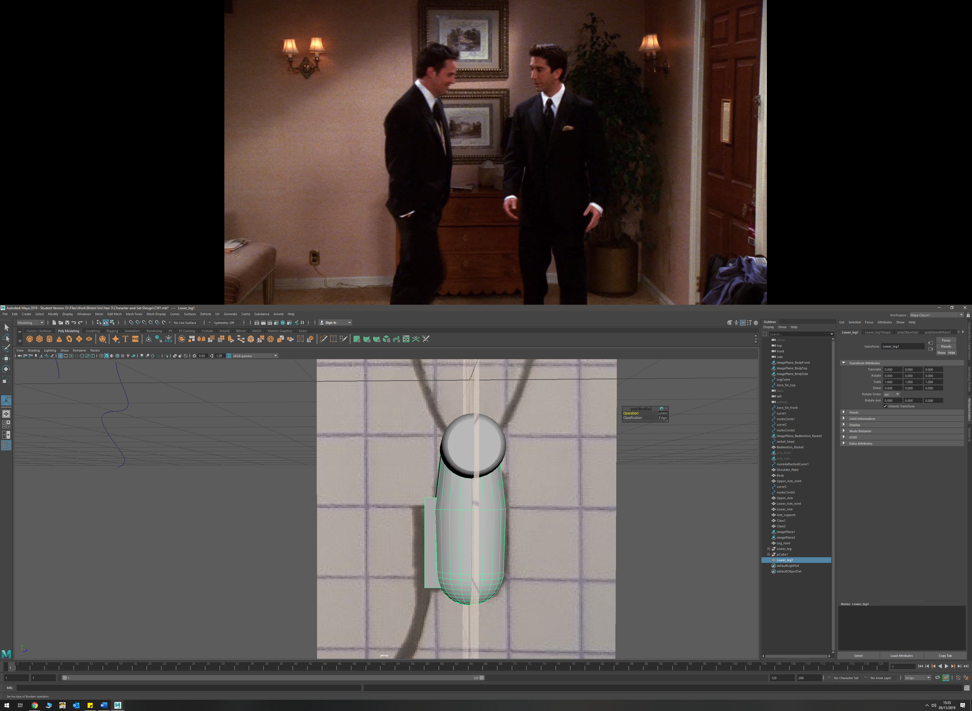

* Traced around the sketch with and EP curve to create the outline for the blade, then duplicated this curve. Did a loft between the curves, then extruded this new polygon to get depth

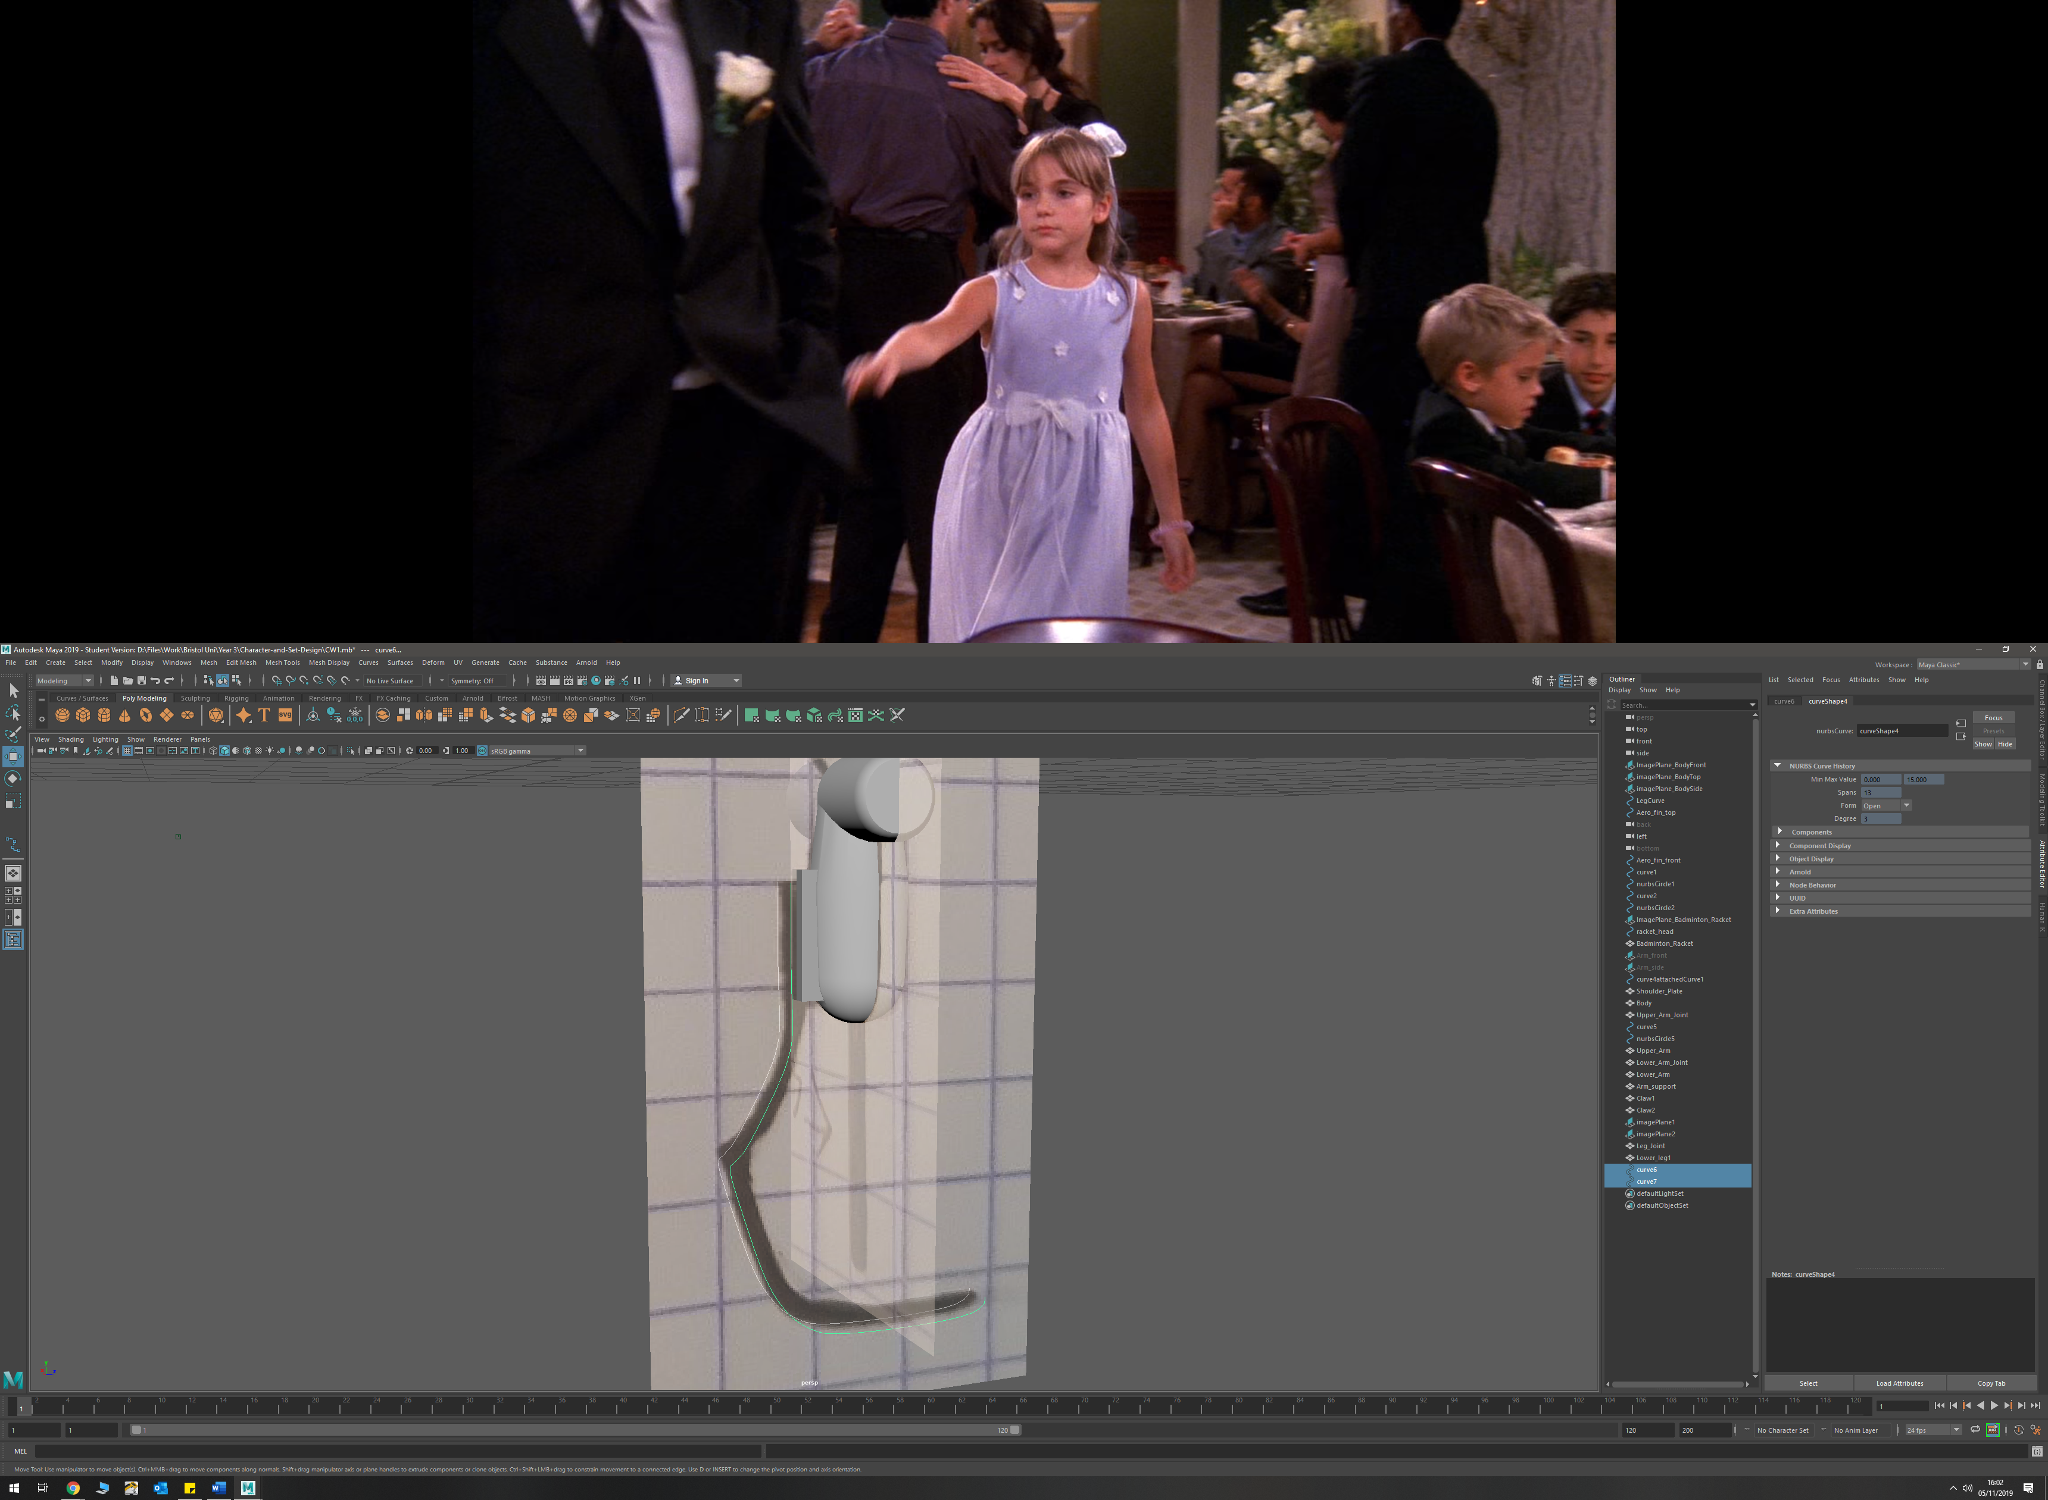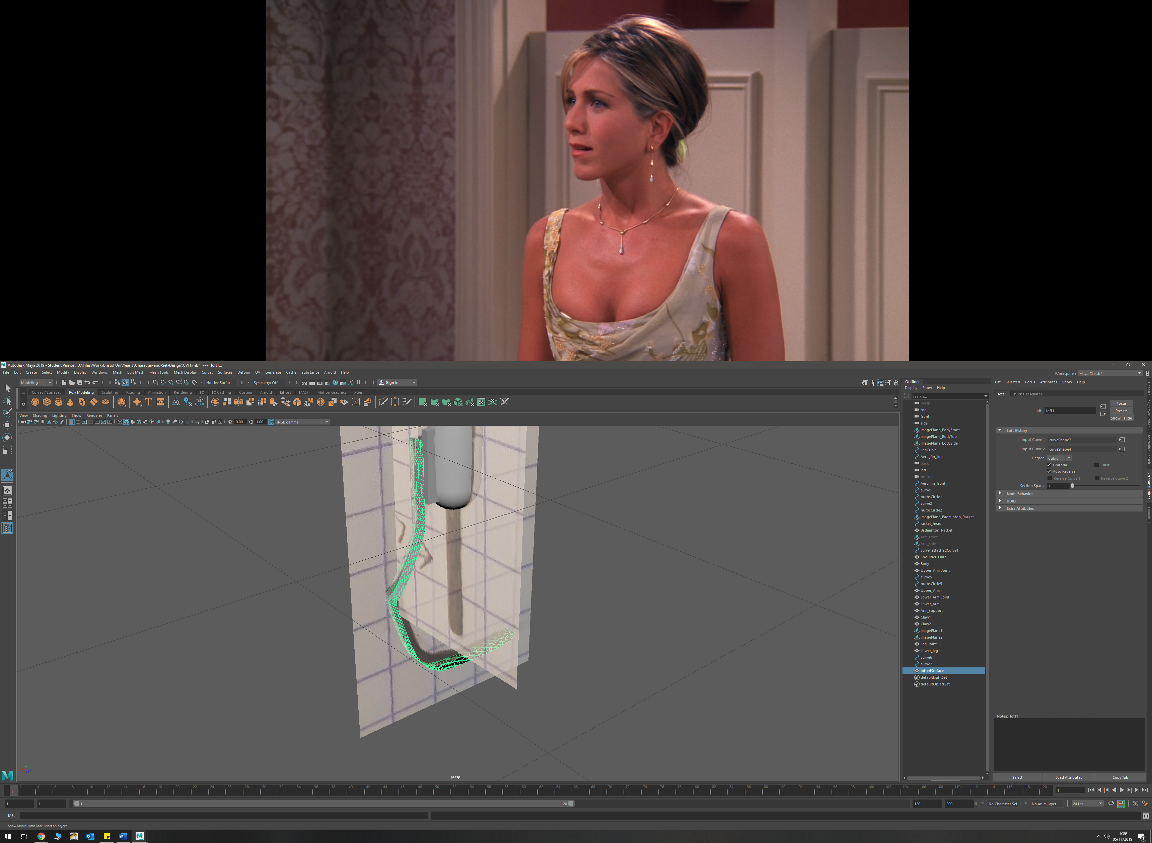

* Added blade screw detail by circularising faces, and then extruding slightly

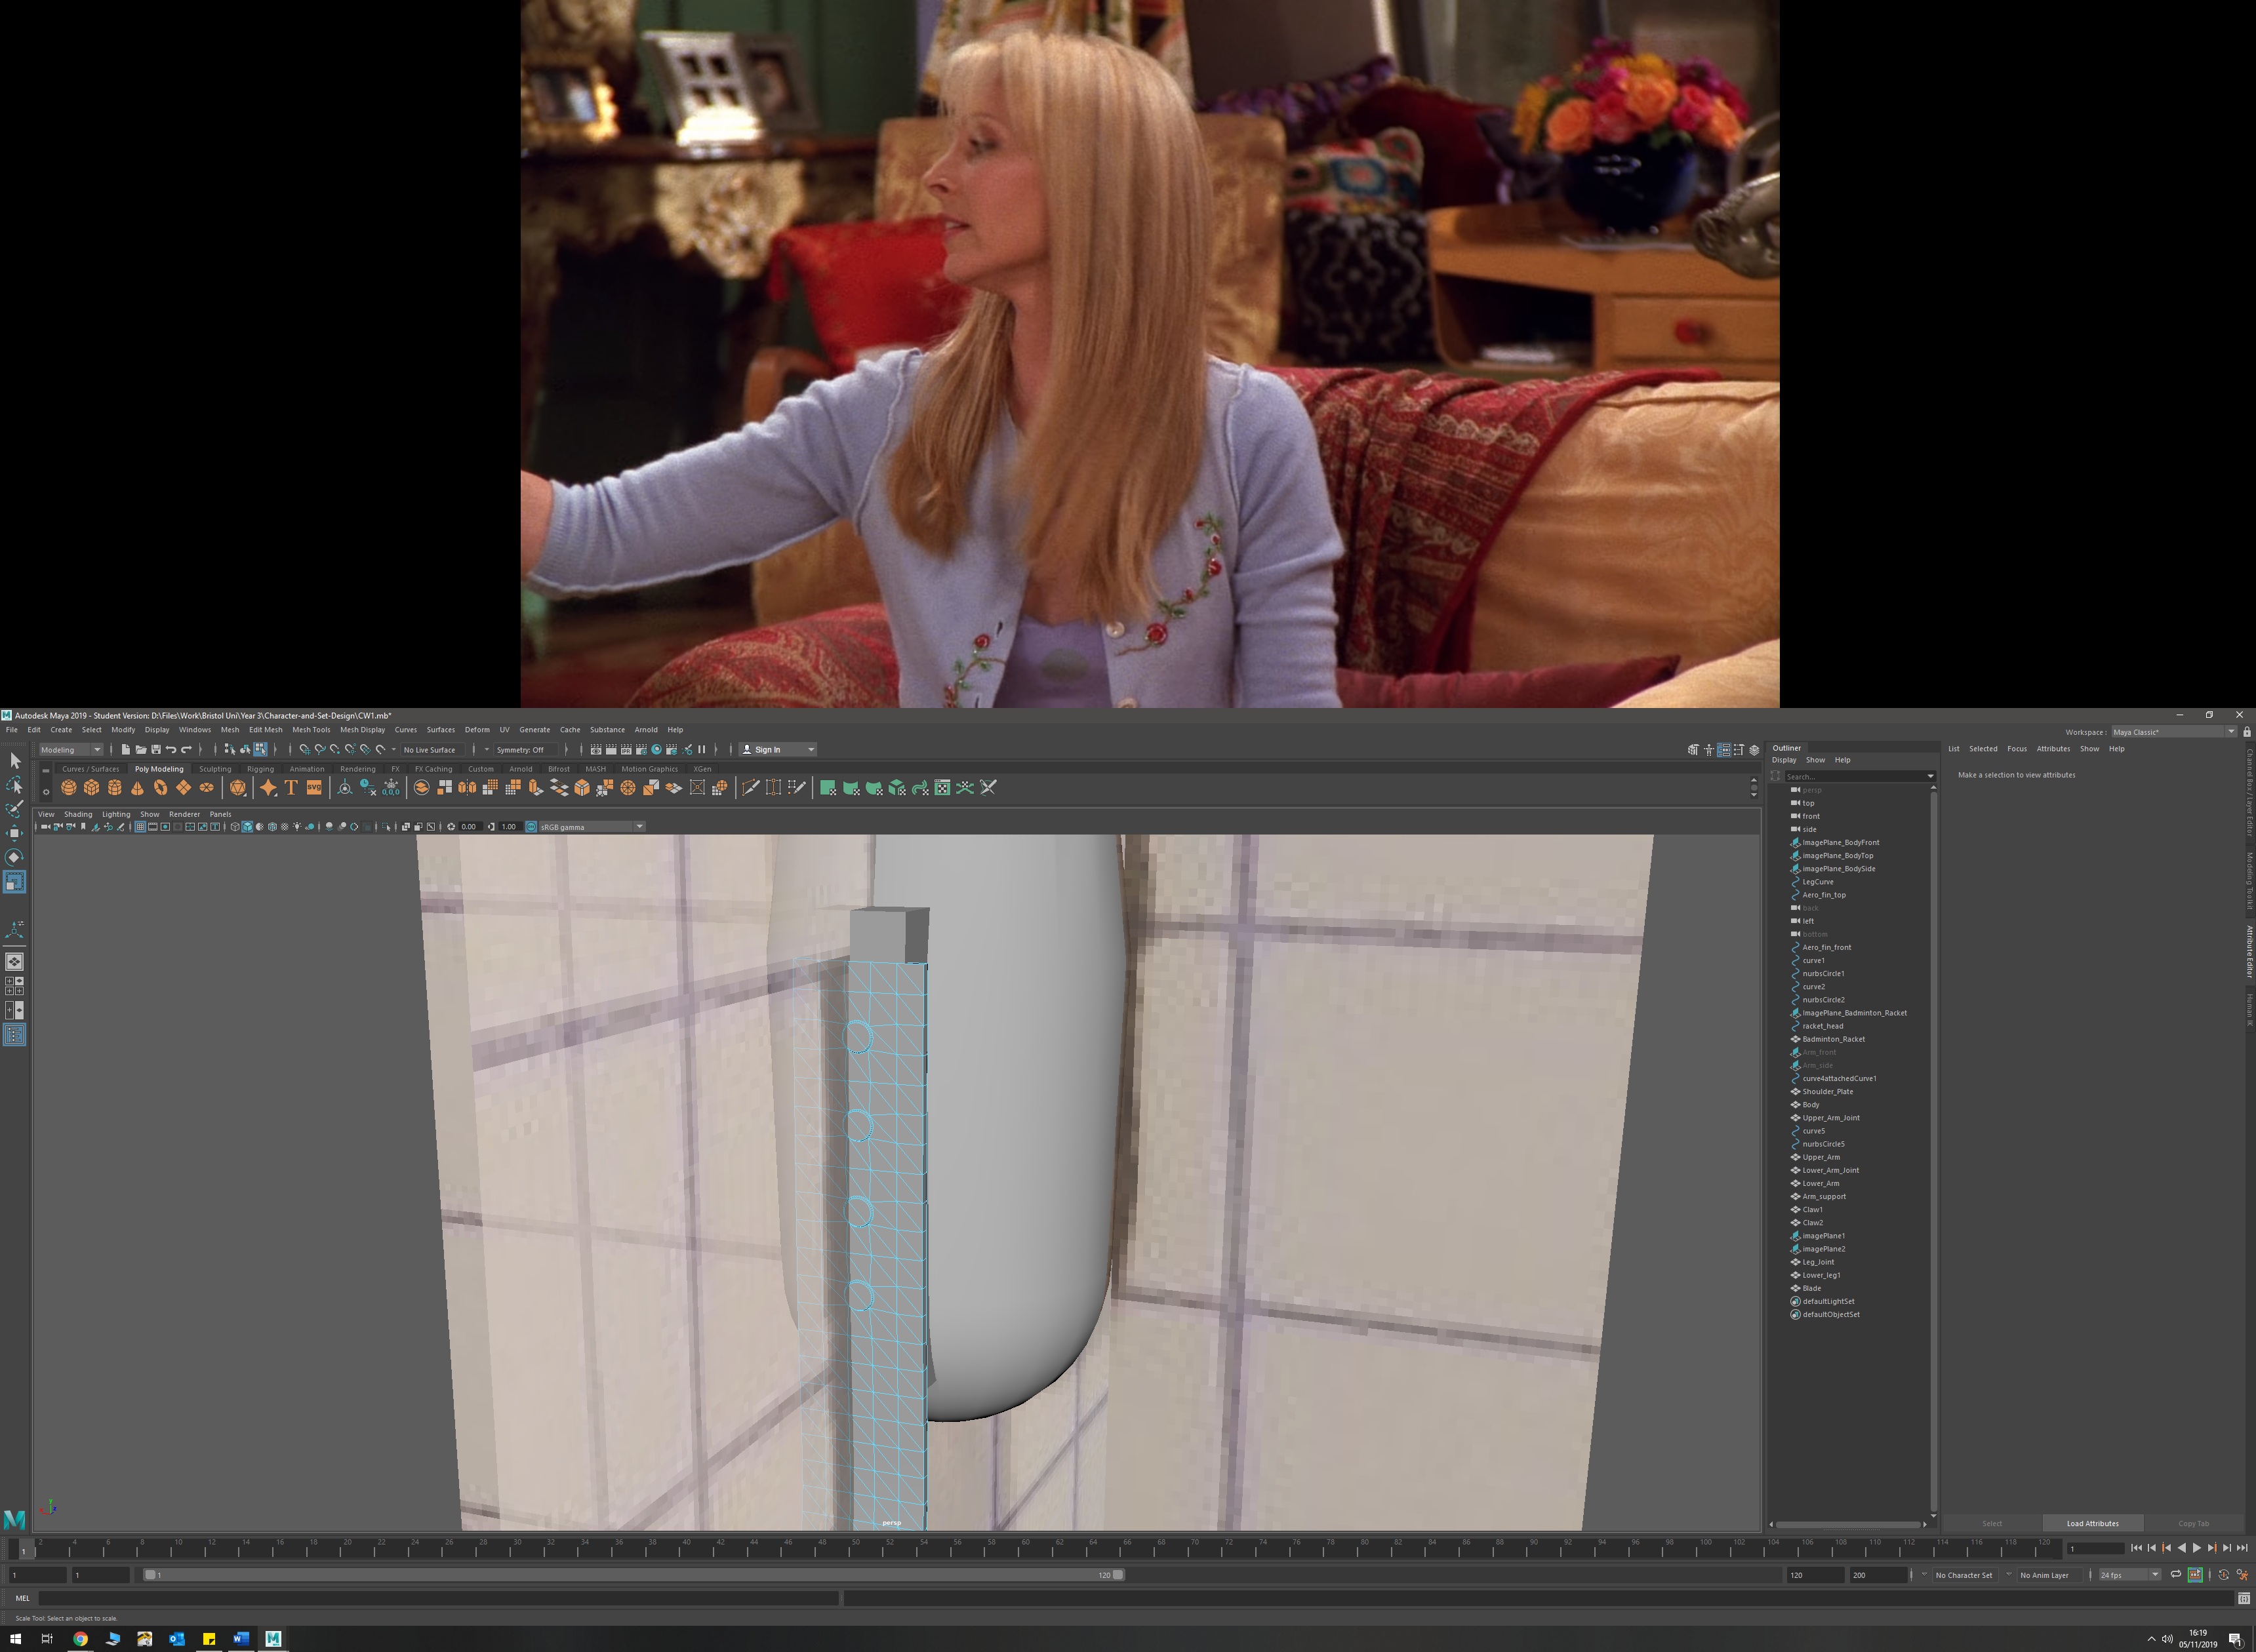

* Upper leg and hip joint was created using polygon prefabs, and then manipulating faces and edges by scaling their size and extruding them where necessary

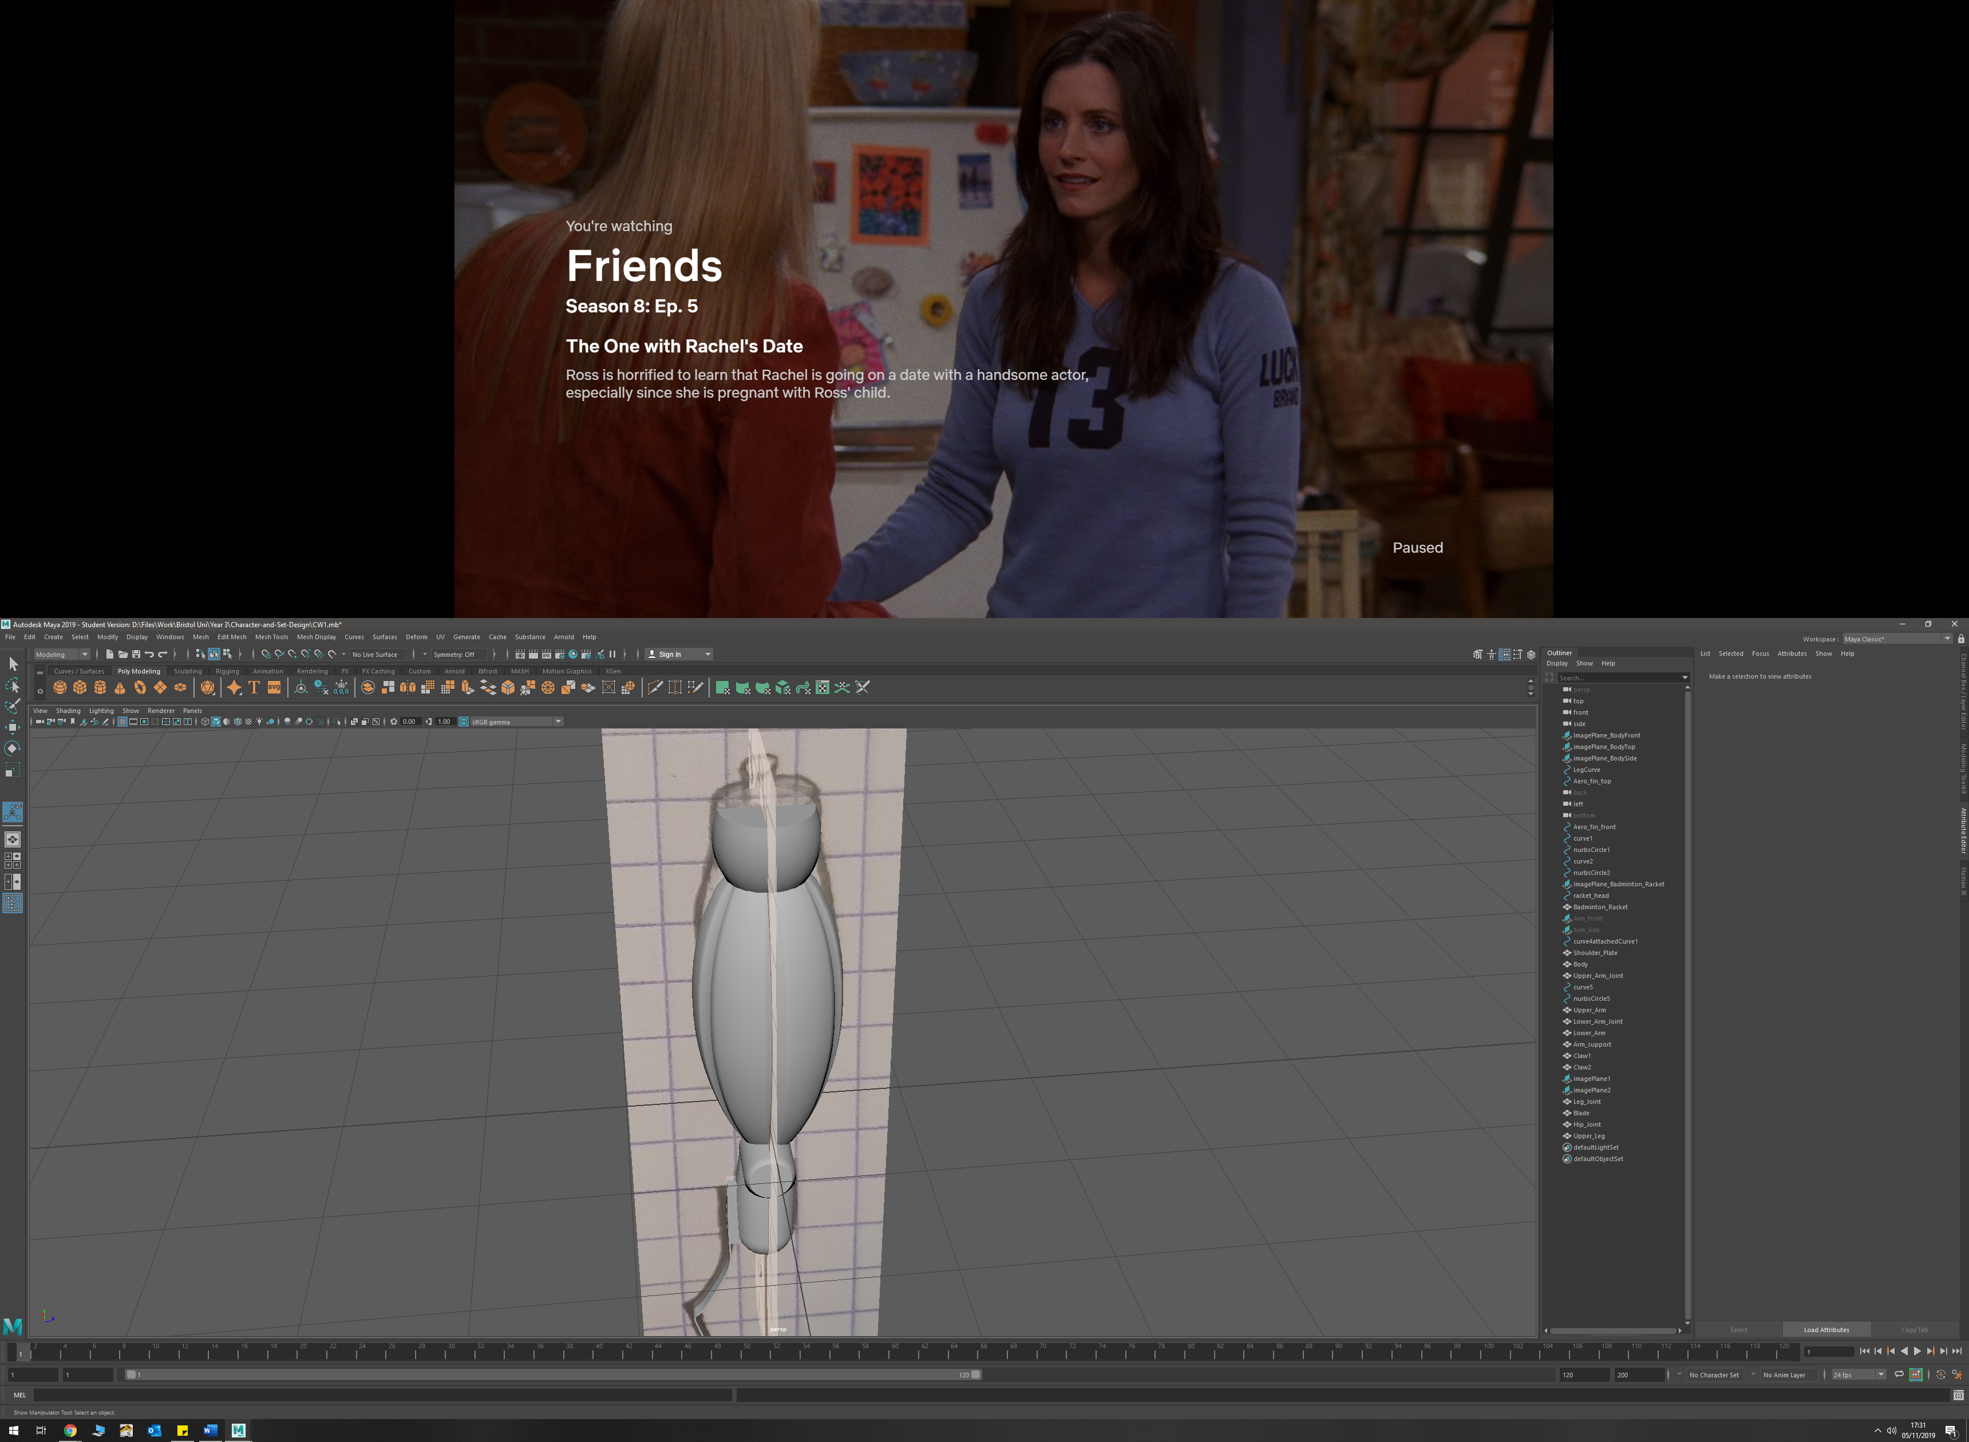

**Process and Discussion**

2-3 pages

**Appendix**

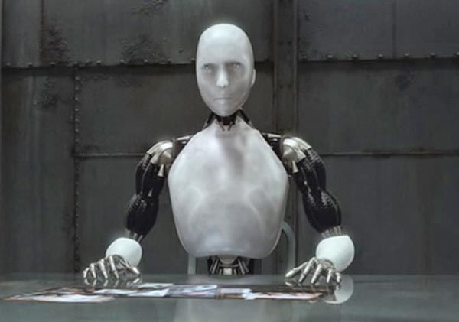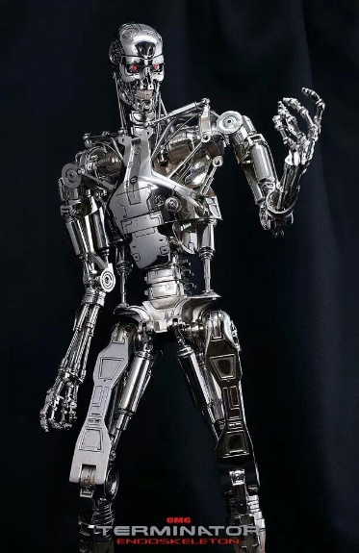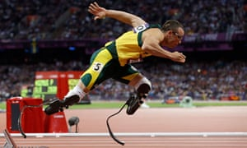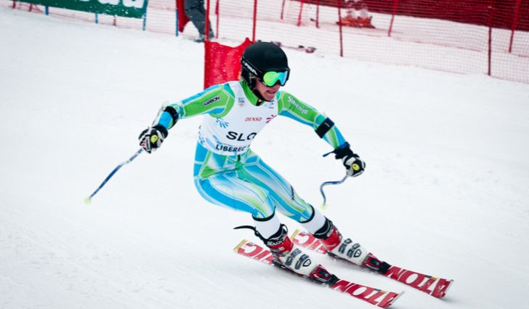**Style Sheet and Visual References**

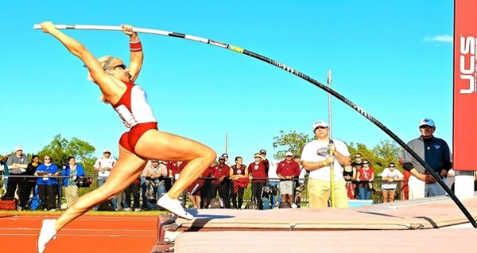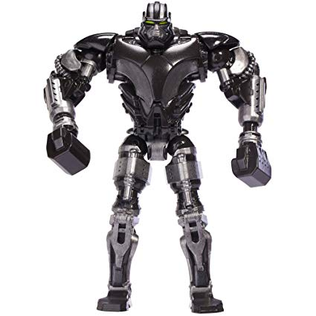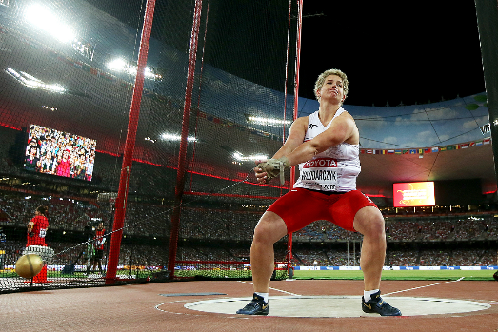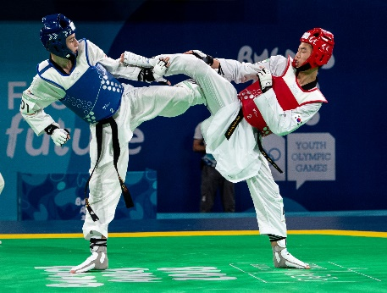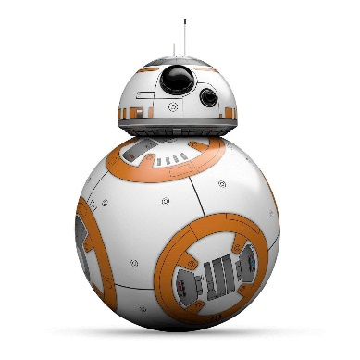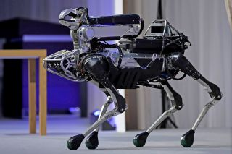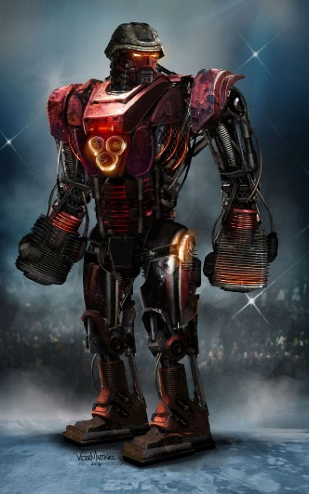

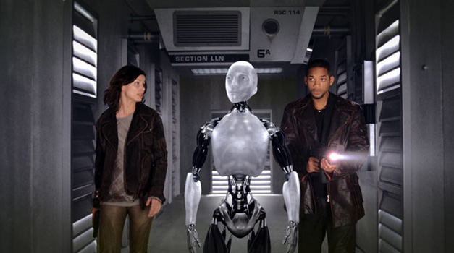

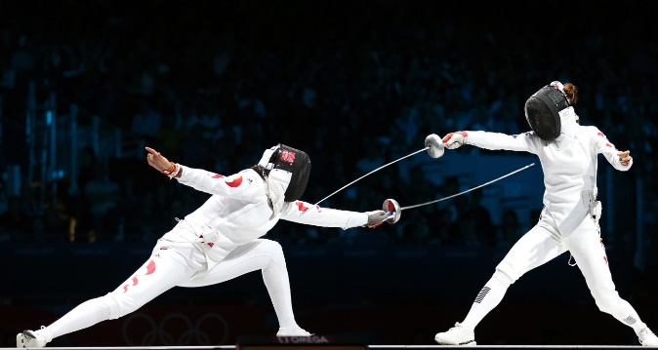

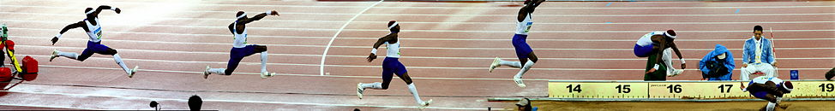

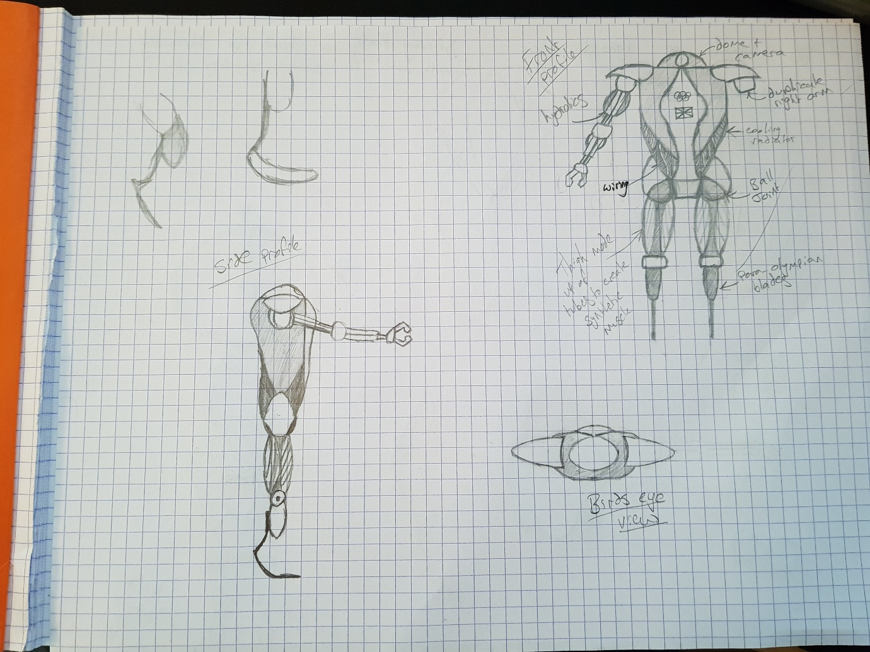**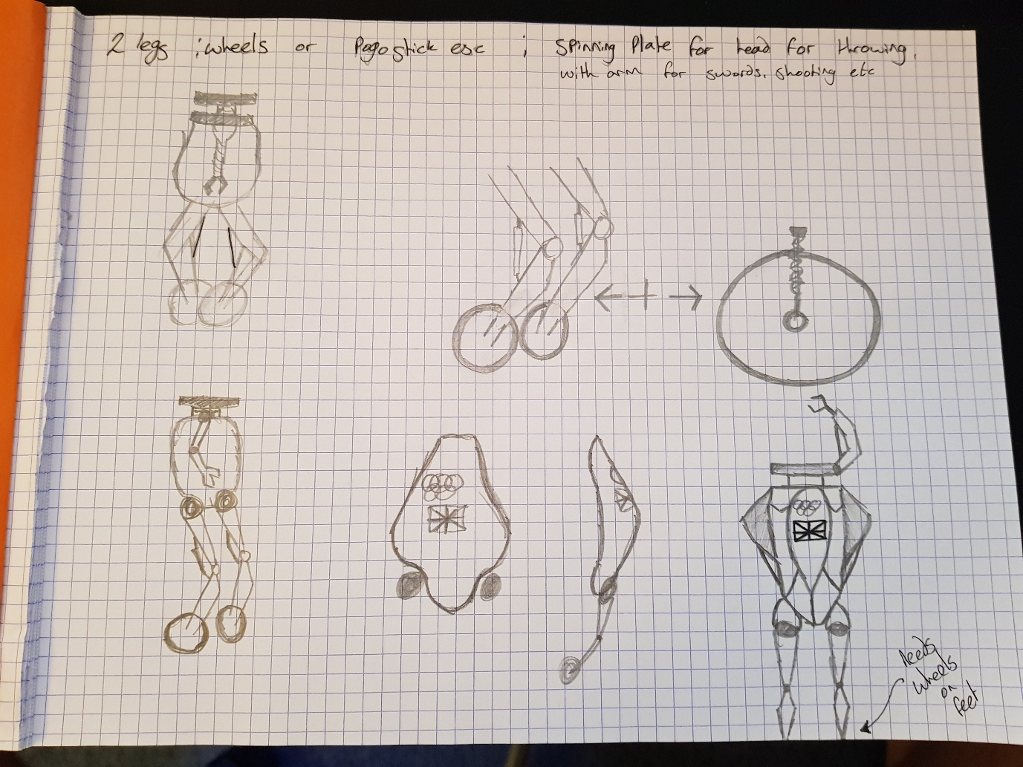Development Drawings**

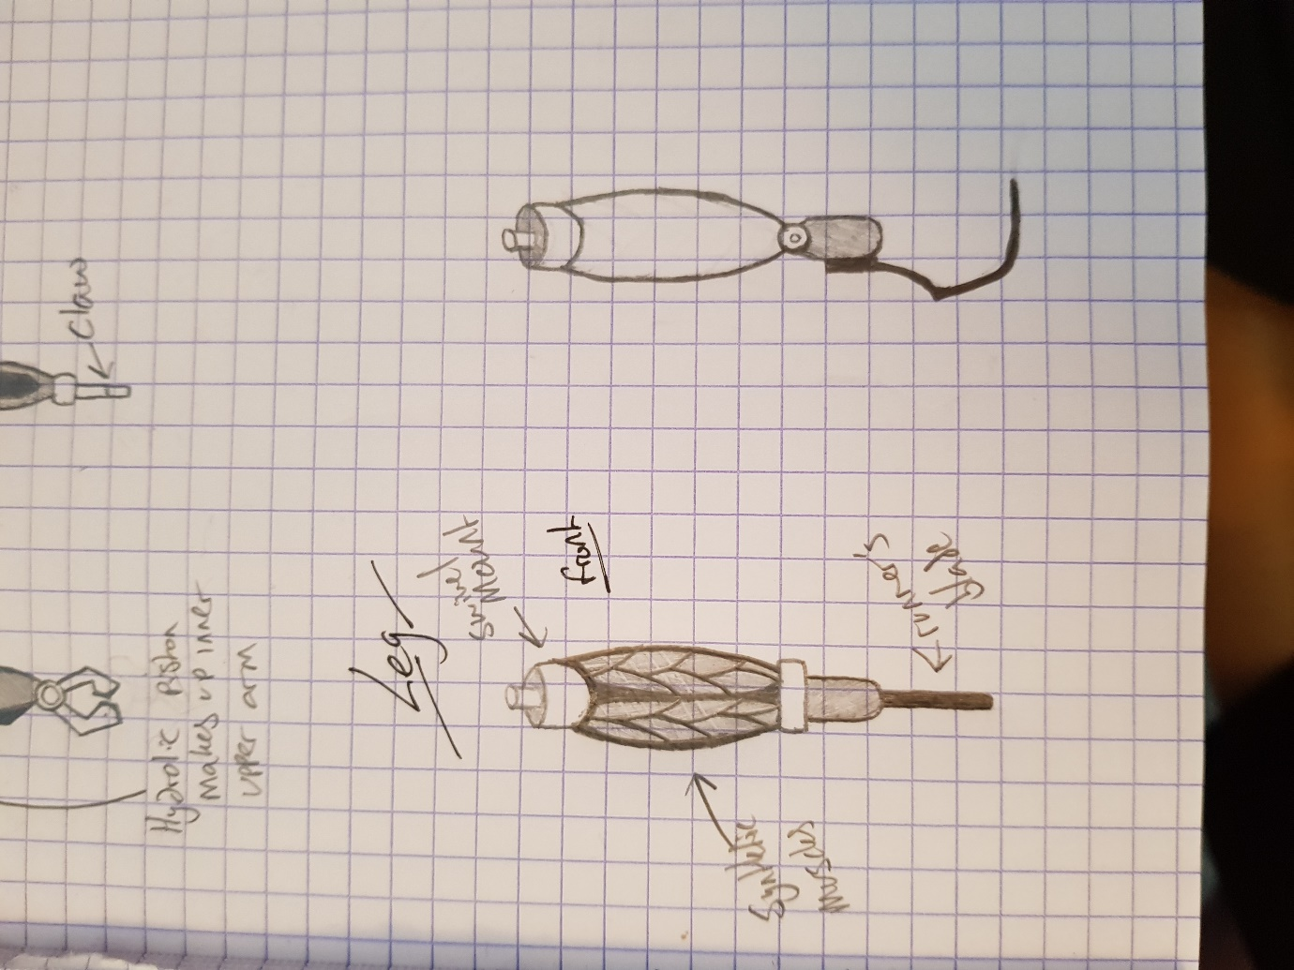**Sketches and Blueprints**

